STROKE PREDICTION USING MACHINE LEARNING

____________________

##### 

##### 

##### 

##### 

##### **STROKE PREDICTION USING MACHINE LEARNING**

##### **A Major Project Report**

***in partial fulfilment for the award of the degree***

***of***

##### **BACHELOR’s OF TECHNOLOGY**

***In***

**COMPUTER SCIENCE ENGINEERING**

###### **by**

##### **MAYANK SINGH, PRITIKA RANA and SHIVAM RATHI**

**Guided by**

**Dr SUNITA TIWARI**

**Assistant. Professor**



**DEPARTMENT OF COMPUTER SCIENCE AND ENGINEERING**

**G.B. PANT GOVT. ENGINEERING COLLEGE, NEW DELHI.**

(AFFILIATED TO GURU GOBIND SINGH INDRAPRASTHA UNIVERSITY, DELHI)

**MAY, 2021**

**CANDIDATE’S DECLARATION**

I hereby certify that the work which is being presented in the Major Project entitled **“Stroke Prediction Using Machine Learning”** in partial fulfilment for the award of the Degree of Bachelor of Technology in Computer Science and Engineering / Information Technology affiliated to **Guru Gobind Singh Indraprastha University, New Delhi** and submitted to the Department of Computer Science and Engineering G. B. Pant Govt. Engineering College is an authentic record of my work carried out during a period from March 2021 to May 2021. The matter represented in this report has not been submitted by me for the award of any other degree of this or any other institute/university.

**Date: - 10-05-2021 Name and Roll No:**

**Mayank Singh (00420907218)**

**Pritika Rana (02420902717)**

**Shivam Rathi (41420902717)**

This is to certify that the above statement made by the candidate is correct to the best of our knowledge.

#### *Signature of Supervisor*

#### **Date: - Name & Designation**

**TABLE OF CONTENTS**

**CHAPTER NO. TITLE PAGE NO.**

**LIST OF FIGURES i**

**ACKNOWLEDGMENT iii**

**ABSTRACT iv**

**CHAPTER 1. INTRODUCTION 1**

1.1 OVERVIEW 1

1.2 MOTIVATION 1

1.3 PROBLEM STATEMENT 1

1.4 SCOPE OF PROJECT 1

1.5 ACCESS TO USERS 2

**CHAPTER 2. RELATED WORKS 3**

2.1 INTRODUCTION 3

2.2 EXISTING SYSTEM 3

2.3 PROPOSED SYSTEM 4

2.3.1 IMAGE FEATURE EXTRACTION 4

2.3.2 THE LANGUAGE MODEL 5

2.3.3 FITTING THE MODEL 6

2.3.4 CAPTION GENERATION 6

2.3.5 SUGGESTION API 6

**CHAPTER 3. PROBLEM DESCRIPTION & SPECIFICATION 7**

3.1 PROBLEM OVERVIEW 7

3.2 SPECIFICATION 7

3.3 REQUIREMENTS 8

3.3.1 SOFTWARE REQUIREMENTS 8

3.3.2 HARDWARE REQUIREMENTS 8

3.3.3 OTHER REQUIREMENTS 9

**CHAPTER 4. SYSTEM DESIGN 10**

4.1 INTRODUCTION 10

4.1.1 DATA SOURCES 10

4.1.2 CONVOLUTION NEURAL NETWORK 10

4.1.3 RECURRENT NEURAL NETWORK 11

4.2 ARCHITECTURE DIAGRAM 11

4.3 UML DIAGRAM 12

4.4 DATA FLOW DIAGRAM 14

4.5 FLOW CHART DIAGRAM14

**CHAPTER 5. IMPLEMENTATION AND RESULT 16**

5.1 INTRODUCTION 16

5.2 MODEL SELECTION 16

5.3 IMAGE PREPROCESSING 17

5.4 TEXT PREPROCESSING 19

5.5 CREATING VOCABULARY 21

5.6 PREPARING THE MODEL 23

5.7 CONFIGURING THE MODEL 25

5.8 TRAINING AND SAVING THE MODEL 28

5.9 PREDICTING THE CAPTIONS 29

5.10 WEB PAGE DEVELOPMENT 31

5.11 API INTEGRATION 32

5.12 PROVIDING USER WITH CAPTIONS32

**CHAPTER 6. CONCLUSION AND FUTURE SCOPE 34**

6.1 CONCLUSION 34

6.2 FUTURE SCOPE34

**CHAPTER 7. REFERENCES 36**

**APPENDICES 39**

**APPENDIX 1: DETAILED TEST STRATEGY AND TEST CASES 39**

**APPENDIX 2: USER GUIDE 40**

**List of Figures**

**Figure No. Figure Title Page No.**

1 Flow Diagram of the project 8

2 Architecture of the image captioning model 11

3 Illustration image of functioning of the captioning model 12

4 Use Case Diagram for the captioning system 12

5 DFD Level 0 13

6 DFD Level 1 13

7 DFD Level 2 14

8 State Chart Diagram of the system 14

9 Flow chart for the caption generation process 15

10 Code Snippet showing the selection and adjustment of the model 16

11 Output representing different layers of the selected model 17

12 Code snippet showing preprocessing of images 17

13 A sample picture fetched from the dataset 18

14 Code snippet - Extracting feature map from passed images 18

15 Output representing the process of feature map creations 19

16 Code snippet showing text preprocessing 20

17 Sample captions fetched from Flickr8k.token.txt 20

18 Code snippet showing the process of caption dictionary creation 21

19 Sample view of caption dictionary 21

20 Code snippet showing Vocabulary Creation Process 22

21 Sample output showing the count of different words 22

22 Sample output showing the word dictionary 23

23 Sample output showing the integer form captions 23

24 Code snippet showing the max length of the caption present 24

25 Output showing the length of the largest caption in our collection 24

26 Code snippet showing the input preparation for the model 24

27 Code snippet showing the conversion to NumPy array form 25

28 Sample output showing the shapes of input 25

29 Configuring process of the image and language model 26

30 Output showing the image sequential model 26

31 Output showing the language sequential model 27

32 Output showing the combined mode 27

33 Detailed layout of the model along with shapes of inputs 28

34 Code snippet showing the training process 29

35 Sample output of the training process 29

36 Sample output of the inverse dictionary 29

37 Code snippet showing the image preprocessing for testing 30

38 Code snippet showing the prediction process and results 30

39 Some sample results generated by the model 31

40 Layout of the Home page of the Web App 33

41 Sample final results on the Web Platform 33

A1 Sample image showing loss and accuracy obtained by the model 38

**ACKNOWLEDGEMENT**

I would like to express my sincere gratitude to my supervisor’s **Dr Sunita Tiwari** & **Dr Anu Saini** for providing their invaluable guidance, comments and suggestions throughout the project. I would specially thank Dr Sunita Tiwari for constantly motivating me to work harder and suggesting me different ways to tackle the problems encountered.

Also, I would like to thank my team members for their assistance in the project. I would like to express my gratitude for the Department of Computer Science Engineering, Gobind Ballabh Pant Government Engineering college to provide me with the opportunity to work on this project and to all the teachers and mentors guiding along the way.

* Mayank Singh (00420907218)
* Pritika Rana (02420902717)
* Shivam Rathi (41420902717)

**ABSTRACT**

The project Stroke Prediction Using Machine Learning provides user an ability to check the chances of stroke to him/her, based on different parameters asked to him/her. The user interacts with the project with the help of a Web Platform which contains a form having different key parameters which constitutes in stroke. On providing these inputs the model predicts the chances of stroke to him/her.

Stroke is a deadly disease and a leading cause of death. In most of the case the patient suffers grave consequences, along with the patient the family and relatives also suffer a lot. But studies suggest that 80 percent of stroke can be pre-diagnosed and, in that scenario, patient can be saved. There are some key parameters which contributes to chances of stroke. There parameter includes age, gender, hypertension, blood pressure, heart disease, average glucose level, BMI, smoking habits, work type, place of residence, marital status, previous history of stroke or heart attack etc. of the patient. As a patient is mostly well aware of these factors, he/she can get a diagnosis in the case of suspicion about chances of stroke. A lot of machine learning methods are developed and are currently under research to predict the chances of stroke based on different parameters.

In this project we have taken 10 different machine learning classifiers and tested them on our dataset “Stroke dataset” for accuracy. Then selected the best one for prediction. We have also performed k-fold validation and hyper-parameter optimization on the model. Along with that we have tried to identify the best features for the classifiers. The inputs gathered from user via the web platform is provided to the model using the flask backend system and the saved model is used for predicting the output which is displayed to the user on the result page.

The project provides user the facility to check the chances of stroke to them based on inputs features at the choice of location and time through their web enabled devices. The project will be hosted online on web app or mobile app and can be used by user from anywhere. Along with this our objective is also to compare various machine learning algorithm and learn how they perform on the dataset for predicting the stroke risk. What are differences among different model and also understand which classifiers performs best and what may be the reasons behind it.

**CHAPTER-1**

**INTRODUCTION**

**1.1 OVERVIEW**

# **Stroke:-**

A **stroke** is a [medical condition](https://en.wikipedia.org/wiki/Disease) in which poor [blood flow](https://en.wikipedia.org/wiki/Cerebral_circulation) to the [brain](https://en.wikipedia.org/wiki/Brain) causes [cell death](https://en.wikipedia.org/wiki/Cell_death).[[5]](https://en.wikipedia.org/wiki/Stroke#cite_note-HLB2014W-5) There are two main types of stroke: [ischemic](https://en.wikipedia.org/wiki/Brain_ischemia), due to lack of blood flow, and [hemorrhagic](https://en.wikipedia.org/wiki/Intracranial_hemorrhage), due to [bleeding](https://en.wikipedia.org/wiki/Bleeding).[[5]](https://en.wikipedia.org/wiki/Stroke#cite_note-HLB2014W-5) Both cause parts of the brain to stop functioning properly.[[5]](https://en.wikipedia.org/wiki/Stroke#cite_note-HLB2014W-5) Signs and symptoms of a stroke may include an [inability to move or feel](https://en.wikipedia.org/wiki/Hemiplegia) on one side of the body, [problems understanding](https://en.wikipedia.org/wiki/Receptive_aphasia) or [speaking](https://en.wikipedia.org/wiki/Expressive_aphasia), [dizziness](https://en.wikipedia.org/wiki/Dizziness), or [loss of vision to one side](https://en.wikipedia.org/wiki/Homonymous_hemianopsia).[[2]](https://en.wikipedia.org/wiki/Stroke#cite_note-Donnan2008-2)[[3]](https://en.wikipedia.org/wiki/Stroke#cite_note-HLB2014S-3) Signs and symptoms often appear soon after the stroke has occurred.[[3]](https://en.wikipedia.org/wiki/Stroke#cite_note-HLB2014S-3) If symptoms last less than one or two hours, the stroke is a [transient ischemic attack](https://en.wikipedia.org/wiki/Transient_ischemic_attack) (TIA), also called a mini-stroke.[[3]](https://en.wikipedia.org/wiki/Stroke#cite_note-HLB2014S-3) A [hemorrhagic stroke](https://en.wikipedia.org/wiki/Subarachnoid_hemorrhage) may also be associated with a [severe headache](https://en.wikipedia.org/wiki/Thunderclap_headache).[[3]](https://en.wikipedia.org/wiki/Stroke#cite_note-HLB2014S-3) The symptoms of a stroke can be permanent.[[5]](https://en.wikipedia.org/wiki/Stroke#cite_note-HLB2014W-5) Long-term complications may include [pneumonia](https://en.wikipedia.org/wiki/Pneumonia) and [loss of bladder control](https://en.wikipedia.org/wiki/Urinary_incontinence).[[3]](https://en.wikipedia.org/wiki/Stroke#cite_note-HLB2014S-3)

[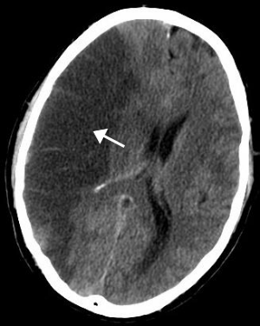](https://en.wikipedia.org/wiki/File:MCA_Territory_Infarct.svg)

Figure 1 [CT scan](https://en.wikipedia.org/wiki/CT_scan) of the brain showing a prior right-sided [ischemic](https://en.wikipedia.org/wiki/Ischemic) stroke from blockage of an artery. Changes on a CT may not be visible early on.

The main [risk factor](https://en.wikipedia.org/wiki/Risk_factor) for stroke is [high blood pressure](https://en.wikipedia.org/wiki/Hypertension).[[6]](https://en.wikipedia.org/wiki/Stroke#cite_note-HLB2014C-6) Other risk factors include [tobacco smoking](https://en.wikipedia.org/wiki/Tobacco_smoking), [obesity](https://en.wikipedia.org/wiki/Obesity), [high blood cholesterol](https://en.wikipedia.org/wiki/Hypercholesterolemia), [diabetes mellitus](https://en.wikipedia.org/wiki/Diabetes_mellitus), a previous TIA, [end-stage kidney disease](https://en.wikipedia.org/wiki/End-stage_kidney_disease), and [atrial fibrillation](https://en.wikipedia.org/wiki/Atrial_fibrillation).[[2]](https://en.wikipedia.org/wiki/Stroke#cite_note-Donnan2008-2)[[6]](https://en.wikipedia.org/wiki/Stroke#cite_note-HLB2014C-6)[[7]](https://en.wikipedia.org/wiki/Stroke#cite_note-Hu2018-7) An ischemic stroke is typically caused by blockage of a blood vessel, though there are also less common causes.[[12]](https://en.wikipedia.org/wiki/Stroke#cite_note-HLB2014T-12)[[13]](https://en.wikipedia.org/wiki/Stroke#cite_note-13)[[14]](https://en.wikipedia.org/wiki/Stroke#cite_note-14) A hemorrhagic stroke is caused by either [bleeding directly into the brain](https://en.wikipedia.org/wiki/Intracerebral_hemorrhage) or into the [space](https://en.wikipedia.org/wiki/Subarachnoid_hemorrhage) between the [brain's membranes](https://en.wikipedia.org/wiki/Meninges).[[12]](https://en.wikipedia.org/wiki/Stroke#cite_note-HLB2014T-12)[[15]](https://en.wikipedia.org/wiki/Stroke#cite_note-Feigin05-15) Bleeding may occur due to a ruptured [brain aneurysm](https://en.wikipedia.org/wiki/Intracranial_aneurysm).[[12]](https://en.wikipedia.org/wiki/Stroke#cite_note-HLB2014T-12) Diagnosis is typically based on a [physical exam](https://en.wikipedia.org/wiki/Physical_exam) and supported by [medical imaging](https://en.wikipedia.org/wiki/Medical_imaging) such as a [CT scan](https://en.wikipedia.org/wiki/CT_scan) or [MRI scan](https://en.wikipedia.org/wiki/Magnetic_resonance_imaging).[[8]](https://en.wikipedia.org/wiki/Stroke#cite_note-HLB2014D-8) A CT scan can rule out bleeding, but may not necessarily rule out ischemia, which early on typically does not show up on a CT scan.[[9]](https://en.wikipedia.org/wiki/Stroke#cite_note-AFP2009-9) Other tests such as an [electrocardiogram](https://en.wikipedia.org/wiki/Electrocardiogram) (ECG) and [blood tests](https://en.wikipedia.org/wiki/Blood_test) are done to determine risk factors and rule out other possible causes.[[8]](https://en.wikipedia.org/wiki/Stroke#cite_note-HLB2014D-8) [Low blood sugar](https://en.wikipedia.org/wiki/Low_blood_sugar) may cause similar symptoms.[[8]](https://en.wikipedia.org/wiki/Stroke#cite_note-HLB2014D-8)

Prevention includes decreasing risk factors, [surgery to open up the arteries to the brain](https://en.wikipedia.org/wiki/Carotid_endarterectomy) in those with problematic [carotid narrowing](https://en.wikipedia.org/wiki/Carotid_stenosis), and [warfarin](https://en.wikipedia.org/wiki/Warfarin) in people with [atrial fibrillation](https://en.wikipedia.org/wiki/Atrial_fibrillation).[[2]](https://en.wikipedia.org/wiki/Stroke#cite_note-Donnan2008-2) [Aspirin](https://en.wikipedia.org/wiki/Aspirin) or [statins](https://en.wikipedia.org/wiki/Statin) may be recommended by physicians for prevention.[[2]](https://en.wikipedia.org/wiki/Stroke#cite_note-Donnan2008-2) A stroke or TIA often requires emergency care.[[5]](https://en.wikipedia.org/wiki/Stroke#cite_note-HLB2014W-5) An ischemic stroke, if detected within three to four and half hours, may be treatable with a [medication](https://en.wikipedia.org/wiki/Thrombolytic_drug) that can [break down the clot](https://en.wikipedia.org/wiki/Thrombolysis).[[2]](https://en.wikipedia.org/wiki/Stroke#cite_note-Donnan2008-2) Some hemorrhagic strokes benefit from [surgery](https://en.wikipedia.org/wiki/Neurosurgery).[[2]](https://en.wikipedia.org/wiki/Stroke#cite_note-Donnan2008-2) Treatment to attempt recovery of lost function is called [stroke rehabilitation](https://en.wikipedia.org/wiki/Stroke_rehabilitation), and ideally takes place in a stroke unit; however, these are not available in much of the world.[[2]](https://en.wikipedia.org/wiki/Stroke#cite_note-Donnan2008-2)

In 2013, approximately 6.9 million people had an ischemic stroke and 3.4 million people had a hemorrhagic stroke.[[16]](https://en.wikipedia.org/wiki/Stroke#cite_note-16) In 2015, there were about 42.4 million people who had previously had a stroke and were still alive.[[10]](https://en.wikipedia.org/wiki/Stroke#cite_note-GBD2015Pre-10) Between 1990 and 2010 the number of strokes which occurred each year decreased by approximately 10% in the [developed world](https://en.wikipedia.org/wiki/Developed_world) and increased by 10% in the developing world.[[17]](https://en.wikipedia.org/wiki/Stroke#cite_note-Fei2013-17) In 2015, stroke was the second most [frequent cause of death](https://en.wikipedia.org/wiki/List_of_causes_of_death_by_rate) after [coronary artery disease](https://en.wikipedia.org/wiki/Coronary_artery_disease), accounting for 6.3 million deaths (11% of the total).[[11]](https://en.wikipedia.org/wiki/Stroke#cite_note-GBD2015De-11) About 3.0 million deaths resulted from ischemic stroke while 3.3 million deaths resulted from hemorrhagic stroke.[[11]](https://en.wikipedia.org/wiki/Stroke#cite_note-GBD2015De-11) About half of people who have had a stroke live less than one year.[[2]](https://en.wikipedia.org/wiki/Stroke#cite_note-Donnan2008-2) Overall, two thirds of strokes occurred in those over 65 years old.[[17]](https://en.wikipedia.org/wiki/Stroke#cite_note-Fei2013-17)

## Classification

[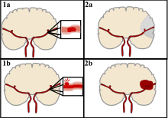](https://en.wikipedia.org/wiki/File:Ischemic_Stroke.svg)

There are two main categories of strokes. Ischemic (top), typically caused by a blood clot in an artery (1a) resulting in brain death to the affected area (2a). Hemorrhagic (bottom), caused by blood leaking into or around the brain from a ruptured blood vessel (1b) allowing blood to pool in the affected area (2b) thus increasing the pressure on the brain.

[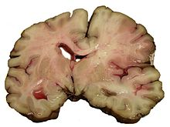](https://en.wikipedia.org/wiki/File:MCA-Stroke-Brain-Human-2.JPG)

A slice of brain from the autopsy of a person who had an acute [middle cerebral artery (MCA)](https://en.wikipedia.org/wiki/Middle_cerebral_artery) stroke

Strokes can be classified into two major categories: [ischemic](https://en.wikipedia.org/wiki/Ischemia) and [hemorrhagic](https://en.wikipedia.org/wiki/Bleeding).[[18]](https://en.wikipedia.org/wiki/Stroke#cite_note-18) Ischemic strokes are caused by [interruption of the blood supply](https://en.wikipedia.org/wiki/Perfusion#Malperfusion) to the brain, while hemorrhagic strokes result from the rupture of a [blood vessel](https://en.wikipedia.org/wiki/Blood_vessel) or an [abnormal vascular structure](https://en.wikipedia.org/wiki/Cerebral_arteriovenous_malformation). About 87% of strokes are ischemic, the rest being hemorrhagic. Bleeding can develop inside areas of ischemia, a condition known as "hemorrhagic transformation." It is unknown how many hemorrhagic strokes actually start as ischemic strokes.[[2]](https://en.wikipedia.org/wiki/Stroke#cite_note-Donnan2008-2)

### Definition

In the 1970s the [World Health Organization](https://en.wikipedia.org/wiki/World_Health_Organization) defined stroke as a "neurological deficit of cerebrovascular cause that persists beyond 24 hours or is interrupted by death within 24 hours",[[19]](https://en.wikipedia.org/wiki/Stroke#cite_note-19) although the word "stroke" is centuries old. This definition was supposed to reflect the reversibility of tissue damage and was devised for the purpose, with the time frame of 24 hours being chosen arbitrarily. The 24-hour limit divides stroke from [transient ischemic attack](https://en.wikipedia.org/wiki/Transient_ischemic_attack), which is a related syndrome of stroke symptoms that resolve completely within 24 hours.[[2]](https://en.wikipedia.org/wiki/Stroke#cite_note-Donnan2008-2) With the availability of treatments that can reduce stroke severity when given early, many now prefer alternative terminology, such as brain attack and acute ischemic cerebrovascular syndrome (modeled after [heart attack](https://en.wikipedia.org/wiki/Myocardial_infarction) and [acute coronary syndrome](https://en.wikipedia.org/wiki/Acute_coronary_syndrome), respectively), to reflect the urgency of stroke symptoms and the need to act swiftly.[[20]](https://en.wikipedia.org/wiki/Stroke#cite_note-20)

### Ischemic

In an ischemic stroke, blood supply to part of the brain is decreased, leading to dysfunction of the brain tissue in that area. There are four reasons why this might happen:

1. [Thrombosis](https://en.wikipedia.org/wiki/Thrombosis) (obstruction of a blood vessel by a blood clot forming locally)
2. [Embolism](https://en.wikipedia.org/wiki/Embolism) (obstruction due to an [embolus](https://en.wikipedia.org/wiki/Embolus) from elsewhere in the body),[[2]](https://en.wikipedia.org/wiki/Stroke#cite_note-Donnan2008-2)
3. Systemic hypoperfusion (general decrease in blood supply, e.g., in [shock](https://en.wikipedia.org/wiki/Shock_(circulatory)))[[21]](https://en.wikipedia.org/wiki/Stroke#cite_note-21)
4. [Cerebral venous sinus thrombosis](https://en.wikipedia.org/wiki/Cerebral_venous_sinus_thrombosis).[[22]](https://en.wikipedia.org/wiki/Stroke#cite_note-Stam2005-22)

A stroke without an obvious explanation is termed [cryptogenic](https://en.wikipedia.org/wiki/Idiopathic_disease) (of unknown origin); this constitutes 30–40% of all ischemic strokes.[[2]](https://en.wikipedia.org/wiki/Stroke#cite_note-Donnan2008-2)[[23]](https://en.wikipedia.org/wiki/Stroke#cite_note-Guercini-23)

There are various classification systems for acute ischemic stroke. The Oxford Community Stroke Project classification (OCSP, also known as the Bamford or Oxford classification) relies primarily on the initial symptoms; based on the extent of the symptoms, the stroke episode is classified as [total anterior circulation infarct](https://en.wikipedia.org/wiki/Total_anterior_circulation_infarct) (TACI), [partial anterior circulation infarct](https://en.wikipedia.org/wiki/Partial_anterior_circulation_infarct) (PACI), [lacunar infarct](https://en.wikipedia.org/wiki/Lacunar_infarct) (LACI) or [posterior circulation infarct](https://en.wikipedia.org/wiki/Posterior_circulation_infarct) (POCI). These four entities predict the extent of the stroke, the area of the brain that is affected, the underlying cause, and the prognosis.[[24]](https://en.wikipedia.org/wiki/Stroke#cite_note-24)[[25]](https://en.wikipedia.org/wiki/Stroke#cite_note-25) The TOAST (Trial of [Org 10172](https://en.wikipedia.org/wiki/Danaparoid) in Acute Stroke Treatment) classification is based on clinical symptoms as well as results of further investigations; on this basis, a stroke is classified as being due to (1) thrombosis or embolism due to [atherosclerosis](https://en.wikipedia.org/wiki/Atherosclerosis) of a large artery, (2) an embolism originating in the [heart](https://en.wikipedia.org/wiki/Heart), (3) complete blockage of a small blood vessel, (4) other determined cause, (5) undetermined cause (two possible causes, no cause identified, or incomplete investigation).[[26]](https://en.wikipedia.org/wiki/Stroke#cite_note-26) [Users](https://en.wikipedia.org/wiki/Recreational_drug_use) of [stimulants](https://en.wikipedia.org/wiki/Stimulant) such as [cocaine](https://en.wikipedia.org/wiki/Cocaine) and [methamphetamine](https://en.wikipedia.org/wiki/Methamphetamine) are at a high risk for ischemic strokes.[[27]](https://en.wikipedia.org/wiki/Stroke#cite_note-27)

### Hemorrhagic

Main articles: [Intracerebral hemorrhage](https://en.wikipedia.org/wiki/Intracerebral_hemorrhage) and [Subarachnoid hemorrhage](https://en.wikipedia.org/wiki/Subarachnoid_hemorrhage)

[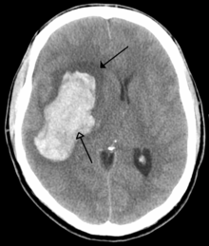](https://en.wikipedia.org/wiki/File:Parachemableedwithedema.png)

[CT scan](https://en.wikipedia.org/wiki/CT_scan) of an intraparenchymal bleed (bottom arrow) with surrounding edema (top arrow)

There are two main types of hemorrhagic stroke:[[28]](https://en.wikipedia.org/wiki/Stroke#cite_note-28)[[29]](https://en.wikipedia.org/wiki/Stroke#cite_note-29)

* [Intracerebral hemorrhage](https://en.wikipedia.org/wiki/Intracerebral_hemorrhage), which is basically bleeding within the brain itself (when an artery in the brain bursts, flooding the surrounding tissue with blood), due to either [intraparenchymal hemorrhage](https://en.wikipedia.org/wiki/Intraparenchymal_hemorrhage) (bleeding within the brain tissue) or [intraventricular hemorrhage](https://en.wikipedia.org/wiki/Intraventricular_hemorrhage) (bleeding within the brain's [ventricular system](https://en.wikipedia.org/wiki/Ventricular_system)).
* [Subarachnoid hemorrhage](https://en.wikipedia.org/wiki/Subarachnoid_hemorrhage), which is basically bleeding that occurs outside of the brain tissue but still within the skull, and precisely between the [arachnoid mater](https://en.wikipedia.org/wiki/Arachnoid_mater) and [pia mater](https://en.wikipedia.org/wiki/Pia_mater) (the delicate *innermost* layer of the three layers of the [meninges](https://en.wikipedia.org/wiki/Meninges) that surround the brain).

The above two main types of hemorrhagic stroke are also two different forms of [intracranial hemorrhage](https://en.wikipedia.org/wiki/Intracranial_hemorrhage), which is the accumulation of blood anywhere within the [cranial vault](https://en.wikipedia.org/wiki/Cranial_vault); but the other forms of intracranial hemorrhage, such as [epidural hematoma](https://en.wikipedia.org/wiki/Epidural_hematoma) (bleeding between the skull and the [dura mater](https://en.wikipedia.org/wiki/Dura_mater), which is the thick *outermost* layer of the meninges that surround the brain) and [subdural hematoma](https://en.wikipedia.org/wiki/Subdural_hematoma) (bleeding in the [subdural space](https://en.wikipedia.org/wiki/Subdural_space)), are not considered "hemorrhagic strokes".[[30]](https://en.wikipedia.org/wiki/Stroke#cite_note-30)

Hemorrhagic strokes may occur on the background of alterations to the blood vessels in the brain, such as [cerebral amyloid angiopathy](https://en.wikipedia.org/wiki/Cerebral_amyloid_angiopathy), [cerebral arteriovenous malformation](https://en.wikipedia.org/wiki/Cerebral_arteriovenous_malformation) and an [intracranial aneurysm](https://en.wikipedia.org/wiki/Intracranial_aneurysm), which can cause intraparenchymal or subarachnoid hemorrhage.[[*citation needed*](https://en.wikipedia.org/wiki/Wikipedia:Citation_needed)]

In addition to neurological impairment, hemorrhagic strokes usually cause specific symptoms (for instance, subarachnoid hemorrhage classically causes a severe [headache](https://en.wikipedia.org/wiki/Headache) known as a [thunderclap headache](https://en.wikipedia.org/wiki/Thunderclap_headache)) or reveal evidence of a previous [head injury](https://en.wikipedia.org/wiki/Head_injury).

## Signs and symptoms

Stroke symptoms typically start suddenly, over seconds to minutes, and in most cases do not progress further. The symptoms depend on the area of the brain affected. The more extensive the area of the brain affected, the more functions that are likely to be lost. Some forms of stroke can cause additional symptoms. For example, in intracranial hemorrhage, the affected area may compress other structures. Most forms of stroke are not associated with a [headache](https://en.wikipedia.org/wiki/Headache), apart from subarachnoid hemorrhage and cerebral venous thrombosis and occasionally intracerebral hemorrhage.[[*citation needed*](https://en.wikipedia.org/wiki/Wikipedia:Citation_needed)]

### Early recognition

Various systems have been proposed to increase recognition of stroke. Different findings are able to predict the presence or absence of stroke to different degrees. Sudden-onset face weakness, arm drift (i.e., if a person, when asked to raise both arms, involuntarily lets one arm drift downward) and abnormal speech are the findings most likely to lead to the correct identification of a case of stroke, increasing the likelihood by 5.5 when at least one of these is present. Similarly, when all three of these are absent, the likelihood of stroke is decreased (– [likelihood ratio](https://en.wikipedia.org/wiki/Likelihood_ratios_in_diagnostic_testing) of 0.39).[[31]](https://en.wikipedia.org/wiki/Stroke#cite_note-pmid15900010-31) While these findings are not perfect for diagnosing stroke, the fact that they can be evaluated relatively rapidly and easily make them very valuable in the acute setting.

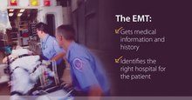[Play media](https://upload.wikimedia.org/wikipedia/commons/7/7d/CDC_video_about_stroke_emergency_treatment.ogv)

A [Centers for Disease Control and Prevention](https://en.wikipedia.org/wiki/Centers_for_Disease_Control_and_Prevention) public service announcement on emergency medical treatment after or during a stroke from 2021.

A mnemonic to remember the warning signs of stroke is [FAST](https://en.wikipedia.org/wiki/FAST_(stroke)) (facial droop, arm weakness, speech difficulty, and time to call emergency services),[[32]](https://en.wikipedia.org/wiki/Stroke#cite_note-32) as advocated by the [Department of Health (United Kingdom)](https://en.wikipedia.org/wiki/Department_of_Health_(United_Kingdom)) and the [Stroke Association](https://en.wikipedia.org/wiki/Stroke_Association), the [American Stroke Association](https://en.wikipedia.org/wiki/American_Stroke_Association), the [National Stroke Association](https://en.wikipedia.org/wiki/National_Stroke_Association) (US), the [Los Angeles Prehospital Stroke Screen (LAPSS)](https://en.wikipedia.org/wiki/Los_Angeles_Prehospital_Stroke_Screen_(LAPSS))[[33]](https://en.wikipedia.org/wiki/Stroke#cite_note-33) and the [Cincinnati Prehospital Stroke Scale](https://en.wikipedia.org/wiki/Cincinnati_Stroke_Scale) (CPSS).[[34]](https://en.wikipedia.org/wiki/Stroke#cite_note-34) Use of these scales is recommended by professional guidelines.[[35]](https://en.wikipedia.org/wiki/Stroke#cite_note-NICECG68-35) FAST is less reliable in the recognition of posterior circulation strokes.[[36]](https://en.wikipedia.org/wiki/Stroke#cite_note-36)

For people referred to the [emergency room](https://en.wikipedia.org/wiki/Emergency_room), early recognition of stroke is deemed important as this can expedite diagnostic tests and treatments. A scoring system called ROSIER (recognition of stroke in the emergency room) is recommended for this purpose; it is based on features from the medical history and physical examination.[[35]](https://en.wikipedia.org/wiki/Stroke#cite_note-NICECG68-35)[[37]](https://en.wikipedia.org/wiki/Stroke#cite_note-37)

### Subtypes

If the area of the brain affected includes one of the three prominent [central nervous system pathways](https://en.wikipedia.org/wiki/Neural_pathway)—the [spinothalamic tract](https://en.wikipedia.org/wiki/Spinothalamic_tract), [corticospinal tract](https://en.wikipedia.org/wiki/Corticospinal_tract), and the [dorsal column–medial lemniscus pathway](https://en.wikipedia.org/wiki/Dorsal_column%E2%80%93medial_lemniscus_pathway), symptoms may include:

* [hemiplegia](https://en.wikipedia.org/wiki/Hemiplegia) and [muscle weakness of the face](https://en.wikipedia.org/wiki/Central_facial_palsy)
* numbness
* reduction in sensory or vibratory sensation
* initial [flaccidity](https://en.wikipedia.org/wiki/Flaccidity) (reduced muscle tone), replaced by [spasticity](https://en.wikipedia.org/wiki/Spasticity) (increased muscle tone), [excessive reflexes](https://en.wikipedia.org/wiki/Hyperreflexia), and obligatory synergies.[[38]](https://en.wikipedia.org/wiki/Stroke#cite_note-OSul07_719-38)

In most cases, the symptoms affect only one side of the body (unilateral). Depending on the part of the brain affected, the defect in the brain is *usually* on the [opposite side](https://en.wikipedia.org/wiki/Contralateral) of the body. However, since these pathways also travel in the [spinal cord](https://en.wikipedia.org/wiki/Spinal_cord) and any lesion there can also produce these symptoms, the presence of any one of these symptoms does not necessarily indicate a stroke. In addition to the above CNS pathways, the [*brainstem*](https://en.wikipedia.org/wiki/Brainstem) gives rise to most of the twelve [cranial nerves](https://en.wikipedia.org/wiki/Cranial_nerves). A [brainstem stroke](https://en.wikipedia.org/wiki/Brainstem_stroke_syndrome) affecting the brainstem and brain, therefore, can produce symptoms relating to deficits in these cranial nerves:[[*citation needed*](https://en.wikipedia.org/wiki/Wikipedia:Citation_needed)]

* altered smell, taste, hearing, or vision (total or partial)
* drooping of eyelid ([ptosis](https://en.wikipedia.org/wiki/Ptosis_(eyelid))) and weakness of [ocular muscles](https://en.wikipedia.org/wiki/Extraocular_muscles)
* decreased reflexes: gag, swallow, pupil reactivity to light
* decreased sensation and muscle weakness of the face
* [balance problems](https://en.wikipedia.org/wiki/Balance_disorder) and [nystagmus](https://en.wikipedia.org/wiki/Nystagmus)
* altered breathing and heart rate
* weakness in [sternocleidomastoid muscle](https://en.wikipedia.org/wiki/Sternocleidomastoid_muscle) with inability to turn head to one side
* weakness in tongue (inability to stick out the tongue or move it from side to side)

If the [*cerebral cortex*](https://en.wikipedia.org/wiki/Cerebral_cortex) is involved, the CNS pathways can again be affected, but also can produce the following symptoms:

* [aphasia](https://en.wikipedia.org/wiki/Aphasia) (difficulty with verbal expression, auditory comprehension, [reading](https://en.wikipedia.org/wiki/Alexia_(condition)) and [writing](https://en.wikipedia.org/wiki/Agraphia); [Broca's](https://en.wikipedia.org/wiki/Broca's_area) or [Wernicke's area](https://en.wikipedia.org/wiki/Wernicke's_area) typically involved)
* [dysarthria](https://en.wikipedia.org/wiki/Dysarthria) ([motor speech disorder](https://en.wikipedia.org/wiki/Motor_speech_disorders) resulting from neurological injury)
* [apraxia](https://en.wikipedia.org/wiki/Apraxia) (altered voluntary movements)
* [visual field](https://en.wikipedia.org/wiki/Visual_field) defect
* memory deficits (involvement of [temporal lobe](https://en.wikipedia.org/wiki/Temporal_lobe))
* [hemineglect](https://en.wikipedia.org/wiki/Hemineglect) (involvement of [parietal lobe](https://en.wikipedia.org/wiki/Parietal_lobe))
* disorganized thinking, confusion, [hypersexual](https://en.wikipedia.org/wiki/Hypersexual) gestures (with involvement of frontal lobe)
* [lack of insight](https://en.wikipedia.org/wiki/Anosognosia) of his or her, usually stroke-related, disability

If the [*cerebellum*](https://en.wikipedia.org/wiki/Cerebellum) is involved, [ataxia](https://en.wikipedia.org/wiki/Ataxia#Cerebellar) might be present and this includes:

* altered walking [gait](https://en.wikipedia.org/wiki/Gait_abnormality)
* altered [movement coordination](https://en.wikipedia.org/wiki/Motor_coordination)
* [vertigo](https://en.wikipedia.org/wiki/Vertigo_(medical)) and or disequilibrium

### Associated symptoms

[Loss of consciousness](https://en.wikipedia.org/wiki/Unconsciousness), headache, and vomiting usually occur more often in hemorrhagic stroke than in thrombosis because of the increased [intracranial pressure](https://en.wikipedia.org/wiki/Intracranial_pressure) from the leaking blood compressing the brain.

If symptoms are maximal at onset, the cause is more likely to be a subarachnoid hemorrhage or an embolic stroke.

## Causes

### Thrombotic stroke

[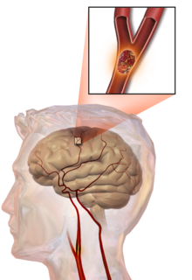](https://en.wikipedia.org/wiki/File:Blausen_0836_Stroke.png)

Illustration of an embolic stroke, showing a blockage lodged in a blood vessel.

In thrombotic stroke, a thrombus[[39]](https://en.wikipedia.org/wiki/Stroke#cite_note-39) (blood clot) usually forms around [atherosclerotic](https://en.wikipedia.org/wiki/Atherosclerosis) plaques. Since blockage of the artery is gradual, onset of symptomatic thrombotic strokes is slower than that of a hemorrhagic stroke. A thrombus itself (even if it does not completely block the blood vessel) can lead to an embolic stroke (see below) if the thrombus breaks off and travels in the bloodstream, at which point it is called an [embolus](https://en.wikipedia.org/wiki/Embolus). Two types of thrombosis can cause stroke:

* *Large vessel disease* involves the [common](https://en.wikipedia.org/wiki/Common_carotid_artery) and [internal carotid arteries](https://en.wikipedia.org/wiki/Internal_carotid_artery), the [vertebral artery](https://en.wikipedia.org/wiki/Vertebral_artery), and the [Circle of Willis](https://en.wikipedia.org/wiki/Circle_of_Willis).[[40]](https://en.wikipedia.org/wiki/Stroke#cite_note-40) Diseases that may form [thrombi](https://en.wikipedia.org/wiki/Thrombi) in the large vessels include (in descending incidence): atherosclerosis, [vasoconstriction](https://en.wikipedia.org/wiki/Vasoconstriction) (tightening of the artery), [aortic](https://en.wikipedia.org/wiki/Aortic_dissection), [carotid](https://en.wikipedia.org/wiki/Carotid_artery_dissection) or [vertebral artery dissection](https://en.wikipedia.org/wiki/Vertebral_artery_dissection), various inflammatory diseases of the blood vessel wall ([Takayasu arteritis](https://en.wikipedia.org/wiki/Takayasu_arteritis), [giant cell arteritis](https://en.wikipedia.org/wiki/Giant_cell_arteritis), [vasculitis](https://en.wikipedia.org/wiki/Vasculitis)), noninflammatory vasculopathy, [Moyamoya disease](https://en.wikipedia.org/wiki/Moyamoya_disease) and [fibromuscular dysplasia](https://en.wikipedia.org/wiki/Fibromuscular_dysplasia).
* [*Small vessel disease*](https://en.wikipedia.org/wiki/Small_vessel_disease) involves the smaller arteries inside the brain: branches of the [circle of Willis](https://en.wikipedia.org/wiki/Circle_of_Willis), middle cerebral artery, stem, and arteries arising from the distal vertebral and [basilar artery](https://en.wikipedia.org/wiki/Basilar_artery).[[41]](https://en.wikipedia.org/wiki/Stroke#cite_note-41) Diseases that may form thrombi in the small vessels include (in descending incidence): [lipohyalinosis](https://en.wikipedia.org/wiki/Lipohyalinosis) (build-up of fatty hyaline matter in the blood vessel as a result of high blood pressure and aging) and [fibrinoid degeneration](https://en.wikipedia.org/w/index.php?title=Fibrinoid_degeneration&action=edit&redlink=1) (a stroke involving these vessels is known as a [lacunar stroke](https://en.wikipedia.org/wiki/Lacunar_stroke)) and microatheroma (small atherosclerotic plaques).[[42]](https://en.wikipedia.org/wiki/Stroke#cite_note-42)

[Sickle-cell anemia](https://en.wikipedia.org/wiki/Sickle-cell_disease), which can cause [blood cells](https://en.wikipedia.org/wiki/Blood_cell) to clump up and block blood vessels, can also lead to stroke. A stroke is the second leading cause of death in people under 20 with sickle-cell anemia.[[43]](https://en.wikipedia.org/wiki/Stroke#cite_note-NINDS1999-43) [Air pollution](https://en.wikipedia.org/wiki/Air_pollution) may also increase stroke risk.[[44]](https://en.wikipedia.org/wiki/Stroke#cite_note-44)

### Embolic stroke

An embolic stroke refers to an [arterial embolism](https://en.wikipedia.org/wiki/Arterial_embolism) (a blockage of an artery) by an [embolus](https://en.wikipedia.org/wiki/Embolus), a traveling particle or debris in the arterial bloodstream originating from elsewhere. An embolus is most frequently a thrombus, but it can also be a number of other substances including [fat](https://en.wikipedia.org/wiki/Fat_embolism) (e.g., from [bone marrow](https://en.wikipedia.org/wiki/Bone_marrow) in a [broken bone](https://en.wikipedia.org/wiki/Bone_fracture)), air, [cancer](https://en.wikipedia.org/wiki/Cancer) cells or clumps of [bacteria](https://en.wikipedia.org/wiki/Bacteria) (usually from infectious [endocarditis](https://en.wikipedia.org/wiki/Endocarditis)).[[45]](https://en.wikipedia.org/wiki/Stroke#cite_note-Robbins-45)

Because an embolus arises from elsewhere, local therapy solves the problem only temporarily. Thus, the source of the embolus must be identified. Because the embolic blockage is sudden in onset, symptoms usually are maximal at the start. Also, symptoms may be transient as the embolus is partially resorbed and moves to a different location or dissipates altogether.

Emboli most commonly arise from the [heart](https://en.wikipedia.org/wiki/Heart) (especially in [atrial fibrillation](https://en.wikipedia.org/wiki/Atrial_fibrillation)) but may originate from elsewhere in the arterial tree. In [paradoxical embolism](https://en.wikipedia.org/wiki/Paradoxical_embolism), a [deep vein thrombosis](https://en.wikipedia.org/wiki/Deep_vein_thrombosis) embolizes through an [atrial](https://en.wikipedia.org/wiki/Atrial_septal_defect) or [ventricular septal defect](https://en.wikipedia.org/wiki/Ventricular_septal_defect) in the heart into the brain.[[45]](https://en.wikipedia.org/wiki/Stroke#cite_note-Robbins-45)

Causes of stroke related to the heart can be distinguished between high and low-risk:[[46]](https://en.wikipedia.org/wiki/Stroke#cite_note-ay-46)

* High risk: atrial fibrillation and [paroxysmal atrial fibrillation](https://en.wikipedia.org/wiki/Paroxysmal_atrial_fibrillation), [rheumatic disease](https://en.wikipedia.org/wiki/Rheumatic_fever) of the [mitral](https://en.wikipedia.org/wiki/Mitral_valve) or [aortic valve](https://en.wikipedia.org/wiki/Aortic_valve) disease, [artificial heart valves](https://en.wikipedia.org/wiki/Artificial_heart_valve), known cardiac thrombus of the atrium or ventricle, [sick sinus syndrome](https://en.wikipedia.org/wiki/Sick_sinus_syndrome), sustained [atrial flutter](https://en.wikipedia.org/wiki/Atrial_flutter), recent myocardial infarction, chronic myocardial infarction together with [ejection fraction](https://en.wikipedia.org/wiki/Ejection_fraction) <28 percent, symptomatic [congestive heart failure](https://en.wikipedia.org/wiki/Congestive_heart_failure) with ejection fraction <30 percent, [dilated cardiomyopathy](https://en.wikipedia.org/wiki/Dilated_cardiomyopathy), [Libman-Sacks endocarditis](https://en.wikipedia.org/wiki/Libman-Sacks_endocarditis), [Marantic endocarditis](https://en.wikipedia.org/wiki/Marantic_endocarditis), [infective endocarditis](https://en.wikipedia.org/wiki/Infective_endocarditis), [papillary fibroelastoma](https://en.wikipedia.org/wiki/Papillary_fibroelastoma), [left atrial myxoma](https://en.wikipedia.org/wiki/Atrial_myxoma) and [coronary artery bypass graft](https://en.wikipedia.org/wiki/Coronary_artery_bypass_graft) (CABG) surgery.
* Low risk/potential: calcification of the annulus (ring) of the mitral valve, patent foramen ovale (PFO), atrial septal aneurysm, atrial septal aneurysm *with* patent foramen ovale, left ventricular aneurysm without thrombus, isolated left atrial "smoke" on [echocardiography](https://en.wikipedia.org/wiki/Echocardiography) (no [mitral stenosis](https://en.wikipedia.org/wiki/Mitral_stenosis) or atrial fibrillation), complex atheroma in the [ascending aorta](https://en.wikipedia.org/wiki/Ascending_aorta) or proximal arch.

Among those who have a complete blockage of one of the carotid arteries, the risk of stroke on that side is about one percent per year.[[47]](https://en.wikipedia.org/wiki/Stroke#cite_note-47)

A special form of embolic stroke is the [embolic stroke of undetermined source](https://en.wikipedia.org/wiki/Embolic_stroke_of_undetermined_source) (ESUS). This subset of cryptogenic stroke is defined as a non-lacunar brain infarct without proximal arterial stenosis or cardioembolic sources. About one out of six ischemic strokes could be classified as ESUS.[[48]](https://en.wikipedia.org/wiki/Stroke#cite_note-48)

### Cerebral hypoperfusion

[Cerebral hypoperfusion](https://en.wikipedia.org/wiki/Shock_(circulatory)) is the reduction of blood flow to all parts of the brain. The reduction could be to a particular part of the brain depending on the cause. It is most commonly due to [heart failure](https://en.wikipedia.org/wiki/Heart_failure) from [cardiac arrest](https://en.wikipedia.org/wiki/Cardiac_arrest) or arrhythmias, or from reduced [cardiac output](https://en.wikipedia.org/wiki/Cardiac_output) as a result of [myocardial infarction](https://en.wikipedia.org/wiki/Myocardial_infarction), [pulmonary embolism](https://en.wikipedia.org/wiki/Pulmonary_embolism), [pericardial effusion](https://en.wikipedia.org/wiki/Pericardial_effusion), or bleeding.[[*citation needed*](https://en.wikipedia.org/wiki/Wikipedia:Citation_needed)] [Hypoxemia](https://en.wikipedia.org/wiki/Hypoxia_(medical)) (low blood oxygen content) may precipitate the hypoperfusion. Because the reduction in blood flow is global, all parts of the brain may be affected, especially vulnerable "watershed" areas—border zone regions supplied by the major cerebral arteries. A [watershed stroke](https://en.wikipedia.org/wiki/Watershed_stroke) refers to the condition when the blood supply to these areas is compromised. Blood flow to these areas does not necessarily stop, but instead it may lessen to the point where brain damage can occur.

### Venous thrombosis

[Cerebral venous sinus thrombosis](https://en.wikipedia.org/wiki/Cerebral_venous_sinus_thrombosis) leads to stroke due to locally increased venous pressure, which exceeds the pressure generated by the arteries. Infarcts are more likely to undergo hemorrhagic transformation (leaking of blood into the damaged area) than other types of ischemic stroke.[[22]](https://en.wikipedia.org/wiki/Stroke#cite_note-Stam2005-22)

### Intracerebral hemorrhage

It generally occurs in small arteries or arterioles and is commonly due to hypertension,[[49]](https://en.wikipedia.org/wiki/Stroke#cite_note-49) intracranial vascular malformations (including [cavernous angiomas](https://en.wikipedia.org/wiki/Cavernous_angioma) or [arteriovenous malformations](https://en.wikipedia.org/wiki/Arteriovenous_malformation)), cerebral [amyloid angiopathy](https://en.wikipedia.org/wiki/Amyloid_angiopathy), or infarcts into which secondary hemorrhage has occurred.[[2]](https://en.wikipedia.org/wiki/Stroke#cite_note-Donnan2008-2) Other potential causes are trauma, [bleeding disorders](https://en.wikipedia.org/wiki/Hemophilia), [amyloid angiopathy](https://en.wikipedia.org/wiki/Amyloid_angiopathy), [illicit drug use](https://en.wikipedia.org/wiki/Recreational_drug_use) (e.g., amphetamines or [cocaine](https://en.wikipedia.org/wiki/Cocaine)). The hematoma enlarges until pressure from surrounding tissue limits its growth, or until it decompresses by emptying into the [ventricular system](https://en.wikipedia.org/wiki/Ventricular_system), [CSF](https://en.wikipedia.org/wiki/Cerebrospinal_fluid) or the pial surface. A third of intracerebral bleed is into the brain's ventricles. ICH has a [mortality rate](https://en.wikipedia.org/wiki/Mortality_rate) of 44 percent after 30 days, higher than ischemic stroke or [subarachnoid hemorrhage](https://en.wikipedia.org/wiki/Subarachnoid_hemorrhage) (which technically may also be classified as a type of stroke[[2]](https://en.wikipedia.org/wiki/Stroke#cite_note-Donnan2008-2)).

### Other

Other causes may include spasm of an artery. This may occur due to [cocaine](https://en.wikipedia.org/wiki/Cocaine).[[50]](https://en.wikipedia.org/wiki/Stroke#cite_note-50)

### Silent stroke

A [silent stroke](https://en.wikipedia.org/wiki/Silent_stroke) is a stroke that does not have any outward symptoms, and people are typically unaware they have had a stroke. Despite not causing identifiable symptoms, a silent stroke still damages the brain and places the person at increased risk for both [transient ischemic attack](https://en.wikipedia.org/wiki/Transient_ischemic_attack) and major stroke in the future. Conversely, those who have had a major stroke are also at risk of having silent strokes.[[51]](https://en.wikipedia.org/wiki/Stroke#cite_note-51) In a broad study in 1998, more than 11 million people were estimated to have experienced a stroke in the United States. Approximately 770,000 of these strokes were symptomatic and 11 million were first-ever silent MRI infarcts or [hemorrhages](https://en.wikipedia.org/wiki/Hemorrhage). Silent strokes typically cause [lesions](https://en.wikipedia.org/wiki/Lesion) which are detected via the use of neuroimaging such as [MRI](https://en.wikipedia.org/wiki/MRI). Silent strokes are estimated to occur at five times the rate of symptomatic strokes.[[52]](https://en.wikipedia.org/wiki/Stroke#cite_note-Dutch_TIA92-52)[[53]](https://en.wikipedia.org/wiki/Stroke#cite_note-53) The risk of silent stroke increases with age, but may also affect younger adults and children, especially those with acute [anemia](https://en.wikipedia.org/wiki/Anemia).[[52]](https://en.wikipedia.org/wiki/Stroke#cite_note-Dutch_TIA92-52)[[54]](https://en.wikipedia.org/wiki/Stroke#cite_note-54)

## Pathophysiology

### Ischemic

[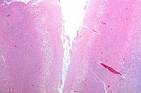](https://en.wikipedia.org/wiki/File:Cortical_pseudolaminar_necrosis_-_lfb_-_very_low_mag.jpg)

[Micrograph](https://en.wikipedia.org/wiki/Micrograph) showing [cortical pseudolaminar necrosis](https://en.wikipedia.org/wiki/Cortical_pseudolaminar_necrosis), a finding seen in strokes on [medical imaging](https://en.wikipedia.org/wiki/Medical_imaging) and at [autopsy](https://en.wikipedia.org/wiki/Autopsy). [H&E-LFB stain](https://en.wikipedia.org/wiki/LFB_stain).

[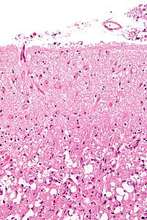](https://en.wikipedia.org/wiki/File:Reactive_astrocytes_-_lfb_-_high_mag.jpg)

[Micrograph](https://en.wikipedia.org/wiki/Micrograph) of the superficial [cerebral cortex](https://en.wikipedia.org/wiki/Cerebral_cortex) showing neuron loss and [reactive astrocytes](https://en.wikipedia.org/wiki/Reactive_astrocytes) in a person that has had a stroke. [H&E-LFB stain](https://en.wikipedia.org/wiki/LFB_stain).

Ischemic stroke occurs because of a loss of blood supply to part of the brain, initiating the [ischemic cascade](https://en.wikipedia.org/wiki/Ischemic_cascade).[[55]](https://en.wikipedia.org/wiki/Stroke#cite_note-Deb-55) Brain tissue ceases to function if deprived of oxygen for more than 60 to 90 seconds[[*citation needed*](https://en.wikipedia.org/wiki/Wikipedia:Citation_needed)], and after approximately three hours will suffer irreversible injury possibly leading to the death of the tissue, i.e., [infarction](https://en.wikipedia.org/wiki/Infarction). (This is why fibrinolytics such as [alteplase](https://en.wikipedia.org/wiki/Alteplase) are given only until three hours since the onset of the stroke.) Atherosclerosis may disrupt the blood supply by narrowing the lumen of blood vessels leading to a reduction of blood flow, by causing the formation of blood clots within the vessel, or by releasing showers of small [emboli](https://en.wikipedia.org/wiki/Emboli) through the disintegration of atherosclerotic plaques.[[56]](https://en.wikipedia.org/wiki/Stroke#cite_note-56) Embolic infarction occurs when emboli formed elsewhere in the circulatory system, typically in the heart as a consequence of atrial fibrillation, or in the carotid arteries, break off, enter the cerebral circulation, then lodge in and block brain blood vessels. Since blood vessels in the brain are now blocked, the brain becomes low in energy, and thus it resorts to using [anaerobic metabolism](https://en.wikipedia.org/wiki/Anaerobic_metabolism) within the region of brain tissue affected by ischemia. Anaerobic metabolism produces less [adenosine triphosphate](https://en.wikipedia.org/wiki/Adenosine_triphosphate) (ATP) but releases a by-product called [lactic acid](https://en.wikipedia.org/wiki/Lactic_acid). Lactic acid is an irritant which could potentially destroy cells since it is an acid and disrupts the normal acid-base balance in the brain. The ischemia area is referred to as the "ischemic [penumbra](https://en.wikipedia.org/wiki/Penumbra_(medicine))".[[57]](https://en.wikipedia.org/wiki/Stroke#cite_note-57)

As oxygen or glucose becomes depleted in ischemic brain tissue, the production of [high energy phosphate](https://en.wikipedia.org/wiki/High_energy_phosphate) compounds such as adenosine triphosphate (ATP) fails, leading to failure of energy-dependent processes (such as ion pumping) necessary for tissue cell survival. This sets off a series of interrelated events that result in cellular injury and death. A major cause of neuronal injury is the release of the excitatory neurotransmitter glutamate. The concentration of glutamate outside the cells of the nervous system is normally kept low by so-called uptake carriers, which are powered by the concentration gradients of ions (mainly Na+) across the cell membrane. However, stroke cuts off the supply of oxygen and glucose which powers the ion pumps maintaining these gradients. As a result, the transmembrane ion gradients run down, and glutamate transporters reverse their direction, releasing glutamate into the extracellular space. Glutamate acts on receptors in nerve cells (especially NMDA receptors), producing an influx of calcium which activates enzymes that digest the cells' proteins, lipids, and nuclear material. Calcium influx can also lead to the failure of [mitochondria](https://en.wikipedia.org/wiki/Mitochondria), which can lead further toward energy depletion and may trigger cell death due to [programmed cell death](https://en.wikipedia.org/wiki/Apoptosis).[[58]](https://en.wikipedia.org/wiki/Stroke#cite_note-PMID8761323-58)

Ischemia also induces production of [oxygen free radicals](https://en.wikipedia.org/wiki/Radical_(chemistry)) and other [reactive oxygen species](https://en.wikipedia.org/wiki/Reactive_oxygen_species). These react with and damage a number of cellular and extracellular elements. Damage to the blood vessel lining or endothelium is particularly important. In fact, many antioxidant neuroprotectants such as [uric acid](https://en.wikipedia.org/wiki/Uric_acid) and [NXY-059](https://en.wikipedia.org/wiki/NXY-059) work at the level of the endothelium and not in the brain *per se*. Free radicals also directly initiate elements of the programmed cell death cascade by means of [redox signaling](https://en.wikipedia.org/wiki/Redox_signaling).[[59]](https://en.wikipedia.org/wiki/Stroke#cite_note-PMID11149664-59)

These processes are the same for any type of ischemic tissue and are referred to collectively as the *ischemic cascade*. However, brain tissue is especially vulnerable to ischemia since it has little respiratory reserve and is completely dependent on [aerobic metabolism](https://en.wikipedia.org/wiki/Aerobic_metabolism), unlike most other organs.

In addition to damaging effects on brain cells, ischemia and infarction can result in loss of structural integrity of brain tissue and blood vessels, partly through the release of matrix metalloproteases, which are zinc- and calcium-dependent enzymes that break down collagen, [hyaluronic acid](https://en.wikipedia.org/wiki/Hyaluronan), and other elements of [connective tissue](https://en.wikipedia.org/wiki/Connective_tissue). Other proteases also contribute to this process. The loss of vascular structural integrity results in a breakdown of the protective [blood brain barrier](https://en.wikipedia.org/wiki/Blood_brain_barrier) that contributes to [cerebral edema](https://en.wikipedia.org/wiki/Cerebral_edema), which can cause secondary progression of the brain injury.[[*citation needed*](https://en.wikipedia.org/wiki/Wikipedia:Citation_needed)]

### Hemorrhagic

Hemorrhagic strokes are classified based on their underlying pathology. Some causes of hemorrhagic stroke are [hypertensive hemorrhage](https://en.wikipedia.org/wiki/Hypertensive), ruptured [aneurysm](https://en.wikipedia.org/wiki/Aneurysm), ruptured [AV fistula](https://en.wikipedia.org/wiki/AV_fistula), transformation of prior ischemic infarction, and drug-induced [bleeding](https://en.wikipedia.org/wiki/Bleeding).[[60]](https://en.wikipedia.org/wiki/Stroke#cite_note-60) They result in tissue injury by causing compression of tissue from an expanding [hematoma](https://en.wikipedia.org/wiki/Hematoma) or hematomas. In addition, the pressure may lead to a loss of blood supply to affected tissue with resulting [infarction](https://en.wikipedia.org/wiki/Infarction), and the blood released by brain hemorrhage appears to have direct toxic effects on brain tissue and [vasculature](https://en.wikipedia.org/wiki/Vasculature).[[43]](https://en.wikipedia.org/wiki/Stroke#cite_note-NINDS1999-43)[[61]](https://en.wikipedia.org/wiki/Stroke#cite_note-Wang_2010-61) [Inflammation](https://en.wikipedia.org/wiki/Inflammation) contributes to the [secondary brain injury](https://en.wikipedia.org/wiki/Secondary_brain_injury) after hemorrhage.[[61]](https://en.wikipedia.org/wiki/Stroke#cite_note-Wang_2010-61)

## Diagnosis

[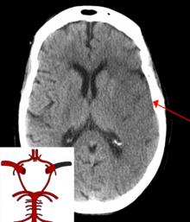](https://en.wikipedia.org/wiki/File:StrokeMCA_overlay.png)

A CT showing early signs of a middle cerebral artery stroke with loss of definition of the gyri and grey white boundary

[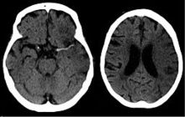](https://en.wikipedia.org/wiki/File:Dens_media_sign_mit_Mediainfarkt_-_CCT_001.jpg)

Dens media sign in a patient with middle cerebral artery infarction shown on the left. Right image after 7 hours.

Stroke is diagnosed through several techniques: a neurological examination (such as the [NIHSS](https://en.wikipedia.org/wiki/NIHSS)), CT scans (most often without contrast enhancements) or [MRI scans](https://en.wikipedia.org/wiki/MRI_scan), [Doppler ultrasound](https://en.wikipedia.org/wiki/Doppler_ultrasound), and [arteriography](https://en.wikipedia.org/wiki/Arteriography). The diagnosis of stroke itself is clinical, with assistance from the imaging techniques. Imaging techniques also assist in determining the subtypes and cause of stroke. There is yet no commonly used [blood test](https://en.wikipedia.org/wiki/Blood_test) for the stroke diagnosis itself, though blood tests may be of help in finding out the likely cause of stroke.[[62]](https://en.wikipedia.org/wiki/Stroke#cite_note-hill2005-62)

### Physical examination

A [physical examination](https://en.wikipedia.org/wiki/Physical_examination), including taking a [medical history](https://en.wikipedia.org/wiki/Medical_history) of the symptoms and a neurological status, helps giving an evaluation of the location and severity of a stroke. It can give a standard score on e.g., the [NIH stroke scale](https://en.wikipedia.org/wiki/NIH_stroke_scale).

### Imaging

For diagnosing ischemic (blockage) stroke in the emergency setting:[[63]](https://en.wikipedia.org/wiki/Stroke#cite_note-pmid17258669-63)

* CT scans (*without* contrast enhancements)

[sensitivity](https://en.wikipedia.org/wiki/Sensitivity_(tests))= 16% (less than 10% within first 3 hours of symptom onset)

[specificity](https://en.wikipedia.org/wiki/Specificity_(tests))= 96%

* MRI scan

sensitivity= 83%

specificity= 98%

For diagnosing hemorrhagic stroke in the emergency setting:

* CT scans (*without* contrast enhancements)

sensitivity= 89%

specificity= 100%

* MRI scan

sensitivity= 81%

specificity= 100%

For detecting chronic hemorrhages, MRI scan is more sensitive.[[64]](https://en.wikipedia.org/wiki/Stroke#cite_note-pmid15494579-64)

For the assessment of stable stroke, nuclear medicine scans SPECT and PET/CT may be helpful. SPECT documents cerebral blood flow and PET with FDG isotope the metabolic activity of the neurons.

CT scans may not detect an ischemic stroke, especially if it is small, of recent onset, or in the brainstem or cerebellum areas. A CT scan is more to *rule out* certain stroke mimics and detect bleeding.[[9]](https://en.wikipedia.org/wiki/Stroke#cite_note-AFP2009-9)

### Underlying cause

[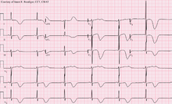](https://en.wikipedia.org/wiki/File:Left_MCA_Stroke.png)

12-lead ECG of a patient with a stroke, showing large deeply inverted [T-waves](https://en.wikipedia.org/wiki/T_wave). Various ECG changes may occur in people with strokes and other brain disorders.

When a stroke has been diagnosed, various other studies may be performed to determine the underlying cause. With the current treatment and diagnosis options available, it is of particular importance to determine whether there is a peripheral source of emboli. Test selection may vary since the cause of stroke varies with age, [comorbidity](https://en.wikipedia.org/wiki/Comorbidity) and the clinical presentation. The following are commonly used techniques:

* an [ultrasound/doppler study](https://en.wikipedia.org/wiki/Medical_ultrasonography) of the [carotid arteries](https://en.wikipedia.org/wiki/Carotid_artery) (to detect [carotid stenosis](https://en.wikipedia.org/wiki/Carotid_stenosis)) or dissection of the precerebral arteries;
* an [electrocardiogram](https://en.wikipedia.org/wiki/Electrocardiogram) (ECG) and [echocardiogram](https://en.wikipedia.org/wiki/Echocardiogram) (to identify [arrhythmias](https://en.wikipedia.org/wiki/Cardiac_arrhythmia) and resultant clots in the heart which may spread to the brain vessels through the bloodstream);
* a [Holter monitor](https://en.wikipedia.org/wiki/Holter_monitor) study to identify intermittent [abnormal heart rhythms](https://en.wikipedia.org/wiki/Heart_arrhythmia);
* an [angiogram](https://en.wikipedia.org/wiki/Angiogram) of the cerebral vasculature (if a bleed is thought to have originated from an [aneurysm](https://en.wikipedia.org/wiki/Aneurysm) or [arteriovenous malformation](https://en.wikipedia.org/wiki/Arteriovenous_malformation));
* blood tests to determine if [blood cholesterol is high](https://en.wikipedia.org/wiki/Hypercholesterolemia), if there is an abnormal [tendency to bleed](https://en.wikipedia.org/wiki/Bleeding_diathesis), and if some rarer processes such as [homocystinuria](https://en.wikipedia.org/wiki/Homocysteinuria) might be involved.

For hemorrhagic strokes, a [CT](https://en.wikipedia.org/wiki/Computed_tomography_angiography) or [MRI scan with intravascular contrast](https://en.wikipedia.org/wiki/Magnetic_resonance_angiography) may be able to identify abnormalities in the brain arteries (such as aneurysms) or other sources of bleeding, and structural MRI if this shows no cause. If this too does not identify an underlying reason for the bleeding, invasive [cerebral angiography](https://en.wikipedia.org/wiki/Cerebral_angiography) could be performed but this requires access to the bloodstream with an intravascular catheter and can cause further strokes as well as complications at the insertion site and this investigation is therefore reserved for specific situations.[[65]](https://en.wikipedia.org/wiki/Stroke#cite_note-Wilson2015-65) If there are symptoms suggesting that the hemorrhage might have occurred as a result of [venous thrombosis](https://en.wikipedia.org/wiki/Cerebral_venous_sinus_thrombosis), CT or MRI venography can be used to examine the cerebral veins.[[65]](https://en.wikipedia.org/wiki/Stroke#cite_note-Wilson2015-65)

### Misdiagnosis

Among people with ischemic strokes, misdiagnosis occurs 2 to 26% of the time.[[66]](https://en.wikipedia.org/wiki/Stroke#cite_note-Bak2018-66) A "stroke chameleon" (SC) is stroke which is diagnosed as something else.[[66]](https://en.wikipedia.org/wiki/Stroke#cite_note-Bak2018-66)[[67]](https://en.wikipedia.org/wiki/Stroke#cite_note-Stroke_chameleons,_Dupre_et._al,_2013-67)

People not having a stroke may also be misdiagnosed as a stroke. Giving thrombolytics (clot-busting) in such cases causes intracerebral bleeding 1 to 2% of the time, which is less than that of people with strokes. This unnecessary treatment adds to health care costs. Even so, the AHA/ASA guidelines state that starting intravenous tPA in possible mimics is preferred to delaying treatment for additional testing.[[66]](https://en.wikipedia.org/wiki/Stroke#cite_note-Bak2018-66)

Women, African-Americans, Hispanic-Americans, Asian and Pacific Islanders are more often misdiagnosed for a condition other than stroke when in fact having a stroke. In addition, adults under 44 years-of-age are seven times more likely to have a stroke missed than are adults over 75 years-of-age. This is especially the case for younger people with posterior circulation infarcts.[[66]](https://en.wikipedia.org/wiki/Stroke#cite_note-Bak2018-66) Some medical centers have used hyperacute MRI in experimental studies for persons initially thought to have a low likelihood of stroke. And in some of these persons, strokes have been found which were then treated with thrombolytic medication.[[66]](https://en.wikipedia.org/wiki/Stroke#cite_note-Bak2018-66)

## Prevention

Given the disease burden of strokes, [prevention](https://en.wikipedia.org/wiki/Prevention_(medical)) is an important [public health](https://en.wikipedia.org/wiki/Public_health) concern.[[68]](https://en.wikipedia.org/wiki/Stroke#cite_note-pmid12234233-68) [Primary prevention](https://en.wikipedia.org/wiki/Primary_prevention) is less effective than secondary prevention (as judged by the [number needed to treat](https://en.wikipedia.org/wiki/Number_needed_to_treat) to prevent one stroke per year).[[68]](https://en.wikipedia.org/wiki/Stroke#cite_note-pmid12234233-68) Recent guidelines detail the evidence for primary prevention in stroke.[[69]](https://en.wikipedia.org/wiki/Stroke#cite_note-PreventionGuidelines-69) In those who are otherwise healthy, aspirin does not appear beneficial and thus is not recommended.[[70]](https://en.wikipedia.org/wiki/Stroke#cite_note-70) In people who have had a myocardial infarction or those with a high cardiovascular risk, it provides some protection against a first stroke.[[71]](https://en.wikipedia.org/wiki/Stroke#cite_note-AP01-71)[[72]](https://en.wikipedia.org/wiki/Stroke#cite_note-BMJ2002-72) In those who have previously had a stroke, treatment with medications such as [aspirin](https://en.wikipedia.org/wiki/Aspirin), [clopidogrel](https://en.wikipedia.org/wiki/Clopidogrel), and [dipyridamole](https://en.wikipedia.org/wiki/Dipyridamole) may be beneficial.[[71]](https://en.wikipedia.org/wiki/Stroke#cite_note-AP01-71) The [U.S. Preventive Services Task Force](https://en.wikipedia.org/wiki/U.S._Preventive_Services_Task_Force) (USPSTF) recommends against [screening](https://en.wikipedia.org/wiki/Screening_(medicine)) for [carotid artery stenosis](https://en.wikipedia.org/wiki/Carotid_artery_stenosis) in those without symptoms.[[73]](https://en.wikipedia.org/wiki/Stroke#cite_note-73)

### Risk factors

The most important modifiable risk factors for stroke are high blood pressure and atrial fibrillation although the size of the effect is small with 833 people have to be treated for 1 year to prevent one stroke.[[74]](https://en.wikipedia.org/wiki/Stroke#cite_note-74)[[75]](https://en.wikipedia.org/wiki/Stroke#cite_note-75) Other modifiable risk factors include high blood cholesterol levels, [diabetes mellitus](https://en.wikipedia.org/wiki/Diabetes_mellitus), [end-stage kidney disease](https://en.wikipedia.org/wiki/End-stage_kidney_disease),[[7]](https://en.wikipedia.org/wiki/Stroke#cite_note-Hu2018-7) cigarette smoking[[76]](https://en.wikipedia.org/wiki/Stroke#cite_note-76)[[77]](https://en.wikipedia.org/wiki/Stroke#cite_note-pmid7596004-77) (active and passive), heavy [alcohol](https://en.wikipedia.org/wiki/Alcohol_consumption_and_health) use,[[78]](https://en.wikipedia.org/wiki/Stroke#cite_note-pmid12578491-78) drug use,[[79]](https://en.wikipedia.org/wiki/Stroke#cite_note-pmid1891081-79) lack of [physical activity](https://en.wikipedia.org/wiki/Physical_activity), [obesity](https://en.wikipedia.org/wiki/Obesity), processed [red meat](https://en.wikipedia.org/wiki/Red_meat) consumption,[[80]](https://en.wikipedia.org/wiki/Stroke#cite_note-80) and unhealthy diet.[[81]](https://en.wikipedia.org/wiki/Stroke#cite_note-American_heart_risk-81) Smoking just one cigarette per day increases the risk more than 30%.[[82]](https://en.wikipedia.org/wiki/Stroke#cite_note-82) Alcohol use could predispose to ischemic stroke, as well as intracerebral and subarachnoid hemorrhage via multiple mechanisms (for example, via hypertension, atrial fibrillation, rebound [thrombocytosis](https://en.wikipedia.org/wiki/Thrombocytosis) and [platelet aggregation](https://en.wikipedia.org/wiki/Platelet_aggregation) and [clotting](https://en.wikipedia.org/wiki/Clotting) disturbances).[[83]](https://en.wikipedia.org/wiki/Stroke#cite_note-pmid3810763-83) Drugs, most commonly amphetamines and cocaine, can induce stroke through damage to the blood vessels in the brain and acute hypertension.[[84]](https://en.wikipedia.org/wiki/Stroke#cite_note-Harrison's-84)[[85]](https://en.wikipedia.org/wiki/Stroke#cite_note-pmid17404126-85) [Migraine](https://en.wikipedia.org/wiki/Migraine) with [aura](https://en.wikipedia.org/wiki/Aura_(symptom)) doubles a person's risk for ischemic stroke.[[86]](https://en.wikipedia.org/wiki/Stroke#cite_note-Stroke2009-86)[[87]](https://en.wikipedia.org/wiki/Stroke#cite_note-87) Untreated, [celiac disease](https://en.wikipedia.org/wiki/Celiac_disease) regardless of the presence of symptoms can be an underlying cause of stroke, both in children and adults.[[88]](https://en.wikipedia.org/wiki/Stroke#cite_note-CiaccioLewis2017-88)

High levels of physical activity reduce the risk of stroke by about 26%.[[89]](https://en.wikipedia.org/wiki/Stroke#cite_note-BMJ2016-89) There is a lack of high quality studies looking at promotional efforts to improve lifestyle factors.[[90]](https://en.wikipedia.org/wiki/Stroke#cite_note-pmid14705756-90) Nonetheless, given the large body of circumstantial evidence, best medical management for stroke includes advice on diet, exercise, smoking and alcohol use.[[91]](https://en.wikipedia.org/wiki/Stroke#cite_note-endart-review-91) Medication is the most common method of stroke prevention; [carotid endarterectomy](https://en.wikipedia.org/wiki/Carotid_endarterectomy) can be a useful surgical method of preventing stroke.

#### Blood pressure

[High blood pressure](https://en.wikipedia.org/wiki/Hypertension) accounts for 35–50% of stroke risk.[[92]](https://en.wikipedia.org/wiki/Stroke#cite_note-pmid8614485-92) Blood pressure reduction of 10 mmHg systolic or 5 mmHg diastolic reduces the risk of stroke by ~40%.[[93]](https://en.wikipedia.org/wiki/Stroke#cite_note-93) Lowering blood pressure has been conclusively shown to prevent both ischemic and hemorrhagic strokes.[[94]](https://en.wikipedia.org/wiki/Stroke#cite_note-Psaty2003-94)[[95]](https://en.wikipedia.org/wiki/Stroke#cite_note-pmid8551820-95) It is equally important in secondary prevention.[[96]](https://en.wikipedia.org/wiki/Stroke#cite_note-pmid9412649-96) Even people older than 80 years and those with [isolated systolic hypertension](https://en.wikipedia.org/wiki/Isolated_systolic_hypertension) benefit from antihypertensive therapy.[[97]](https://en.wikipedia.org/wiki/Stroke#cite_note-INDANAsub-97)[[98]](https://en.wikipedia.org/wiki/Stroke#cite_note-Staessen2000-98)[[99]](https://en.wikipedia.org/wiki/Stroke#cite_note-HYVET-NEJM2008-99) The available evidence does not show large differences in stroke prevention between antihypertensive drugs—therefore, other factors such as protection against other forms of cardiovascular disease and cost should be considered.[[100]](https://en.wikipedia.org/wiki/Stroke#cite_note-BPLT-100)[[101]](https://en.wikipedia.org/wiki/Stroke#cite_note-pmid12479763-101) The routine use of [beta-blockers](https://en.wikipedia.org/wiki/Beta-blocker) following a stroke or TIA has not been shown to result in benefits.[[102]](https://en.wikipedia.org/wiki/Stroke#cite_note-102)

#### Blood lipids

High cholesterol levels have been inconsistently associated with (ischemic) stroke.[[95]](https://en.wikipedia.org/wiki/Stroke#cite_note-pmid8551820-95)[[103]](https://en.wikipedia.org/wiki/Stroke#cite_note-NEJM1989-103) [Statins](https://en.wikipedia.org/wiki/Statins) have been shown to reduce the risk of stroke by about 15%.[[104]](https://en.wikipedia.org/wiki/Stroke#cite_note-Statins2008-104) Since earlier meta-analyses of other [lipid-lowering drugs](https://en.wikipedia.org/wiki/Lipid-lowering_drugs) did not show a decreased risk,[[105]](https://en.wikipedia.org/wiki/Stroke#cite_note-pmid7802520-105) statins might exert their effect through mechanisms other than their lipid-lowering effects.[[104]](https://en.wikipedia.org/wiki/Stroke#cite_note-Statins2008-104)

#### Diabetes mellitus

[Diabetes mellitus](https://en.wikipedia.org/wiki/Diabetes_mellitus) increases the risk of stroke by 2 to 3 times. While intensive blood sugar control has been shown to reduce small blood vessel complications such as [kidney damage](https://en.wikipedia.org/wiki/Diabetic_nephropathy) and [damage to the retina of the eye](https://en.wikipedia.org/wiki/Diabetic_retinopathy) it has not been shown to reduce large blood vessel complications such as stroke.[[106]](https://en.wikipedia.org/wiki/Stroke#cite_note-UKPDS-106)[[107]](https://en.wikipedia.org/wiki/Stroke#cite_note-ProACTIVE-107)

#### Anticoagulation drugs

Oral anticoagulants such as [warfarin](https://en.wikipedia.org/wiki/Warfarin) have been the mainstay of stroke prevention for over 50 years. However, several studies have shown that aspirin and other [antiplatelets](https://en.wikipedia.org/wiki/Antiplatelet_drug) are highly effective in [secondary prevention](https://en.wikipedia.org/wiki/Secondary_prevention) after a stroke or transient ischemic attack.[[71]](https://en.wikipedia.org/wiki/Stroke#cite_note-AP01-71) Low doses of aspirin (for example 75–150 mg) are as effective as high doses but have fewer side effects; the lowest effective dose remains unknown.[[108]](https://en.wikipedia.org/wiki/Stroke#cite_note-pmid10371234-108) [Thienopyridines](https://en.wikipedia.org/wiki/Thienopyridine) ([clopidogrel](https://en.wikipedia.org/wiki/Clopidogrel), [ticlopidine](https://en.wikipedia.org/wiki/Ticlopidine)) might be slightly more effective than aspirin and have a decreased risk of [gastrointestinal bleeding](https://en.wikipedia.org/wiki/Gastrointestinal_bleeding), but are more expensive.[[109]](https://en.wikipedia.org/wiki/Stroke#cite_note-CochraneThienopyridines-109) Both aspirin and clopidogrel may be useful in the first few weeks after a minor stroke or high risk TIA.[[110]](https://en.wikipedia.org/wiki/Stroke#cite_note-110) Clopidogrel has less side effects than ticlopidine.[[109]](https://en.wikipedia.org/wiki/Stroke#cite_note-CochraneThienopyridines-109) [Dipyridamole](https://en.wikipedia.org/wiki/Dipyridamole) can be added to aspirin therapy to provide a small additional benefit, even though headache is a common side effect.[[111]](https://en.wikipedia.org/wiki/Stroke#cite_note-ESPRIT-111) Low-dose aspirin is also effective for stroke prevention after having a myocardial infarction.[[72]](https://en.wikipedia.org/wiki/Stroke#cite_note-BMJ2002-72)

Those with [atrial fibrillation](https://en.wikipedia.org/wiki/Atrial_fibrillation) have a 5% a year risk of stroke, and this risk is higher in those with valvular atrial fibrillation.[[112]](https://en.wikipedia.org/wiki/Stroke#cite_note-AFIB-112) Depending on the stroke risk, anticoagulation with medications such as [warfarin](https://en.wikipedia.org/wiki/Warfarin) or aspirin is useful for prevention.[[113]](https://en.wikipedia.org/wiki/Stroke#cite_note-AFib-guidelines-113) Except in people with atrial fibrillation, [oral anticoagulants](https://en.wikipedia.org/wiki/Oral_anticoagulants) are not advised for stroke prevention—any benefit is offset by bleeding risk.[[114]](https://en.wikipedia.org/wiki/Stroke#cite_note-pmid17239798-114)

In primary prevention, however, antiplatelet drugs did not reduce the risk of ischemic stroke but increased the risk of major bleeding.[[115]](https://en.wikipedia.org/wiki/Stroke#cite_note-aspirin-115)[[116]](https://en.wikipedia.org/wiki/Stroke#cite_note-aspirin-meta-116) Further studies are needed to investigate a possible protective effect of aspirin against ischemic stroke in women.[[117]](https://en.wikipedia.org/wiki/Stroke#cite_note-aspirin-women-117)[[118]](https://en.wikipedia.org/wiki/Stroke#cite_note-gender-118)

#### Surgery

[Carotid endarterectomy](https://en.wikipedia.org/wiki/Carotid_endarterectomy) or carotid [angioplasty](https://en.wikipedia.org/wiki/Angioplasty) can be used to remove atherosclerotic narrowing of the [carotid artery](https://en.wikipedia.org/wiki/Carotid_artery). There is evidence supporting this procedure in selected cases.[[91]](https://en.wikipedia.org/wiki/Stroke#cite_note-endart-review-91) Endarterectomy for a significant stenosis has been shown to be useful in preventing further strokes in those who have already had one.[[119]](https://en.wikipedia.org/wiki/Stroke#cite_note-pmid12531577-119) Carotid artery stenting has not been shown to be equally useful.[[120]](https://en.wikipedia.org/wiki/Stroke#cite_note-endarterectomy-meta-120)[[121]](https://en.wikipedia.org/wiki/Stroke#cite_note-121) People are selected for surgery based on age, gender, degree of stenosis, time since symptoms and the person's preferences.[[91]](https://en.wikipedia.org/wiki/Stroke#cite_note-endart-review-91) Surgery is most efficient when not delayed too long—the risk of recurrent stroke in a person who has a 50% or greater stenosis is up to 20% after 5 years, but endarterectomy reduces this risk to around 5%. The number of procedures needed to cure one person was 5 for early surgery (within two weeks after the initial stroke), but 125 if delayed longer than 12 weeks.[[122]](https://en.wikipedia.org/wiki/Stroke#cite_note-pmid15043958-122)[[123]](https://en.wikipedia.org/wiki/Stroke#cite_note-pmid16087900-123)

[Screening](https://en.wikipedia.org/wiki/Screening_(medicine)) for carotid artery narrowing has not been shown to be a useful test in the general population.[[124]](https://en.wikipedia.org/wiki/Stroke#cite_note-USPSTF-carotidUS-124) Studies of surgical intervention for carotid artery stenosis without symptoms have shown only a small decrease in the risk of stroke.[[125]](https://en.wikipedia.org/wiki/Stroke#cite_note-pmid15135594-125)[[126]](https://en.wikipedia.org/wiki/Stroke#cite_note-pmid16235289-126) To be beneficial, the complication rate of the surgery should be kept below 4%. Even then, for 100 surgeries, 5 people will benefit by avoiding stroke, 3 will develop stroke despite surgery, 3 will develop stroke or die due to the surgery itself, and 89 will remain stroke-free but would also have done so without intervention.[[91]](https://en.wikipedia.org/wiki/Stroke#cite_note-endart-review-91)

#### Diet

Nutrition, specifically the [Mediterranean-style diet](https://en.wikipedia.org/wiki/Mediterranean_diet), has the potential for decreasing the risk of having a stroke by more than half.[[127]](https://en.wikipedia.org/wiki/Stroke#cite_note-strokenutrition-127) It does not appear that lowering levels of [homocysteine](https://en.wikipedia.org/wiki/Homocysteine) with [folic acid](https://en.wikipedia.org/wiki/Folic_acid) affects the risk of stroke.[[128]](https://en.wikipedia.org/wiki/Stroke#cite_note-128)[[129]](https://en.wikipedia.org/wiki/Stroke#cite_note-129)

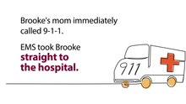[Play media](https://upload.wikimedia.org/wikipedia/commons/f/f7/CDC_video_about_stroke_2.ogv)

A [Centers for Disease Control and Prevention](https://en.wikipedia.org/wiki/Centers_for_Disease_Control_and_Prevention) public service announcement about a woman having a stroke after pregnancy.

### Women

A number of specific recommendations have been made for women including taking aspirin after the 11th week of pregnancy if there is a history of previous chronic high blood pressure and taking blood pressure medications during pregnancy if the blood pressure is greater than 150 mmHg systolic or greater than 100 mmHg diastolic. In those who have previously had [preeclampsia](https://en.wikipedia.org/wiki/Preeclampsia) other risk factors should be treated more aggressively.[[130]](https://en.wikipedia.org/wiki/Stroke#cite_note-Bush2014-130)

### Previous stroke or TIA

Keeping blood pressure below 140/90 mmHg is recommended.[[131]](https://en.wikipedia.org/wiki/Stroke#cite_note-AHA2014-131) Anticoagulation can prevent recurrent ischemic strokes. Among people with nonvalvular atrial fibrillation, anticoagulation can reduce stroke by 60% while antiplatelet agents can reduce stroke by 20%.[[132]](https://en.wikipedia.org/wiki/Stroke#cite_note-pmid17577005-132) However, a recent meta-analysis suggests harm from anticoagulation started early after an embolic stroke.[[133]](https://en.wikipedia.org/wiki/Stroke#cite_note-pmid17204681-133) Stroke prevention treatment for atrial fibrillation is determined according to the [CHA2DS2–VASc score](https://en.wikipedia.org/wiki/CHA2DS2%E2%80%93VASc_score). The most widely used anticoagulant to prevent thromboembolic stroke in people with nonvalvular atrial fibrillation is the oral agent [warfarin](https://en.wikipedia.org/wiki/Warfarin) while a number of newer agents including [dabigatran](https://en.wikipedia.org/wiki/Dabigatran) are alternatives which do not require [prothrombin time](https://en.wikipedia.org/wiki/Prothrombin_time) monitoring.[[131]](https://en.wikipedia.org/wiki/Stroke#cite_note-AHA2014-131)

Anticoagulants, when used following stroke, should not be stopped for dental procedures.[[134]](https://en.wikipedia.org/wiki/Stroke#cite_note-134)

If studies show carotid artery stenosis, and the person has a degree of residual function on the affected side, carotid endarterectomy (surgical removal of the stenosis) may decrease the risk of recurrence if performed rapidly after stroke.

## Management

### Ischemic stroke

Aspirin reduces the overall risk of recurrence by 13% with greater benefit early on.[[135]](https://en.wikipedia.org/wiki/Stroke#cite_note-135) Definitive therapy within the first few hours is aimed at removing the blockage by breaking the clot down ([thrombolysis](https://en.wikipedia.org/wiki/Thrombolysis)), or by removing it mechanically ([thrombectomy](https://en.wikipedia.org/wiki/Thrombectomy)). The philosophical premise underlying the importance of rapid stroke intervention was summed up as *Time is Brain!* in the early 1990s.[[136]](https://en.wikipedia.org/wiki/Stroke#cite_note-136) Years later, that same idea, that rapid cerebral blood flow restoration results in fewer brain cells dying, has been proved and quantified.[[137]](https://en.wikipedia.org/wiki/Stroke#cite_note-137)

Tight blood sugar control in the first few hours does not improve outcomes and may cause harm.[[138]](https://en.wikipedia.org/wiki/Stroke#cite_note-138) High blood pressure is also not typically lowered as this has not been found to be helpful.[[139]](https://en.wikipedia.org/wiki/Stroke#cite_note-139)[[140]](https://en.wikipedia.org/wiki/Stroke#cite_note-140) [Cerebrolysin](https://en.wikipedia.org/wiki/Cerebrolysin), a mix of pig brain tissue used to treat acute ischemic stroke in many Asian and European countries, does not improve outcomes and may increase the risk of severe adverse events.[[141]](https://en.wikipedia.org/wiki/Stroke#cite_note-141)

#### Thrombolysis

[Thrombolysis](https://en.wikipedia.org/wiki/Thrombolysis), such as with [recombinant tissue plasminogen activator](https://en.wikipedia.org/wiki/Recombinant_tissue_plasminogen_activator) (rtPA), in acute ischemic stroke, when given within three hours of symptom onset, results in an overall benefit of 10% with respect to living without disability.[[142]](https://en.wikipedia.org/wiki/Stroke#cite_note-Ward2014-142)[[143]](https://en.wikipedia.org/wiki/Stroke#cite_note-Lancet2014-143) It does not, however, improve chances of survival.[[142]](https://en.wikipedia.org/wiki/Stroke#cite_note-Ward2014-142) Benefit is greater the earlier it is used.[[142]](https://en.wikipedia.org/wiki/Stroke#cite_note-Ward2014-142) Between three and four and a half hours the effects are less clear.[[144]](https://en.wikipedia.org/wiki/Stroke#cite_note-Dyna2014-144)[[145]](https://en.wikipedia.org/wiki/Stroke#cite_note-145)[[146]](https://en.wikipedia.org/wiki/Stroke#cite_note-146) The AHA/ASA recommend it for certain people in this time frame.[[147]](https://en.wikipedia.org/wiki/Stroke#cite_note-147) A 2014 review found a 5% increase in the number of people living without disability at three to six months; however, there was a 2% increased risk of death in the short term.[[143]](https://en.wikipedia.org/wiki/Stroke#cite_note-Lancet2014-143) After four and a half hours thrombolysis worsens outcomes.[[144]](https://en.wikipedia.org/wiki/Stroke#cite_note-Dyna2014-144) These benefits or lack of benefits occurred regardless of the age of the person treated.[[148]](https://en.wikipedia.org/wiki/Stroke#cite_note-Lancet2012-148) There is no reliable way to determine who will have an intracranial bleed post-treatment versus who will not.[[149]](https://en.wikipedia.org/wiki/Stroke#cite_note-149) In those with findings of savable tissue on medical imaging between 4.5 hours and 9 hours or who wake up with a stroke, alteplase results in some benefit.[[150]](https://en.wikipedia.org/wiki/Stroke#cite_note-150)

Its use is endorsed by the [American Heart Association](https://en.wikipedia.org/wiki/American_Heart_Association), the [American College of Emergency Physicians](https://en.wikipedia.org/wiki/American_College_of_Emergency_Physicians) and the [American Academy of Neurology](https://en.wikipedia.org/wiki/American_Academy_of_Neurology) as the recommended treatment for acute stroke within three hours of onset of symptoms as long as there are no other contraindications (such as abnormal lab values, high blood pressure, or recent surgery). This position for tPA is based upon the findings of two studies by one group of investigators[[151]](https://en.wikipedia.org/wiki/Stroke#cite_note-151) which showed that tPA improves the chances for a good neurological outcome. When administered within the first three hours thrombolysis improves functional outcome without affecting mortality.[[152]](https://en.wikipedia.org/wiki/Stroke#cite_note-152) 6.4% of people with large strokes developed substantial brain bleeding as a complication from being given tPA thus part of the reason for increased short term mortality.[[153]](https://en.wikipedia.org/wiki/Stroke#cite_note-Dubinsky06-153) The [American Academy of Emergency Medicine](https://en.wikipedia.org/wiki/American_Academy_of_Emergency_Medicine) had previously stated that objective evidence regarding the applicability of tPA for acute ischemic stroke was insufficient.[[154]](https://en.wikipedia.org/wiki/Stroke#cite_note-154) In 2013 the American College of Emergency Medicine refuted this position,[[155]](https://en.wikipedia.org/wiki/Stroke#cite_note-155) acknowledging the body of evidence for the use of tPA in ischemic stroke;[[156]](https://en.wikipedia.org/wiki/Stroke#cite_note-156) but debate continues.[[157]](https://en.wikipedia.org/wiki/Stroke#cite_note-157)[[158]](https://en.wikipedia.org/wiki/Stroke#cite_note-158) [Intra-arterial fibrinolysis](https://en.wikipedia.org/wiki/Intra-arterial_fibrinolysis), where a catheter is passed up an artery into the brain and the medication is injected at the site of thrombosis, has been found to improve outcomes in people with acute ischemic stroke.[[159]](https://en.wikipedia.org/wiki/Stroke#cite_note-159)

#### Endovascular treatment

Mechanical removal of the blood clot causing the ischemic stroke, called [mechanical thrombectomy](https://en.wikipedia.org/wiki/Thrombectomy), is a potential treatment for occlusion of a large artery, such as the [middle cerebral artery](https://en.wikipedia.org/wiki/Middle_cerebral_artery). In 2015, one review demonstrated the safety and efficacy of this procedure if performed within 12 hours of the onset of symptoms.[[160]](https://en.wikipedia.org/wiki/Stroke#cite_note-160)[[161]](https://en.wikipedia.org/wiki/Stroke#cite_note-161) It did not change the risk of death, but reduced disability compared to the use of intravenous thrombolysis which is generally used in people evaluated for mechanical thrombectomy.[[162]](https://en.wikipedia.org/wiki/Stroke#cite_note-162)[[163]](https://en.wikipedia.org/wiki/Stroke#cite_note-163) Certain cases may benefit from thrombectomy up to 24 hours after the onset of symptoms.[[164]](https://en.wikipedia.org/wiki/Stroke#cite_note-164)

#### Craniectomy

Strokes affecting large portions of the brain can cause significant brain swelling with secondary brain injury in surrounding tissue. This phenomenon is mainly encountered in strokes affecting brain tissue dependent upon the middle cerebral artery for blood supply and is also called "malignant cerebral infarction" because it carries a dismal prognosis. Relief of the pressure may be attempted with medication, but some require [hemicraniectomy](https://en.wikipedia.org/wiki/Hemicraniectomy), the temporary surgical removal of the skull on one side of the head. This decreases the risk of death, although some people – who would otherwise have died – survive with disability.[[165]](https://en.wikipedia.org/wiki/Stroke#cite_note-pmid21190097-165)

### Hemorrhagic stroke

People with [intracerebral hemorrhage](https://en.wikipedia.org/wiki/Intracerebral_hemorrhage) require supportive care, including blood pressure control if required. People are monitored for changes in the level of consciousness, and their blood sugar and oxygenation are kept at optimum levels. Anticoagulants and antithrombotics can make bleeding worse and are generally discontinued (and reversed if possible).[[*citation needed*](https://en.wikipedia.org/wiki/Wikipedia:Citation_needed)] A proportion may benefit from [neurosurgical](https://en.wikipedia.org/wiki/Neurosurgery) intervention to remove the blood and treat the underlying cause, but this depends on the location and the size of the hemorrhage as well as patient-related factors, and ongoing research is being conducted into the question as to which people with intracerebral hemorrhage may benefit.[[166]](https://en.wikipedia.org/wiki/Stroke#cite_note-166)

In [subarachnoid hemorrhage](https://en.wikipedia.org/wiki/Subarachnoid_hemorrhage), early treatment for underlying cerebral aneurysms may reduce the risk of further hemorrhages. Depending on the site of the aneurysm this may be by [surgery that involves opening the skull](https://en.wikipedia.org/wiki/Craniotomy) or [endovascularly](https://en.wikipedia.org/wiki/Interventional_neuroradiology) (through the blood vessels).[[167]](https://en.wikipedia.org/wiki/Stroke#cite_note-167)

### Stroke unit

Ideally, people who have had a stroke are admitted to a "stroke unit", a ward or dedicated area in a hospital staffed by nurses and therapists with experience in stroke treatment. It has been shown that people admitted to a stroke unit have a higher chance of surviving than those admitted elsewhere in hospital, even if they are being cared for by doctors without experience in stroke.[[2]](https://en.wikipedia.org/wiki/Stroke#cite_note-Donnan2008-2)[[168]](https://en.wikipedia.org/wiki/Stroke#cite_note-168) [Nursing care](https://en.wikipedia.org/wiki/Nursing_care) is fundamental in maintaining [skin care](https://en.wikipedia.org/wiki/Skin), feeding, hydration, positioning, and monitoring [vital signs](https://en.wikipedia.org/wiki/Vital_signs) such as temperature, pulse, and blood pressure.[[169]](https://en.wikipedia.org/wiki/Stroke#cite_note-169)

### Rehabilitation

[Stroke rehabilitation](https://en.wikipedia.org/wiki/Stroke_rehabilitation) is the process by which those with disabling strokes undergo treatment to help them return to normal life as much as possible by regaining and relearning the skills of everyday living. It also aims to help the survivor understand and adapt to difficulties, prevent secondary complications, and educate family members to play a supporting role. Stroke rehabilitation should begin almost immediately with a multidisciplinary approach. The rehabilitation team may involve physicians trained in rehabilitation medicine, [neurologists](https://en.wikipedia.org/wiki/Neurologist), [clinical pharmacists](https://en.wikipedia.org/wiki/Clinical_pharmacist), nursing staff, [physiotherapists](https://en.wikipedia.org/wiki/Physiotherapist), [occupational therapists](https://en.wikipedia.org/wiki/Occupational_therapist), [speech-language pathologists](https://en.wikipedia.org/wiki/Speech-language_pathology), and [orthotists](https://en.wikipedia.org/wiki/Orthotist). Some teams may also include [psychologists](https://en.wikipedia.org/wiki/Psychologists) and [social workers](https://en.wikipedia.org/wiki/Social_work), since at least one-third of affected people manifests [post stroke depression](https://en.wikipedia.org/wiki/Post_stroke_depression). Validated instruments such as the [Barthel scale](https://en.wikipedia.org/wiki/Barthel_scale) may be used to assess the likelihood of a person who has had a stroke being able to manage at home with or without support subsequent to discharge from a hospital.[[170]](https://en.wikipedia.org/wiki/Stroke#cite_note-170)

[Stroke rehabilitation](https://en.wikipedia.org/wiki/Stroke_rehabilitation) should be started as quickly as possible and can last anywhere from a few days to over a year. Most return of function is seen in the first few months, and then improvement falls off with the "window" considered officially by [U.S. state](https://en.wikipedia.org/wiki/U.S._state) rehabilitation units and others to be closed after six months, with little chance of further improvement.[[*medical citation needed*](https://en.wikipedia.org/wiki/Wikipedia:Identifying_reliable_sources_(medicine))] However, some people have reported that they continue to improve for years, regaining and strengthening abilities like writing, walking, running, and talking.[[*medical citation needed*](https://en.wikipedia.org/wiki/Wikipedia:Identifying_reliable_sources_(medicine))] Daily rehabilitation exercises should continue to be part of the daily routine for people who have had a stroke. Complete recovery is unusual but not impossible and most people will improve to some extent: proper diet and exercise are known to help the brain to recover.

#### Physical and occupational therapy

Physical and occupational therapy have overlapping areas of expertise; however, physical therapy focuses on joint range of motion and strength by performing exercises and relearning functional tasks such as bed mobility, transferring, walking and other gross motor functions. Physiotherapists can also work with people who have had a stroke to improve awareness and use of the [hemiplegic](https://en.wikipedia.org/wiki/Hemiplegic) side. Rehabilitation involves working on the ability to produce strong movements or the ability to perform tasks using normal patterns. Emphasis is often concentrated on functional tasks and people's goals. One example physiotherapists employ to promote [motor learning](https://en.wikipedia.org/wiki/Motor_learning) involves [constraint-induced movement therapy](https://en.wikipedia.org/wiki/Constraint-induced_movement_therapy). Through continuous practice the person relearns to use and adapt the hemiplegic limb during functional activities to create lasting permanent changes.[[171]](https://en.wikipedia.org/wiki/Stroke#cite_note-171) Physical therapy is effective for recovery of function and mobility after stroke.[[172]](https://en.wikipedia.org/wiki/Stroke#cite_note-CD001920-172) Occupational therapy is involved in training to help relearn everyday activities known as the [activities of daily living](https://en.wikipedia.org/wiki/Activities_of_daily_living) (ADLs) such as eating, drinking, dressing, bathing, cooking, [reading](https://en.wikipedia.org/wiki/Alexia_(condition)) and [writing](https://en.wikipedia.org/wiki/Agraphia), and toileting. Approaches to helping people with urinary incontinence include physical therapy, cognitive therapy, and specialized interventions with experienced medical professionals, however, it is not clear how effective these approaches are at improving urinary incontinence following a stroke.[[173]](https://en.wikipedia.org/wiki/Stroke#cite_note-:3-173)

Treatment of spasticity related to stroke often involves early mobilizations, commonly performed by a physiotherapist, combined with elongation of spastic muscles and sustained stretching through various different positions.[[38]](https://en.wikipedia.org/wiki/Stroke#cite_note-OSul07_719-38) Gaining initial improvement in range of motion is often achieved through rhythmic rotational patterns associated with the affected limb.[[38]](https://en.wikipedia.org/wiki/Stroke#cite_note-OSul07_719-38) After full range has been achieved by the therapist, the limb should be positioned in the lengthened positions to prevent against further contractures, skin breakdown, and disuse of the limb with the use of splints or other tools to stabilize the joint.[[38]](https://en.wikipedia.org/wiki/Stroke#cite_note-OSul07_719-38) Cold in the form of ice wraps or ice packs have been proven to briefly reduce spasticity by temporarily dampening neural firing rates.[[38]](https://en.wikipedia.org/wiki/Stroke#cite_note-OSul07_719-38) [Electrical stimulation](https://en.wikipedia.org/wiki/Sensory_stimulation_therapy#Coactivation) to the antagonist muscles or vibrations has also been used with some success.[[38]](https://en.wikipedia.org/wiki/Stroke#cite_note-OSul07_719-38) Physical therapy is sometimes suggested for people who experience sexual dysfunction following a stroke.[[174]](https://en.wikipedia.org/wiki/Stroke#cite_note-:5-174)

#### Speech and language therapy

[Speech and language therapy](https://en.wikipedia.org/wiki/Speech_and_language_therapy) is appropriate for people with the speech production disorders: [dysarthria](https://en.wikipedia.org/wiki/Dysarthria)[[175]](https://en.wikipedia.org/wiki/Stroke#cite_note-Mackenzie_2011-175) and [apraxia of speech](https://en.wikipedia.org/wiki/Apraxia_of_speech),[[176]](https://en.wikipedia.org/wiki/Stroke#cite_note-West_2005-176) [aphasia](https://en.wikipedia.org/wiki/Aphasia),[[177]](https://en.wikipedia.org/wiki/Stroke#cite_note-177) cognitive-communication impairments, and [problems with swallowing](https://en.wikipedia.org/wiki/Dysphagia). Speech and language therapy for aphasia following stroke compared to no therapy improves functional communication, reading, writing and expressive language. There may be benefit in high intensity and high doses over a longer period, but these higher intensity doses may not be acceptable to everyone.[[172]](https://en.wikipedia.org/wiki/Stroke#cite_note-CD001920-172)

People who have had a stroke may have particular problems, such as [dysphagia](https://en.wikipedia.org/wiki/Dysphagia), which can cause swallowed material to pass into the lungs and cause [aspiration pneumonia](https://en.wikipedia.org/wiki/Aspiration_pneumonia). The condition may improve with time, but in the interim, a [nasogastric tube](https://en.wikipedia.org/wiki/Nasogastric_intubation) may be inserted, enabling liquid food to be given directly into the stomach. If swallowing is still deemed unsafe, then a [percutaneous endoscopic gastrostomy](https://en.wikipedia.org/wiki/Percutaneous_endoscopic_gastrostomy) (PEG) tube is passed and this can remain indefinitely. Swallowing therapy has mixed results as of 2018.[[178]](https://en.wikipedia.org/wiki/Stroke#cite_note-178)

#### Devices

Often, [assistive technology](https://en.wikipedia.org/wiki/Assistive_technology) such as [wheelchairs](https://en.wikipedia.org/wiki/Wheelchairs), walkers and canes may be beneficial. Many mobility problems can be improved by the use of [ankle foot orthoses](https://en.wikipedia.org/wiki/Orthotics#Ankle-foot_orthosis_(AFO)).[[179]](https://en.wikipedia.org/wiki/Stroke#cite_note-179)

#### Physical fitness

A stroke can also reduce people's general fitness.[[180]](https://en.wikipedia.org/wiki/Stroke#cite_note-:2-180) Reduced fitness can reduce capacity for rehabilitation as well as general health.[[181]](https://en.wikipedia.org/wiki/Stroke#cite_note-IQWiG-Fitness-181) Physical exercises as part of a rehabilitation program following a stroke appear safe.[[180]](https://en.wikipedia.org/wiki/Stroke#cite_note-:2-180) Cardiorespiratory fitness training that involves walking in rehabilitation can improve speed, tolerance and independence during walking, and may improve balance.[[180]](https://en.wikipedia.org/wiki/Stroke#cite_note-:2-180) There are inadequate long-term data about the effects of exercise and training on death, dependence and disability after a stroke.[[180]](https://en.wikipedia.org/wiki/Stroke#cite_note-:2-180) The future areas of research may concentrate on the optimal exercise prescription and long-term health benefits of exercise. The effect of physical training on cognition also may be studied further.

The ability to walk independently in their community, indoors or outdoors, is important following stroke. Although no negative effects have been reported, it is unclear if outcomes can improve with these walking programs when compared to usual treatment.[[182]](https://en.wikipedia.org/wiki/Stroke#cite_note-182)

#### Other therapy methods

Some current and future therapy methods include the use of [virtual reality](https://en.wikipedia.org/wiki/Virtual_reality) and video games for rehabilitation. These forms of rehabilitation offer potential for motivating people to perform specific therapy tasks that many other forms do not.[[183]](https://en.wikipedia.org/wiki/Stroke#cite_note-Lange-183) While virtual reality and interactive video gaming are not more effective than conventional therapy for improving upper limb function, when used in conjunction with usual care these approaches may improve upper limb function and ADL function.[[184]](https://en.wikipedia.org/wiki/Stroke#cite_note-:4-184) There are inadequate data on the effect of virtual reality and interactive video gaming on gait speed, balance, participation and quality of life.[[184]](https://en.wikipedia.org/wiki/Stroke#cite_note-:4-184) Many clinics and hospitals are adopting the use of these off-the-shelf devices for exercise, social interaction, and rehabilitation because they are affordable, accessible and can be used within the clinic and home.[[183]](https://en.wikipedia.org/wiki/Stroke#cite_note-Lange-183)

[Mirror therapy](https://en.wikipedia.org/wiki/Mirror_box) is associated with improved motor function of the upper extremity in people who have had a stroke.[[185]](https://en.wikipedia.org/wiki/Stroke#cite_note-185)

Other non-invasive rehabilitation methods used to augment physical therapy of motor function in people recovering from a stroke include [transcranial magnetic stimulation](https://en.wikipedia.org/wiki/Transcranial_magnetic_stimulation) and [transcranial direct-current stimulation](https://en.wikipedia.org/wiki/Transcranial_direct-current_stimulation).[[186]](https://en.wikipedia.org/wiki/Stroke#cite_note-186) and [robotic therapies](https://en.wikipedia.org/wiki/Rehabilitation_robotics).[[187]](https://en.wikipedia.org/wiki/Stroke#cite_note-187) Constraint‐induced movement therapy (CIMT), mental practice, mirror therapy, interventions for sensory impairment, virtual reality and a relatively high dose of repetitive task practice may be effective in improving upper limb function. However, further primary research, specifically of CIMT, mental practice, mirror therapy and virtual reality is needed.[[188]](https://en.wikipedia.org/wiki/Stroke#cite_note-188)

### Self-management

A stroke can affect the ability to live independently and with quality. Self-management programs are a special training that educates stroke survivors about stroke and its consequences, helps them acquire skills to cope with their challenges, and helps them set and meet their own goals during their recovery process. These programs are tailored to the target audience, and led by someone trained and expert in stroke and its consequences (most commonly professionals, but also stroke survivors and peers). A 2016 review reported that these programs improve the quality of life after stroke, without negative effects. People with stroke felt more empowered, happy and satisfied with life after participating in this training.[[189]](https://en.wikipedia.org/wiki/Stroke#cite_note-:0-189)

## Prognosis

Disability affects 75% of stroke survivors enough to decrease their ability to work.[[190]](https://en.wikipedia.org/wiki/Stroke#cite_note-Coffey2000-190) Stroke can affect people physically, mentally, emotionally, or a combination of the three. The results of stroke vary widely depending on size and location of the lesion.[[191]](https://en.wikipedia.org/wiki/Stroke#cite_note-Stanford2005-191)

### Physical effects

Some of the physical disabilities that can result from stroke include muscle weakness, numbness, [pressure sores](https://en.wikipedia.org/wiki/Pressure_sore), [pneumonia](https://en.wikipedia.org/wiki/Pneumonia), [incontinence](https://en.wikipedia.org/wiki/Urinary_incontinence), [apraxia](https://en.wikipedia.org/wiki/Apraxia) (inability to perform learned movements), difficulties carrying out [daily activities](https://en.wikipedia.org/wiki/Activities_of_daily_living), appetite loss, [speech loss](https://en.wikipedia.org/wiki/Aphasia), [vision loss](https://en.wikipedia.org/wiki/Vision_loss) and [pain](https://en.wikipedia.org/wiki/Pain). If the stroke is severe enough, or in a certain location such as parts of the brainstem, [coma](https://en.wikipedia.org/wiki/Coma) or death can result. Up to 10% of people following a stroke develop [seizures](https://en.wikipedia.org/wiki/Seizure), most commonly in the week subsequent to the event; the severity of the stroke increases the likelihood of a seizure.[[192]](https://en.wikipedia.org/wiki/Stroke#cite_note-Reith1997-192)[[193]](https://en.wikipedia.org/wiki/Stroke#cite_note-Burn1997-193) An estimated 15% of people experience urinary incontinence for more than a year following a stroke.[[173]](https://en.wikipedia.org/wiki/Stroke#cite_note-:3-173) 50% of people have a decline in sexual function ([sexual dysfunction](https://en.wikipedia.org/wiki/Sexual_dysfunction)) following a stroke.[[174]](https://en.wikipedia.org/wiki/Stroke#cite_note-:5-174)

### Emotional and mental effects

Emotional and mental dysfunctions correspond to areas in the brain that have been damaged. Emotional problems following a stroke can be due to direct damage to emotional centers in the brain or from frustration and difficulty adapting to new limitations. Post-stroke emotional difficulties include [anxiety](https://en.wikipedia.org/wiki/Anxiety), [panic attacks](https://en.wikipedia.org/wiki/Panic_attack), [flat affect](https://en.wikipedia.org/wiki/Flat_affect) (failure to express emotions), [mania](https://en.wikipedia.org/wiki/Mania), [apathy](https://en.wikipedia.org/wiki/Apathy) and [psychosis](https://en.wikipedia.org/wiki/Psychosis). Other difficulties may include a decreased ability to communicate emotions through facial expression, body language and voice.[[194]](https://en.wikipedia.org/wiki/Stroke#cite_note-194)

Disruption in self-identity, relationships with others, and emotional well-being can lead to social consequences after stroke due to the lack of ability to communicate. Many people who experience communication impairments after a stroke find it more difficult to cope with the social issues rather than physical impairments. Broader aspects of care must address the emotional impact speech impairment has on those who experience difficulties with speech after a stroke.[[195]](https://en.wikipedia.org/wiki/Stroke#cite_note-195) Those who experience a stroke are at risk of [paralysis](https://en.wikipedia.org/wiki/Paralysis) which could result in a self disturbed body image which may also lead to other social issues.[[196]](https://en.wikipedia.org/wiki/Stroke#cite_note-196)

30 to 50% of stroke survivors suffer post-stroke depression, which is characterized by lethargy, irritability, [sleep disturbances](https://en.wikipedia.org/wiki/Sleep_disorder), lowered [self-esteem](https://en.wikipedia.org/wiki/Self-esteem) and withdrawal.[[197]](https://en.wikipedia.org/wiki/Stroke#cite_note-Senelick1994-197) [Depression](https://en.wikipedia.org/wiki/Clinical_depression) can reduce motivation and worsen outcome, but can be treated with social and family support, [psychotherapy](https://en.wikipedia.org/wiki/Psychotherapy) and, in severe cases, [antidepressants](https://en.wikipedia.org/wiki/Antidepressant). Psychotherapy sessions may have a small effect on improving mood and preventing depression after a stroke,[[198]](https://en.wikipedia.org/wiki/Stroke#cite_note-198) however psychotherapy does not appear to be effective at treating depression after a stroke.[[199]](https://en.wikipedia.org/wiki/Stroke#cite_note-:1-199) Antidepressant medications may be useful for treating depression after a stroke.[[199]](https://en.wikipedia.org/wiki/Stroke#cite_note-:1-199)

[Emotional lability](https://en.wikipedia.org/wiki/Emotional_lability), another consequence of stroke, causes the person to switch quickly between emotional highs and lows and to express emotions inappropriately, for instance with an excess of laughing or crying with little or no provocation. While these expressions of emotion usually correspond to the person's actual emotions, a more severe form of emotional lability causes the affected person to laugh and cry pathologically, without regard to context or emotion.[[190]](https://en.wikipedia.org/wiki/Stroke#cite_note-Coffey2000-190) Some people show the opposite of what they feel, for example crying when they are happy.[[200]](https://en.wikipedia.org/wiki/Stroke#cite_note-Villarosa1993-200) Emotional lability occurs in about 20% of those who have had a stroke. Those with a right hemisphere stroke are more likely to have an empathy problems which can make communication harder.[[201]](https://en.wikipedia.org/wiki/Stroke#cite_note-201)

Cognitive deficits resulting from stroke include perceptual disorders, [aphasia](https://en.wikipedia.org/wiki/Aphasia),[[202]](https://en.wikipedia.org/wiki/Stroke#cite_note-Hamilton_2011-202) [dementia](https://en.wikipedia.org/wiki/Dementia),[[203]](https://en.wikipedia.org/wiki/Stroke#cite_note-Leys_2005-203)[[204]](https://en.wikipedia.org/wiki/Stroke#cite_note-204) and problems with attention[[205]](https://en.wikipedia.org/wiki/Stroke#cite_note-Coulthard_2006-205) and memory.[[206]](https://en.wikipedia.org/wiki/Stroke#cite_note-Lim_2009-206) A stroke sufferer may be unaware of his or her own disabilities, a condition called [anosognosia](https://en.wikipedia.org/wiki/Anosognosia). In a condition called [hemispatial neglect](https://en.wikipedia.org/wiki/Hemispatial_neglect), the affected person is unable to attend to anything on the side of space opposite to the damaged hemisphere.Cognitive and psychological outcome after a stroke can be affected by the age at which the stroke happened, pre-stroke baseline intellectual functioning, psychiatric history and whether there is pre-existing brain pathology.[[207]](https://en.wikipedia.org/wiki/Stroke#cite_note-207)

## Epidemiology

[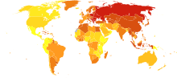](https://en.wikipedia.org/wiki/File:Stroke_world_map-Deaths_per_million_persons-WHO2012.svg)

Stroke deaths per million persons in 2012

  58–316

  317–417

  418–466

  467–518

  519–575

  576–640

  641–771

  772–974

  975-1,683

  1,684–3,477

[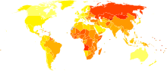](https://en.wikipedia.org/wiki/File:Cerebrovascular_disease_world_map_-_DALY_-_WHO2004.svg)

[Disability-adjusted life year](https://en.wikipedia.org/wiki/Disability-adjusted_life_year) for cerebral vascular disease per 100,000 inhabitants in 2004.[[208]](https://en.wikipedia.org/wiki/Stroke#cite_note-208)

|  |  |
| --- | --- |
| no data    <250    250–425    425–600    600–775    775–950    950–1125 | 1125–1300    1300–1475    1475–1650    1650–1825    1825–2000    >2000 |

Stroke was the second most frequent cause of death worldwide in 2011, accounting for 6.2 million deaths (~11% of the total).[[209]](https://en.wikipedia.org/wiki/Stroke#cite_note-The_top_10_causes_of_death-209) Approximately 17 million people had a stroke in 2010 and 33 million people have previously had a stroke and were still alive.[[17]](https://en.wikipedia.org/wiki/Stroke#cite_note-Fei2013-17) Between 1990 and 2010 the number of strokes decreased by approximately 10% in the developed world and increased by 10% in the developing world.[[17]](https://en.wikipedia.org/wiki/Stroke#cite_note-Fei2013-17) Overall, two-thirds of strokes occurred in those over 65 years old.[[17]](https://en.wikipedia.org/wiki/Stroke#cite_note-Fei2013-17) South Asians are at particularly high risk of stroke, accounting for 40% of global stroke deaths.[[210]](https://en.wikipedia.org/wiki/Stroke#cite_note-Indian_Stroke_Association-210)

It is ranked after heart disease and before cancer.[[2]](https://en.wikipedia.org/wiki/Stroke#cite_note-Donnan2008-2) In the United States stroke is a leading cause of disability, and recently declined from the third leading to the fourth leading cause of death.[[211]](https://en.wikipedia.org/wiki/Stroke#cite_note-pmid21778445-211) Geographic disparities in stroke incidence have been observed, including the existence of a "[stroke belt](https://en.wikipedia.org/wiki/Stroke_belt)" in the [southeastern United States](https://en.wikipedia.org/wiki/Southeastern_United_States), but causes of these disparities have not been explained.

The risk of stroke [increases exponentially](https://en.wikipedia.org/wiki/Exponential_growth) from 30 years of age, and the cause varies by age.[[212]](https://en.wikipedia.org/wiki/Stroke#cite_note-ellekjaer1997-212) Advanced age is one of the most significant stroke risk factors. 95% of strokes occur in people age 45 and older, and two-thirds of strokes occur in those over the age of 65.[[43]](https://en.wikipedia.org/wiki/Stroke#cite_note-NINDS1999-43)[[197]](https://en.wikipedia.org/wiki/Stroke#cite_note-Senelick1994-197) A person's risk of dying if he or she does have a stroke also increases with age. However, stroke can occur at any age, including in childhood.

Family members may have a genetic tendency for stroke or share a lifestyle that contributes to stroke. Higher levels of [Von Willebrand factor](https://en.wikipedia.org/wiki/Von_Willebrand_factor) are more common amongst people who have had ischemic stroke for the first time.[[213]](https://en.wikipedia.org/wiki/Stroke#cite_note-213) The results of this study found that the only significant genetic factor was the person's [blood type](https://en.wikipedia.org/wiki/Blood_type). Having had a stroke in the past greatly increases one's risk of future strokes.

Men are 25% more likely to suffer strokes than women,[[43]](https://en.wikipedia.org/wiki/Stroke#cite_note-NINDS1999-43) yet 60% of deaths from stroke occur in women.[[200]](https://en.wikipedia.org/wiki/Stroke#cite_note-Villarosa1993-200) Since women live longer, they are older on average when they have their strokes and thus more often killed.[[43]](https://en.wikipedia.org/wiki/Stroke#cite_note-NINDS1999-43) Some risk factors for stroke apply only to women. Primary among these are pregnancy, childbirth, [menopause](https://en.wikipedia.org/wiki/Menopause), and the treatment thereof ([HRT](https://en.wikipedia.org/wiki/Hormone_replacement_therapy_(menopause))).

## History

[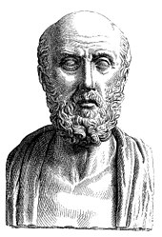](https://en.wikipedia.org/wiki/File:Hippocrates.jpg)

[Hippocrates](https://en.wikipedia.org/wiki/Hippocrates) first described the sudden paralysis that is often associated with stroke.

Episodes of stroke and familial stroke have been reported from the 2nd millennium BC onward in ancient Mesopotamia and Persia.[[214]](https://en.wikipedia.org/wiki/Stroke#cite_note-214) [Hippocrates](https://en.wikipedia.org/wiki/Hippocrates) (460 to 370 BC) was first to describe the phenomenon of sudden [paralysis](https://en.wikipedia.org/wiki/Paralysis) that is often associated with [ischemia](https://en.wikipedia.org/wiki/Ischemia). [Apoplexy](https://en.wikipedia.org/wiki/Apoplexy), from the [Greek](https://en.wikipedia.org/wiki/Greek_language) word meaning "struck down with violence", first appeared in Hippocratic writings to describe this phenomenon.[[215]](https://en.wikipedia.org/wiki/Stroke#cite_note-Stroke1996-Thompson-215)[[216]](https://en.wikipedia.org/wiki/Stroke#cite_note-Merginet2001-Kopito-216) The word *stroke* was used as a synonym for apoplectic [seizure](https://en.wikipedia.org/wiki/Seizure) as early as 1599,[[217]](https://en.wikipedia.org/wiki/Stroke#cite_note-217) and is a fairly literal translation of the Greek term. The term *apoplectic stroke* is an archaic, nonspecific term, for a cerebrovascular accident accompanied by haemorrhage or haemorrhagic stroke.[[218]](https://en.wikipedia.org/wiki/Stroke#cite_note-218) [Martin Luther](https://en.wikipedia.org/wiki/Martin_Luther) was described as having an *apoplectic stroke* that deprived him of his speech shortly before his death in 1546.[[219]](https://en.wikipedia.org/wiki/Stroke#cite_note-219)

In 1658, in his *Apoplexia*, [Johann Jacob Wepfer](https://en.wikipedia.org/wiki/Johann_Jakob_Wepfer) (1620–1695) identified the cause of [hemorrhagic](https://en.wikipedia.org/wiki/Hemorrhagic) stroke when he suggested that people who had [died](https://en.wikipedia.org/wiki/Died) of apoplexy had bleeding in their brains.[[43]](https://en.wikipedia.org/wiki/Stroke#cite_note-NINDS1999-43)[[215]](https://en.wikipedia.org/wiki/Stroke#cite_note-Stroke1996-Thompson-215) Wepfer also identified the main [arteries](https://en.wikipedia.org/wiki/Arteries) supplying the brain, the [vertebral](https://en.wikipedia.org/wiki/Vertebral) and [carotid](https://en.wikipedia.org/wiki/Carotid) arteries, and identified the cause of a type of [ischemic](https://en.wikipedia.org/wiki/Ischemic) stroke known as a [cerebral infarction](https://en.wikipedia.org/wiki/Cerebral_infarction) when he suggested that [apoplexy](https://en.wikipedia.org/wiki/Apoplexy) might be caused by a blockage to those vessels.[[43]](https://en.wikipedia.org/wiki/Stroke#cite_note-NINDS1999-43) [Rudolf Virchow](https://en.wikipedia.org/wiki/Rudolf_Virchow) first described the mechanism of [thromboembolism](https://en.wikipedia.org/wiki/Thromboembolism) as a major factor.[[220]](https://en.wikipedia.org/wiki/Stroke#cite_note-pmid4914683-220)

The term *cerebrovascular accident* was introduced in 1927, reflecting a "growing awareness and acceptance of vascular theories and (...) recognition of the consequences of a sudden disruption in the vascular supply of the brain".[[221]](https://en.wikipedia.org/wiki/Stroke#cite_note-FingerBoller2010-221) Its use is now discouraged by a number of neurology textbooks, reasoning that the connotation of fortuitousness carried by the word *accident* insufficiently highlights the modifiability of the underlying risk factors.[[222]](https://en.wikipedia.org/wiki/Stroke#cite_note-Scadding2011-222)[[223]](https://en.wikipedia.org/wiki/Stroke#cite_note-SirvenMalamut2008-223)[[224]](https://en.wikipedia.org/wiki/Stroke#cite_note-KaufmanMilstein2012-224) *Cerebrovascular insult* may be used interchangeably.[[225]](https://en.wikipedia.org/wiki/Stroke#cite_note-Mosby-225)

The term *brain attack* was introduced for use to underline the acute nature of stroke according to the [American Stroke Association](https://en.wikipedia.org/wiki/American_Stroke_Association),[[225]](https://en.wikipedia.org/wiki/Stroke#cite_note-Mosby-225) which has used the term since 1990,[[226]](https://en.wikipedia.org/wiki/Stroke#cite_note-NSA_Brain_Attack-226) and is used colloquially to refer to both ischemic as well as hemorrhagic stroke.[[227]](https://en.wikipedia.org/wiki/Stroke#cite_note-227)

## Research

As of 2017, [angioplasty](https://en.wikipedia.org/wiki/Angioplasty) and [stents](https://en.wikipedia.org/wiki/Stent) were under preliminary [clinical research](https://en.wikipedia.org/wiki/Clinical_research) to determine the possible therapeutic advantages of these procedures in comparison to therapy with [statins](https://en.wikipedia.org/wiki/Statin), [antithrombotics](https://en.wikipedia.org/wiki/Antithrombotic), or [antihypertensive drugs](https://en.wikipedia.org/wiki/Antihypertensive_drug).[[228]](https://en.wikipedia.org/wiki/Stroke#cite_note-Morris-228)

**1.2 MOTIVATION**

The stroke prediction model provides the chances of stroke to the user. This is done by collecting the inputs from user from the web platform and use the trained model to predict the chance of stroke to the user. It is easy to use and always available and can be accessed from anywhere and anytime through the web enabled device. Whenever a person feels symptoms of stroke like loss in vision in one eye, inability to move or feel on one side of the body, problem in understanding or speaking, dizziness these could be symptoms of stroke. There are some key risk factors like blood pressure, smoking habits, high blood cholesterol, obesity, diabetes, kidney problem etc. which are often know to user. In this case he/she can do a self-diagnosis test for chances for stroke risk to him/her and then consult a doctor. Timely detection can help to a large extend and can even save life in some instances. The easy to access app will provide ease to user. Also, the project will help us understand the capability and factors useful for machine learning classifiers for predicting such results.

**1.3 PROBLEM STATEMENT**

To compare various machine learning classifiers based on accuracy and select the best one to build a system for predicting stroke risk.

**1.4 SCOPE OF PROJECT**

This project provides user will a easy to access app which they can use to check the chances of stroke to them. The aim of the project is to make such app available to everyone. This project also plans to learn which machine learning classifiers are best suited for this kind of job and understand the reason behind it.

**1.5 ACCESS TO USERS**

The project aims to host the web app or mobile app for the users making it easily available for everyone at all time. The interface aims to be very basic and user friendly. The major objective is this app can be used by users on phone instantaneously and does not require any expertise.

**CHAPTER - 2**

**RELATED WORK**

**2.1 INTRODUCTION**

In this section, we will look into some of the earlier works presented in the direction of this project. There has been an extensive amount of work that has already happened in the field of image recognition and natural language processing. While preparing this project we have gathered ideas from different research materials and models. Here, we are going to enlist them.

**2.2 EXISTING SYSTEM**

Lately a lot of research has been done on automatic image captioning. The research can be briefly categorized into three different categories including the template-based approaches, retrieval-based approaches, and novel image caption generation approaches.

The template-based approach is aimed at generating captions by using fixed templates with a number of blank slots, in which way different objects, attributes, and actions are detected first and then the blank spaces in the templates are filled. For example, Farhadi use a triplet of scene elements to fill the template slots for generating image captions. Li et al extract the phrases related to detected objects, attributes, and their relationships for this purpose. Kulkarni et al. adopt a conditional random field (CRF) method to infer the objects, attributes, and prepositions before filling in the gaps. Template-based methods can generate grammatically correct captions. However, templates are predefined and length of captions cannot be variable.

The retrieval-based approach tries to generate description for an image by selecting the most semantically similar sentences from sentence pool or directly copying sentences from other visually similar images. For example, Gong et al. utilize stacked auxiliary embedding method to generate image descriptions from millions of weakly annotated images. Ordonez find similar images in the Flickr database and return the descriptions of these retrieved images to query based on millions of images and their corresponding descriptions. Sun use semantic similarity and visual similarity scores to cluster similar terms and images together first and then retrieve the caption of target image from captions of similar images in the same cluster. Hodosh establish a ranking-based framework to treat sentence-based image description as the task of ranking a set of captions for each test image. These methods generate general and syntactically correct captions. However, it is difficult for them to generate image-specific and semantically correct captions.

Different from the mentioned two categories, novel caption generation approaches mainly use deep learning and machine learning to generate the new captions. A general implementation of this method is to analyze the visual content of the image first and then generate image captions from the visual content using a language model. For instance, Vinyals et al. use CNN as an encoder for image classification and LSTM as a decoder to generate sentence for the description. The main drawbacks of the work are the quick model overfitting, so they use the heavy and expensive GoogLeNet with 22 hidden layers and the absence of attention layer that significantly improved the description accuracy. Karpathy investigate the possibility of generating an image description in natural language. Their approach uses image datasets and their description in natural language and seeks an intermodal correspondence between words from the description and visual data. The first model aligns the fragments of sentences to the visual areas, then forms a single description by multimodal embedding. This description is treated as learning data for a second model of a recurrent neural network that learned to a generate caption. Xu et al. use a convolutional neural network to extract feature maps and LSTM to describe the input image, by processing already extracted feature maps. The limitation of this work is the using of obsolete and expensive Oxford VGGnet, where the quality of image classification is low in the modern CNN . Some researchers have put their attention on classification as Yu. who propose a SVM classification-based two-side cross-domain algorithm by inferring intrinsic user and item features (CTSIF-SVMs), a two-side cross-domain algorithm with expanding user and item features via the latent factor space of auxiliary domains (TSEUIF).

**2.3 PROPOSED SYSTEM**

Our proposed model, for automatic image captioning, is based on ResNet50 and LSTM. The ultimate purpose of this model is to generate the proper description for the given images. To do so, the model is designed with an encoder-decoder architecture based on CNN and RNN. In particular, to extract visual features, we use the ResNet50 network as the encoder to generate a one-dimensional vector representation of the input images. After that, to generate the description sentences, we adopt the LSTM as the language model for the decoder to decode the vector into a sentence.

**2.3.1. Image Feature Extraction**

For image feature extraction we used CNN, RestNet50, which is a deep network that has 50 layers. The image feature extractor needs an image of 224x224x3 size. The model uses ResNet50 pretrained on ImageNet dataset where the features of the image are extracted just before the last layer of classification. Another dense layer is added and converted to get a vector of length 2048.

The model takes an image and produces a caption, encoded as a sequence of 1-K coded words.



where K is the size of the dictionary and *c* is the caption length. We use CNN in particular, ResNet50, to obtain set annotation vectors like the feature vectors. The extractor produces L-vectors, all of which is a D-dimensional representation of the corresponding part of an image.

##### **2.3.2. The Language Model**

In our design, we adopt LSTM as our language model to generate proper caption based on the input vector from the ResNet50 output.



where the output vector of the previous cell ht-1 with the new element of the sequence xt is concatenated and passed as one vector through the layer with the sigmoid activation function.



Two created vectors are used to update the state from Ct-1 to Ct. To do this, we multiply the past state by ƒt to “forget” the data recognized as unnecessary in the previous step, then add .

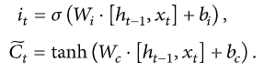

The input gate must determine what values will be updated, and the tanh layer creates a vector of new candidates for  , and values can be added to the cell state.



The obtained values of Ct and ht are transmitted to the neural network input at a time *t*+1.

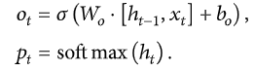

The multiplicative filters allow to effectively train LSTM, as they are good to prevent the exploding and vanishing gradients. Nonlinearity is provided by the sigmoid 𝝈(.) and the hyperbolic tangent h(). In the last equation, is fed to the softmax function to calculate the probability distribution pt over all the words. This function is calculated and optimized on the entire training dataset. The word with maximum probability is selected at each time step and fed into the next time step input to generate a full sentence.

**2.3.3. Fitting the Model**

After building the model, the model is fit using the training dataset. The model is made to run for 50 epochs and the best model is chosen among the 50 epochs by computing loss function on Flickr8k development dataset. The model with the lowest loss function is chosen for generating captions.

**2.3.4. Caption Generation**

To test our trained model, we input an image to the model. Next the image is fed into the feature extractor to recognize what all objects and scenes are depicted in the image, after resizing it. The process of caption generation is done using the RNN trained model. Then for that image, sequentially, word-by-word the caption is generated by selecting the word with maximum weight for the image at that particular iteration. The indexed word is converted to word and then appended into the final caption. When a tag is detected or the size of the caption reaches 40, the final caption is generated and printed along with the input image.

##### **2.3.5. Suggestion API**

Finally, in the web app, the description string is then passed to API which will suggest a few caption options to the user for selecting their preferred one.

**CHAPTER - 3**

**PROBLEM DESCRIPTION AND SPECIFICATION**

**3.1 PROBLEM DESCRIPTION**

The problem introduces a captioning task, which requires a computer vision system to both localize and describe salient regions in images in natural language. The image captioning task generalizes object detection when the descriptions consist of a single word.

**3.2 SPECIFICATION**

Image caption generator is a task that involves computer vision and natural language processing concepts to recognize the context of an image and describe them in a natural language like English.

The aim of image captioning is to automatically describe an image with one or more natural language sentences. This is a problem that integrates computer vision and natural language processing, so its main challenges arise from the need of translating between two distinct, but usually paired modalities. First, it is necessary to detect objects on the scene and determine the relationships between them and then, express the image content correctly with properly formed sentences. The generated description is still much different from the way people describe images because people rely on common sense and experience, point out important details and ignore objects and relationships that they imply. Moreover, they often use imagination to make descriptions vivid and interesting. The process flow diagram below in Figure 1 outlines the working of the project.

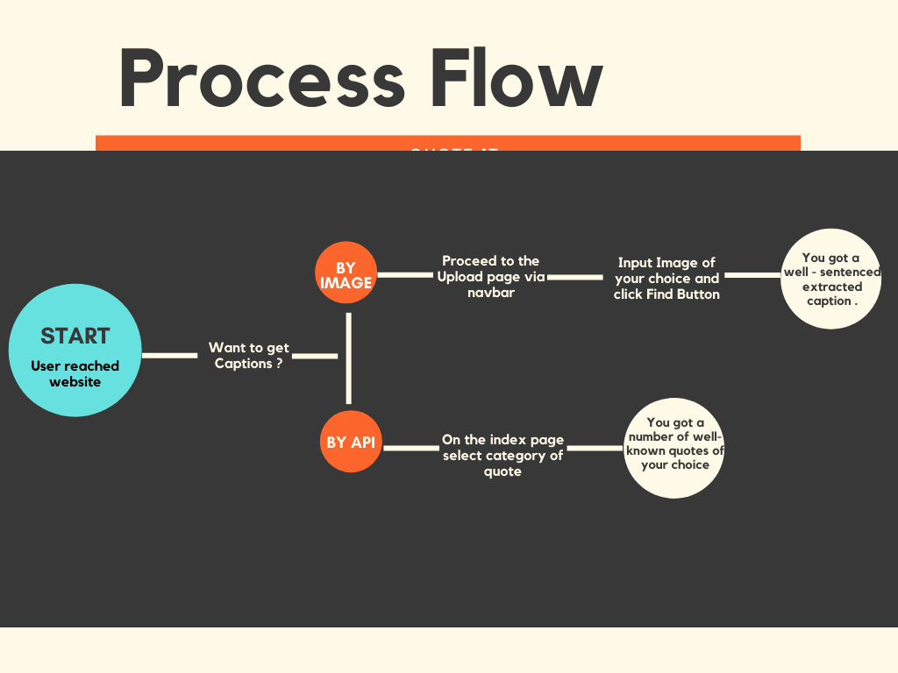

Figure 1: Process Flow Diagram

**3.3 REQUIREMENTS**

**3.3.1 SOFTWARE REQUIREMENTS**

* Python Version 3.6+
* IDE: JupyterLab or PyCharm
* Frameworks:-
  + Flask
  + Bootstrap
* Python Libraries:-
  + Scikit-learn
  + Seaborn
  + Numpy: 1.18.5
  + Pandas: 1.1.14

**3.3.2 HARDWARE REQUIREMENTS**

* Processor:- Intel i3+ or AMD A6+
* RAM:- 2GB/+
* Hard Disk Space:- 2GB

**3.3.3 OTHER REQUIREMENTS**

* Stroke Prediction Dataset
* For training the model - Kaggle Notebook/Colab/JupyterLab should be preferred (Recommended)

**CHAPTER - 4**

**SYSTEM DESIGN**

**4.1 INTRODUCTION**

We have written data preprocessing scripts to process raw input data (both images and captions) into proper format; A pre-trained Convolutional Neural Network architecture as an encoder to extract and encode image features into a higher dimensional vector space; An LSTM-based Recurrent Neural Network as a decoder to convert encoded features to natural language descriptions; Attention mechanism which allows the decoder to see features from a specifically highlighted region of the input image to improve the overall performance

**4.1.1. Data Sources**

We had selected “Stroke-prediction dataset” obtained from Kaggle as our dataset. This dataset contains of 5110 records having 12 attributes (id, age, gender, hypertension, heart disease, marital status, residence type, work type, average glucose level, BMI, smoking status and stroke occurrence). The below image provides the info about the dataset.

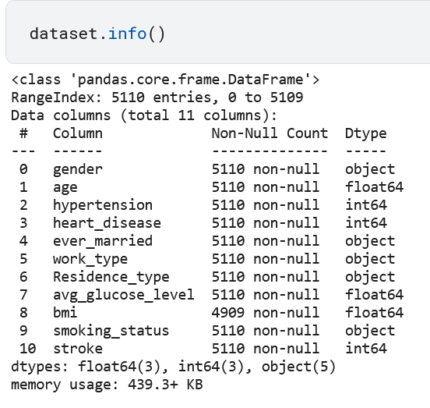

**4.1.2. Convolutional Neural Network (Encoder)**

The encoder needs to extract image features of various sizes and encode them into vector space which can be fed to RNN in a later stage. VGG-16 and ResNet are commonly recommended as image encoders. We chose to modify the pre-trained ResNet50 model provided by Tensorflow library. In this task, CNN is used to encode features instead of classifying images. As a result, we removed the fully connected layers and the max pool layers at the end of the network. Under this new construction, the input image matrix has dimension N ×3×256×256, and the output has dimension N × 14 × 14 × 512. Furthermore, in order to support input images with various sizes, we added an adaptive 2d layer to our CNN architecture.

**4.1.3. Recurrent Neural Network (Decoder)**

The decoder needs to generate image captions word by word using a Recurrent Neural Network - LSTMs which is able to sequentially generate words. The input for the decoder is the encoded image feature vectors from CNN and the encoded image captions produced in data preprocessing stage.

**4.2 ARCHITECTURE DIAGRAM**

The Backend System architecture Diagram is as follows:

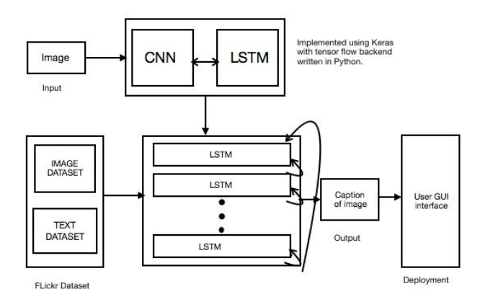

Figure 2: Architecture of the image captioning model

The model uses ResNet50 as the CNN model and generated Region features of the passed images which are feed to RNN(LSTM) network which is fed to the model for predicting the next word in the captions on the basis of highest probability obtained. All these next words are added to generate the captions till the final caption is generated. Figure 2 shows a brief architecture for the project. The image is passed and fed to CNN and LSTM model, which internally is composed of various layers and fed with regional image and text dataset. At the user interacts with the project through the GUI deployed for them. Figure 3 explains the process used by CNN i.e, object detection and feature map preparation. These features along with text dataset are given to the vector of LSTM model with predicts the objects in the image and return the word in the sequence which has the highest probability which is used for generating the caption.

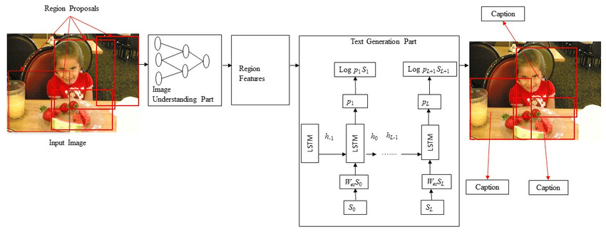

Figure 3: Illustration image of functioning of the captioning model

**4.3 UNIFIED MODELING LANGUAGE(UML)**

**4.3.1 USE CASE DIAGRAM**

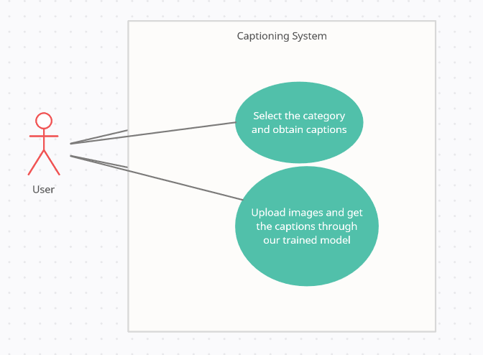

Figure 4: Use Case Diagram for the captioning system

Figure 4 shows that there are basically two use-cases available for the user. When the user visits the web site they can choose:

1. Any category available on the home page to obtain the collection of images of that category and then select and copy the caption of their choice.
2. User can navigate to the Upload section and then upload the image from their device and then by the help of the image caption generator model running in the background he/she can obtain the caption for the provided image.

**4.3.2 DATA FLOW DIAGRAM**

**4.3.2.1 Data Flow Diagram Level 0**

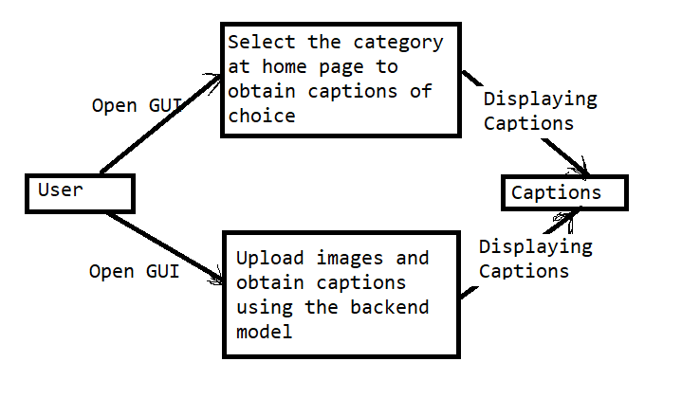

Figure 5: DFD level 0

In Figure 5 the level 0 DFD shows the top-level view of the data flow. It shows that initially when the user interacts with the GUI, they have two option. The first one to choose a caption of their favourite category and the second option is to provide an image to the model for generation caption.

**4.3.2.2 Data Flow Diagram Level 1**

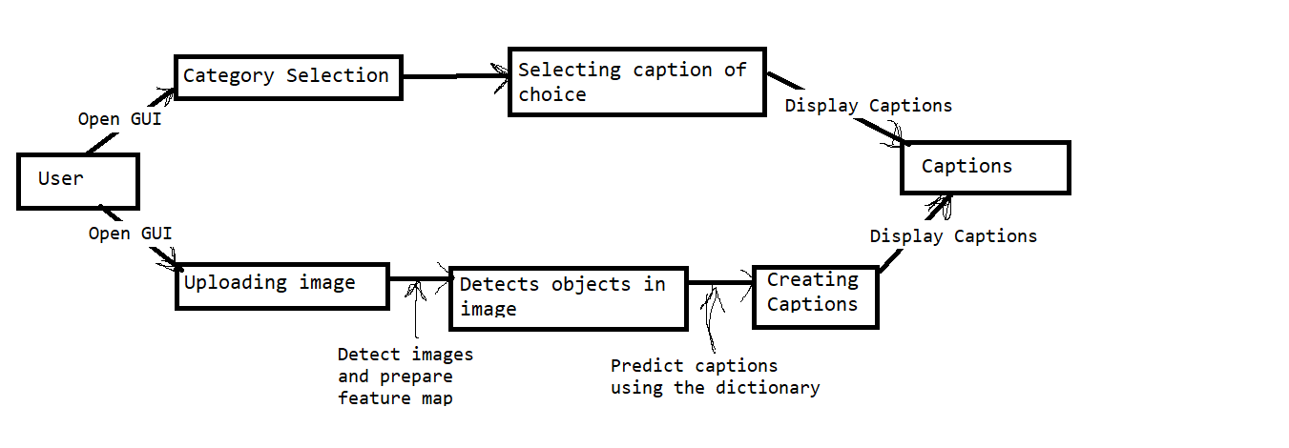

Figure 6: DFD level 1

In figure 6 we see the medium level view of data flow. It shows how the input passed goes through a channel of different segments. In our case when a user uploads the image it passes through the CNN model and the features of the image generated are then passed to Language model which gives the captions to the GUI for display.

**4.3.2.3 Data Flow Diagram Level 2**

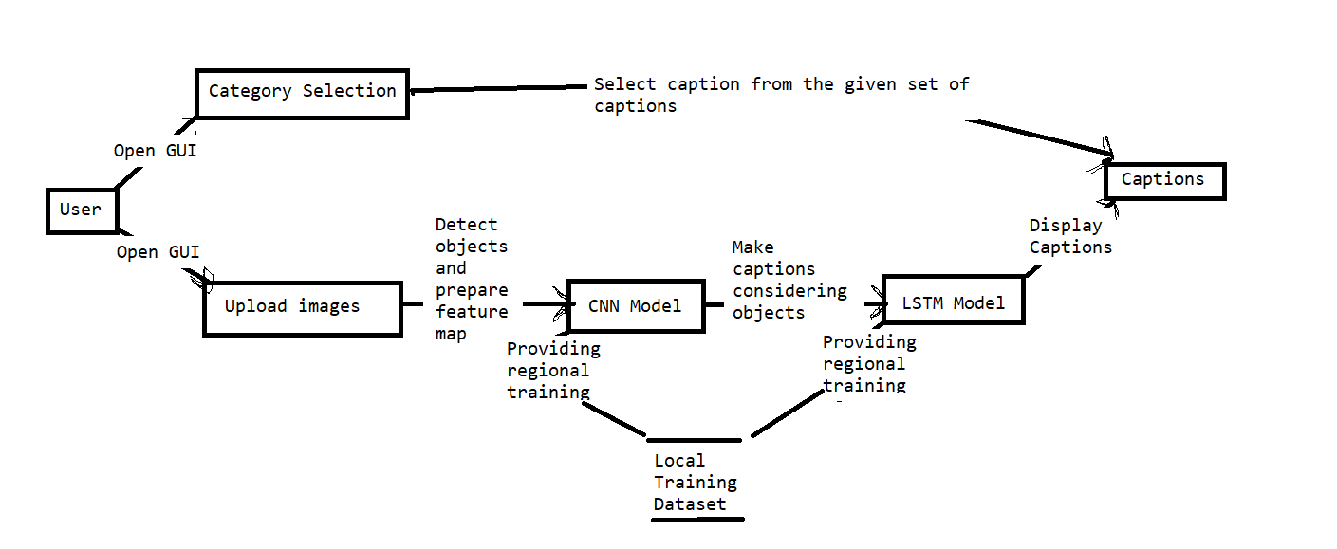

Figure 7: DFD level 2

In figure 7 explains the functioning of the model in great depth. The first option remains the same, but the second option shows the usage of a regional dataset to train the model. This improves the functioning of the model by training the model on our custom dataset.

**4.4 STATE CHART DIAGRAM**

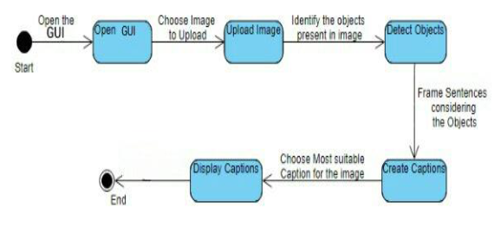

Figure 8: State Chart Diagram of the system

Figure 8 shows the state of the program at every deciding state and its output which are fed to the next state as input. The program basically contains five states as stated in the figure. The GUI and uploading of the image are handled by the flask library. The object detection phase uses the CNN model to detect the objects in the figure and then the create caption state uses the LSTM model to generate the captions.

**4.5 FLOW CHART FOR CAPTION GENERATION PROCESS**

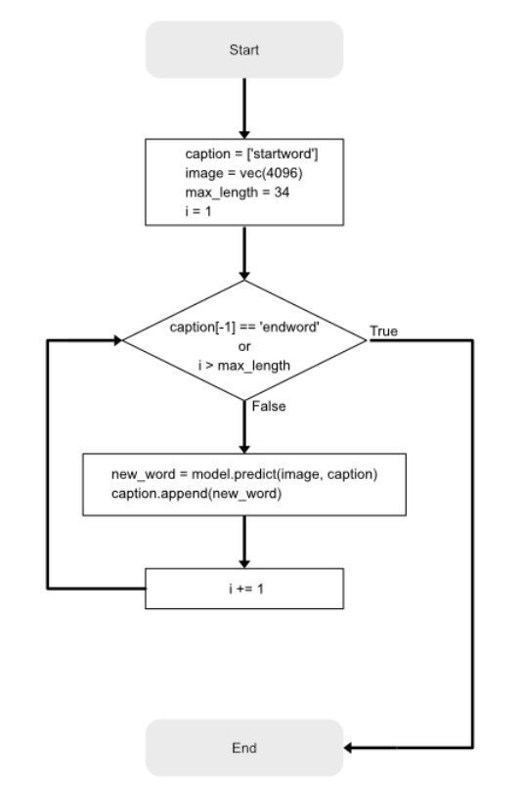

Figure 9: Flow chart for the caption generation process

Figure 9 tells us about the functioning of the caption prediction task. Once the image feature of the passed test image is extracted. The trained model tries to predict the next word in the caption by using the Dense layer and agrmax function. The inverse dictionary is used for obtaining the word corresponding to the integer provided. When the “endword” is passed to the model, it stops and the final caption is given in output.

**CHAPTER - 5**

**IMPLEMENTATION AND RESULT**

**5.1 OVERVIEW**

In this section, we are going to cover all the steps we have taken while implementing the program. The whole program consists of nine different sections which we are going to cover in later sections.

**5.2 MODEL SELECTION**

We have used the ResNet50 model of the TensorFlow in our project for image processing as shown in Figure 10. We first import ResNet50 from the Tensorflow module, which can be found in tensorflow.keras.applications module. Once we import the model, it will download the model from the TensorFlow website and save it into the ‘incept_model’ variable. Then we remove the last two layers of the ResNet50 model as the last to later are not of our use. We also save the model in our local directory using the ‘save’ method; so that it can be used later in offline mode.

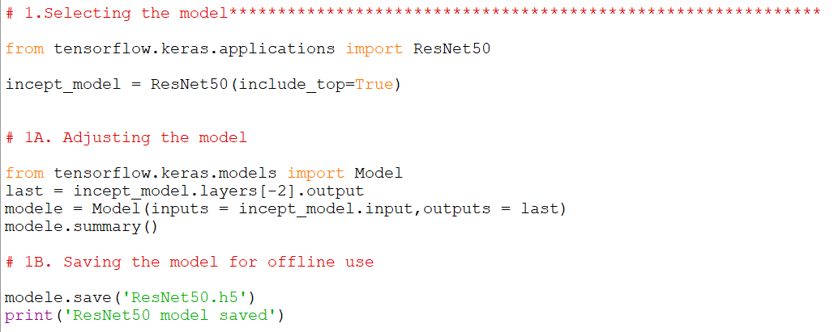

Figure 10: Code Snippet showing the selection and adjustment of the model

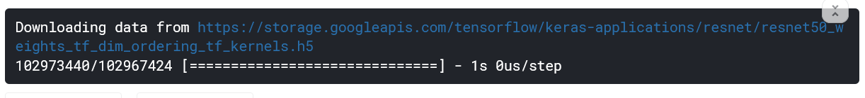

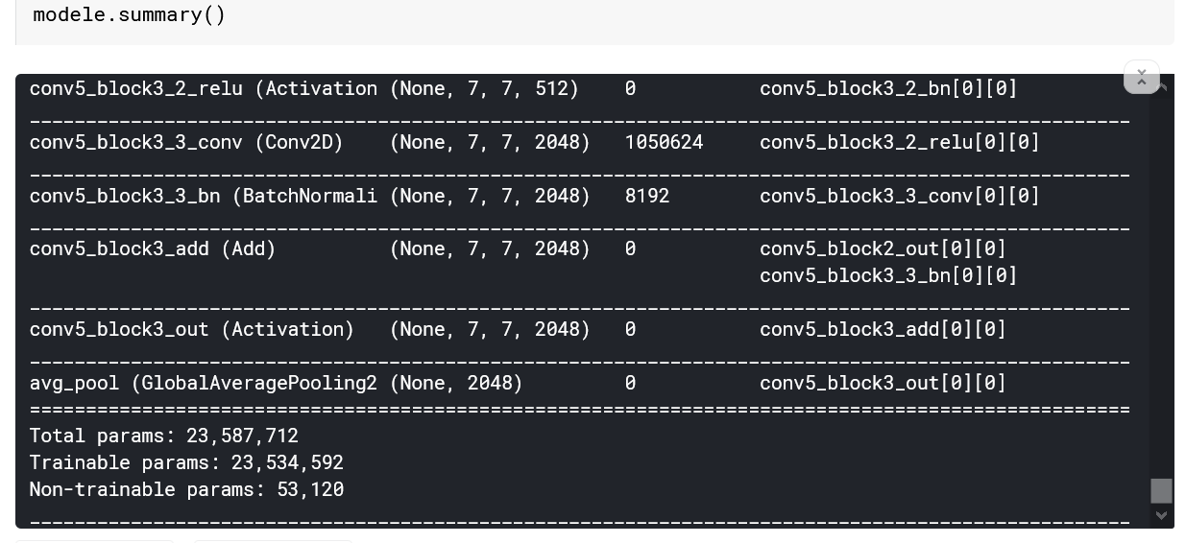

Figure 11: Output representing different layers of the selected model

**5.3 IMAGE PREPROCESSING**

We use ‘Flickr8k Dataset’ which we have downloaded and saved in the local directory as shown in Figure 12. By using the ResNet50 model we are extracting image features and saving it for later use in a pickle file named ‘features.p’.

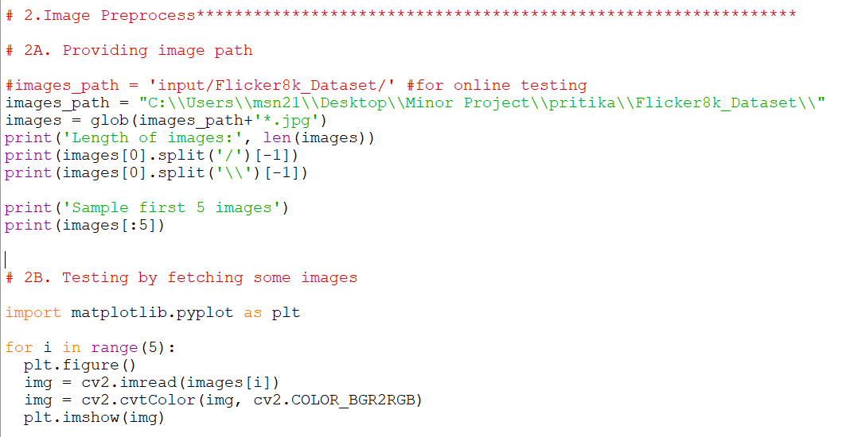

Figure 12: Code snippet showing preprocessing of images

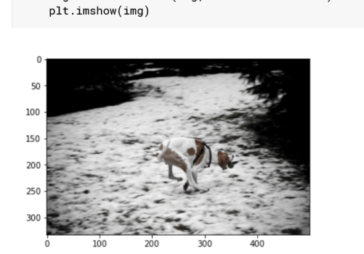

Figure 13: A sample picture fetched from the dataset

Figure 14 shows the process of creating a feature map of a specified limit of images from the regional image dataset. Here we have selected 1500 images for the training purpose because of hardware limitations. The image in the images array is fetched and converted to a coloured and resized image of 224 x 224 x 3 dimension. Then our defined ResNet 50 model as “modele” extracts and store the image feature in the image feature variable in the NumPy array form. The process of extraction is shown in figure 15 and figure 16 shows a snap of image features of some sample images.

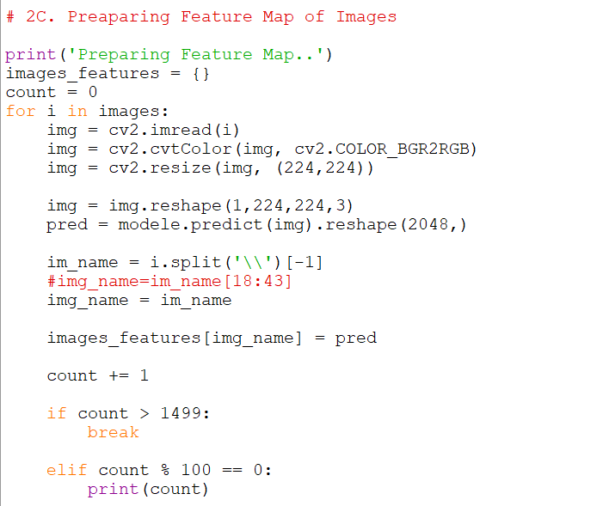

Figure 14: Extracting feature map from the passed images

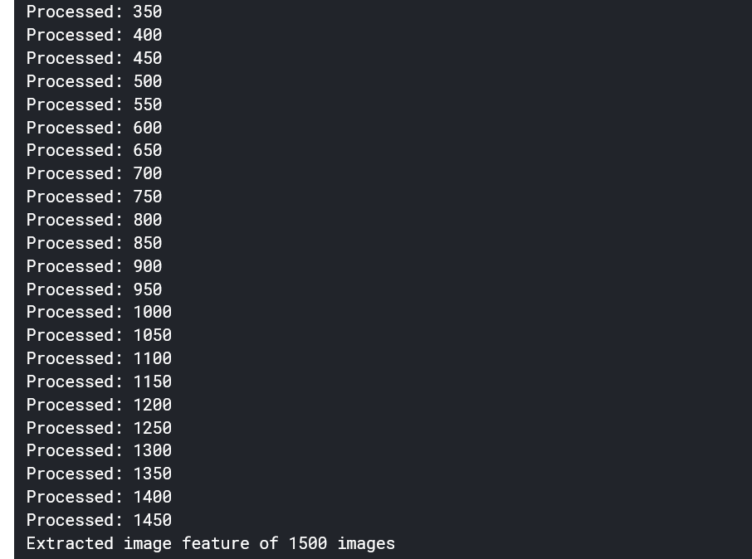

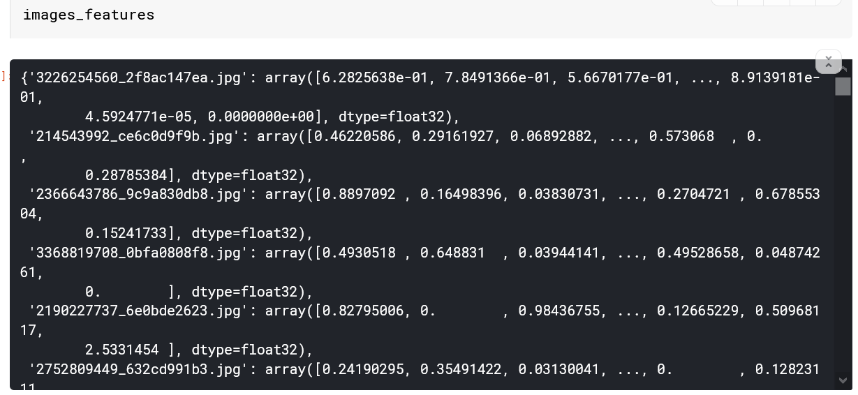

Figure 15: Output representing the process of feature map creations and sample view of the feature map of some images

**5.4 TEXT PREPROCESSING**

We are using ‘Flickr8k.token.txt’ which contains five captions for all the images in the Flickr8k Image dataset. We split them into different lines and convert them in string form, ready for our operation as shown in figure 16 and figure 17. Then we prepare a dictionary consisting of images as the keys and a list of 5 captions as the values for all the images in the feature map that we saved earlier. Then we modify the captions by adding ‘startofseq’ word at the front of every caption denoting the start of the caption and ‘endofseq’ at the end of every caption denoting the end of that particular caption. Then we again attach these modified captions with the respective images as shown in figure 18 and the corresponding results in figure 19. We did this for preparing the caption vector which will later be used by our model for prediction.

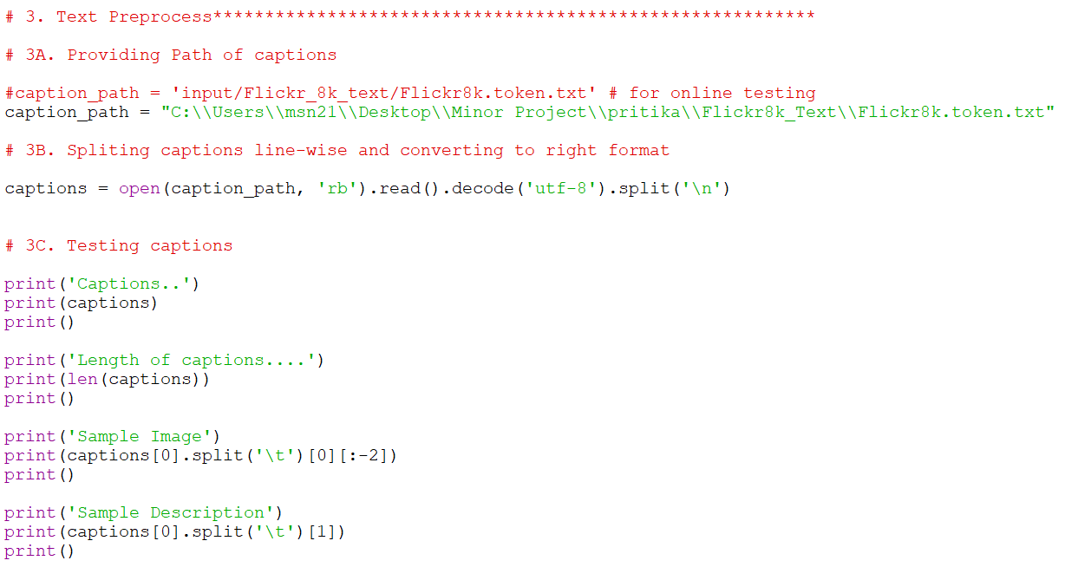

Figure 16: Code snippet showing text preprocessing

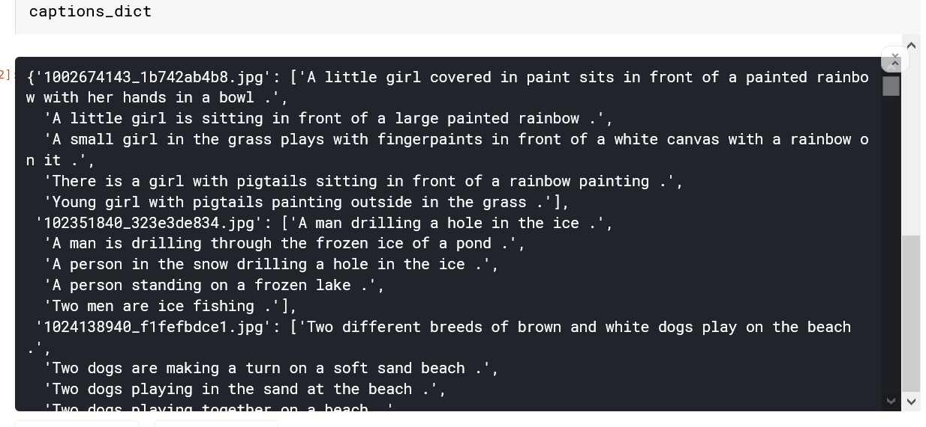

Figure 17: Sample captions fetched from Flickr8k.token.txt

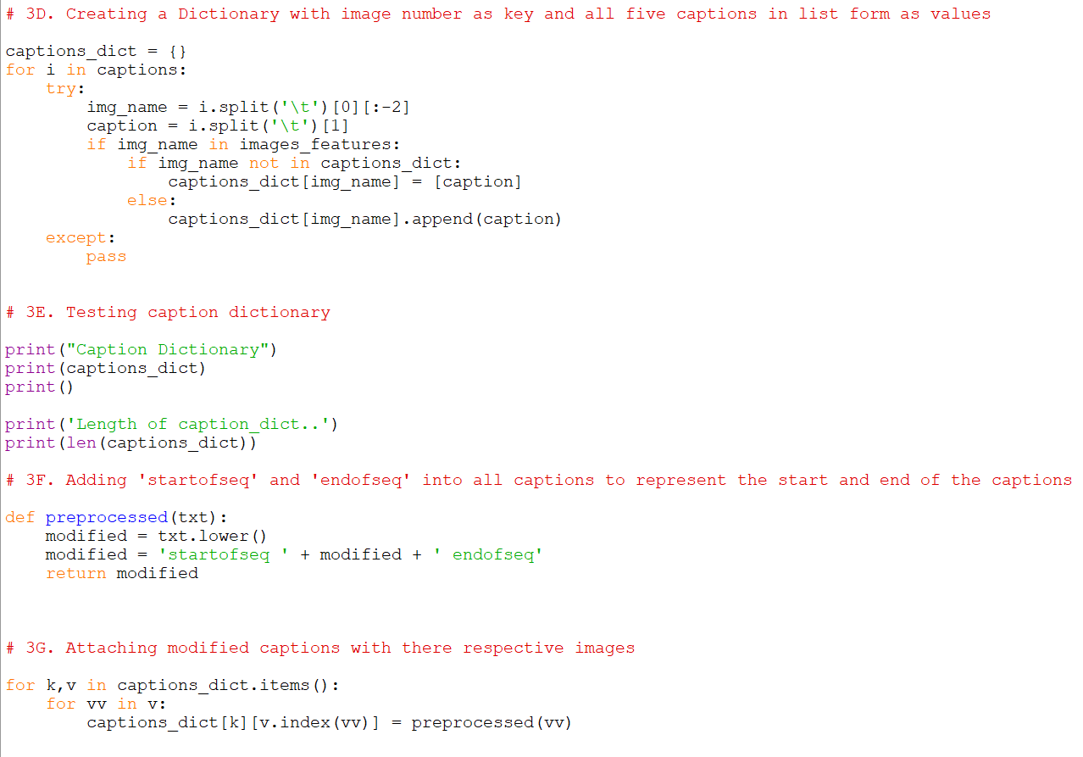

Figure 18: Code snippet representing the modification process of the captions and caption dictionary creation

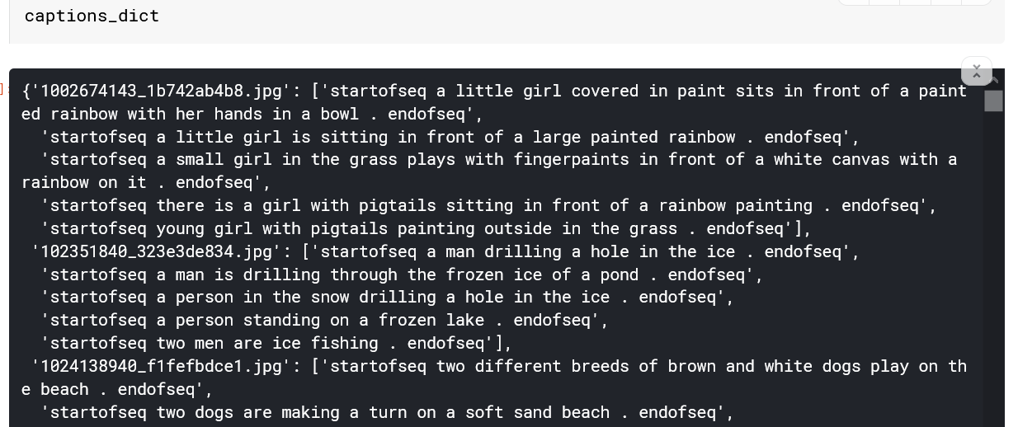

Figure 19: Sample view of caption dictionary

**5.5 CREATING VOCABULARY**

Next, ahead we count the number of times any particular word appears in any of the captions among all the captions present as shown in figure 20 code snippet. Then we provide an integer number to every word forming a dictionary of different words present in the captions as shown in results in figure 22. Then we replace every word in every caption with the integer key corresponding to it as the value in the caption dictionary which earlier had images and the list of its corresponding five captions. The new caption dictionary contains images and corresponding captions but in integer form as shown in figure 23.

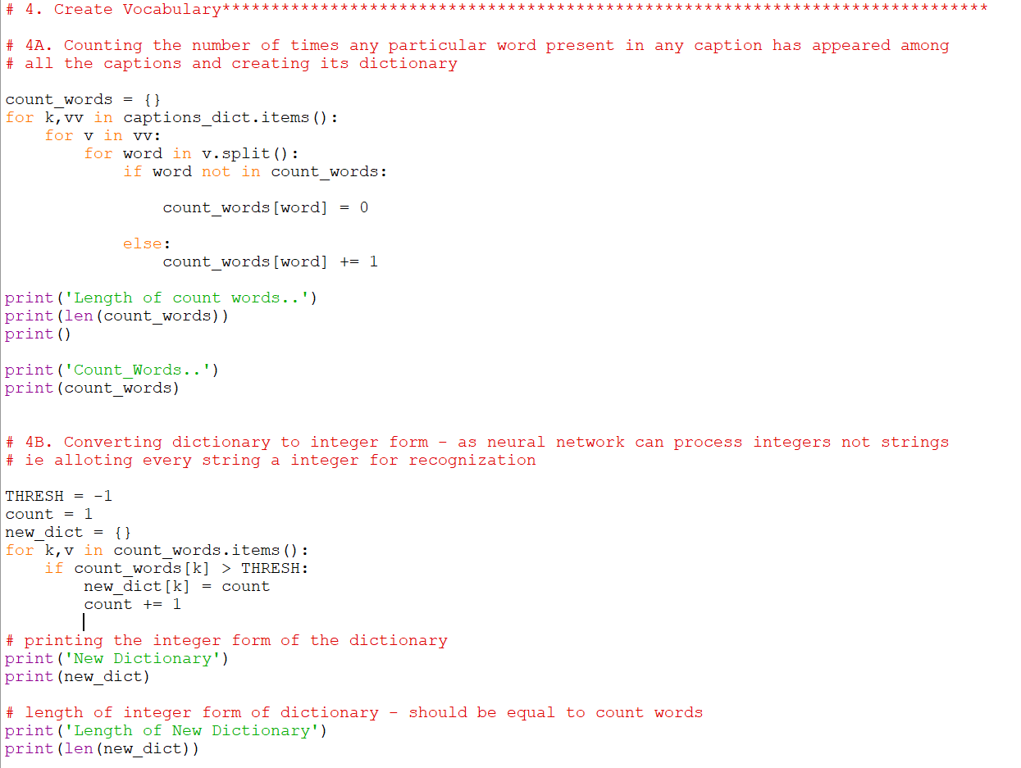

Figure 20: Code snippet showing Vocabulary Creation Process

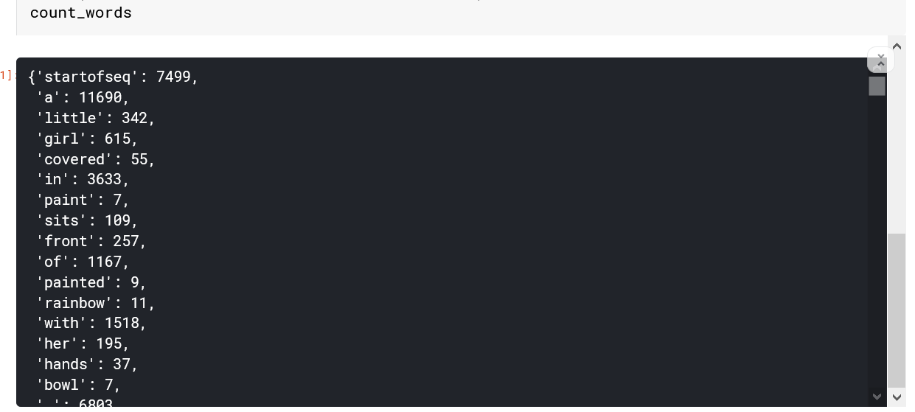

Figure 21: Sample output showing the count of different words

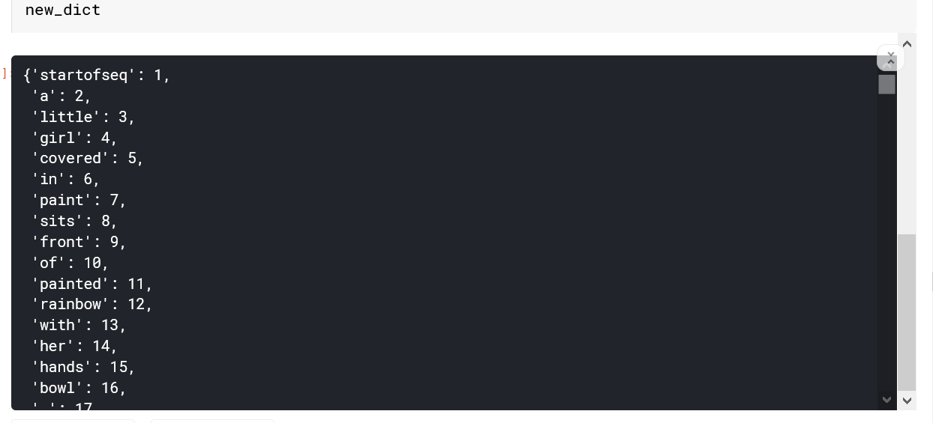

Figure 22: Sample output showing the word dictionary

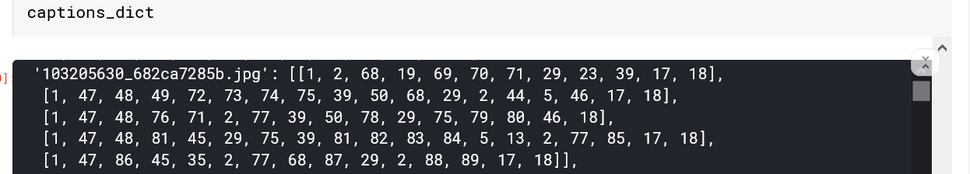

Figure 23: Sample output showing the integer form captions attached with there respective images

**5.6 PREPARING MODEL**

**5.6.1 Preparing Input for the model**

Now we need to obtain the maximum length of the caption that is present in our captions, this will be one of the inputs of the model which will help it decide the length of the caption to be predicted. Vocab size is the number of words we have in the dictionary, this would also be one of the inputs to the model. The process of obtaining the max length caption in our collection is shown in figure 24 with results in figure 25. We use a generator function to prepare the input for training the model. The outputs of the generator function are three NumPy arrays which contain the image and the first words and the next predicted word (the word having the highest probability). The generator method is displayed in figure 26 and a few the variables are created in figure 27 code snippet along with some sample values. Figure 28 shows the length and shape of input which are fed to the model for training.

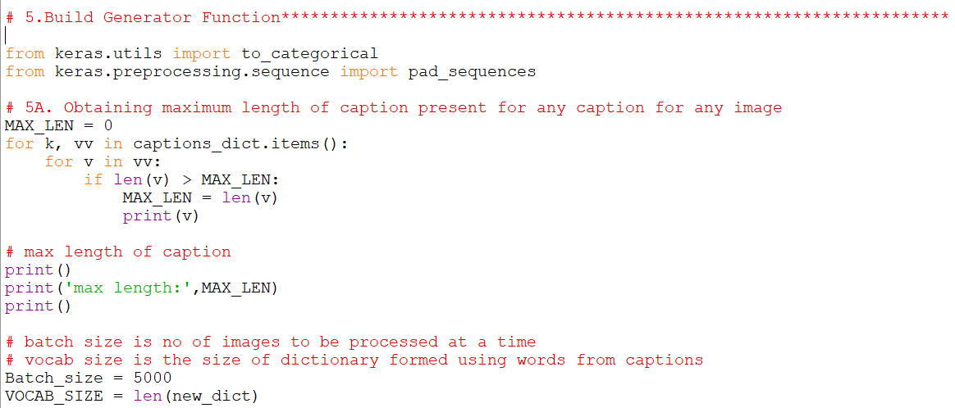

Figure 24: Code snippet showing the max length of the caption present

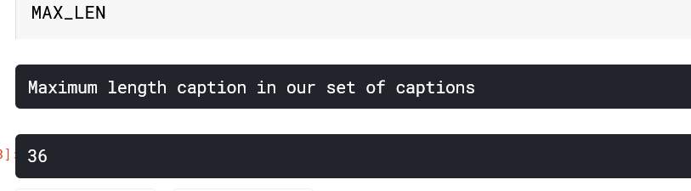

Figure 25: Output showing the length of the largest caption in our collection

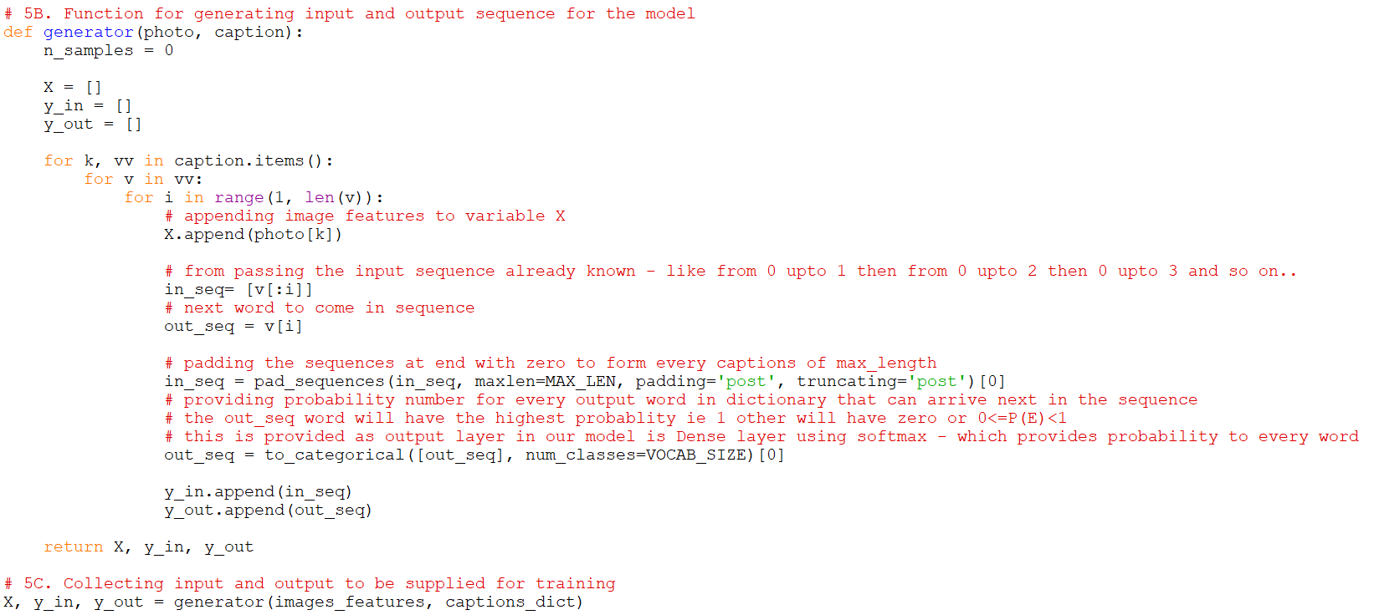

Figure 26: Code snippet showing the input form preparation which will be fed to the model

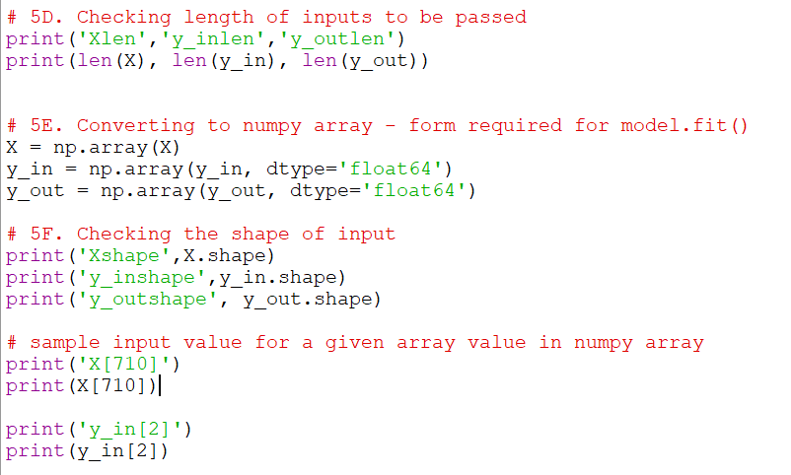

Figure 27: Code snippet showing the testing of shapes of inputs and conversion to NumPy array form

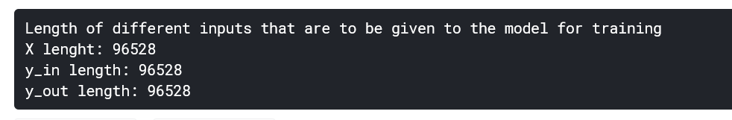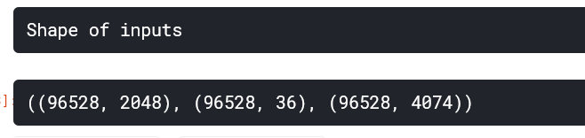

Figure 28: Sample output showing the shapes of input

**5.7 CONFIGURING THE MODEL**

**5.6.2.1 Configuring Image Model**

We use the ‘Sequential’ model present in tensorflow.keras.model library to sequentially add different layers which we want to use for processing the image. We have a ‘Dense layer’ and ‘RepeatVector layer’ and ‘relu’ activation function. The code snippet in Figure 29 highlights the process of configuration of image and language model. Figure 30 and Figure 31 shows the different layers present in the image and language model selected and different parameters they work on.

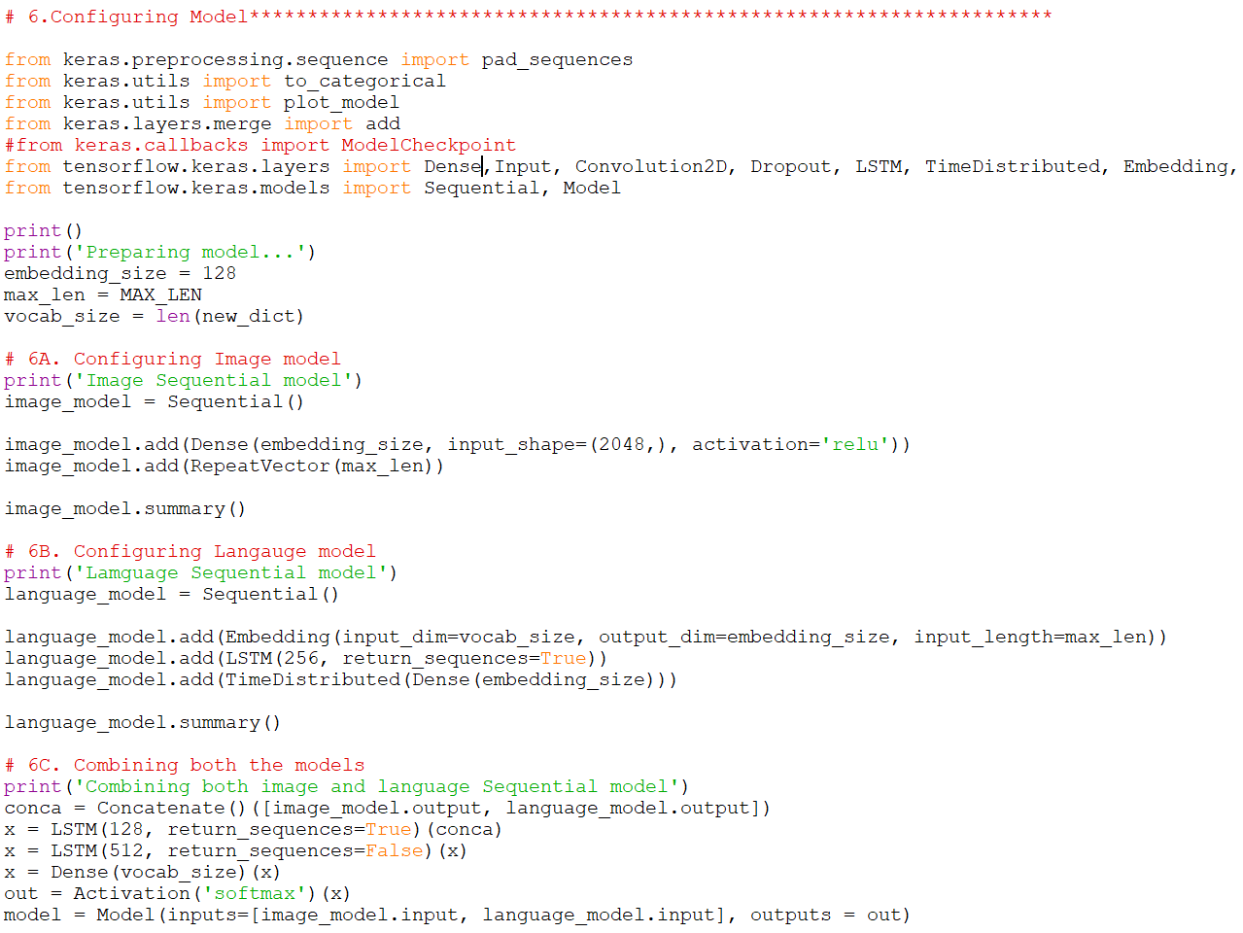

Figure 29: Code snippet showing the configuring process of the image and language model

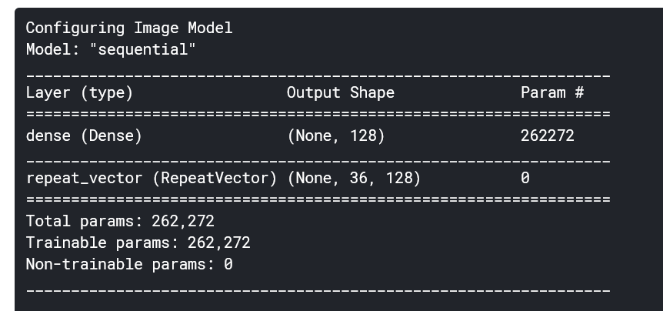

Figure 30: Output showing the image sequential model

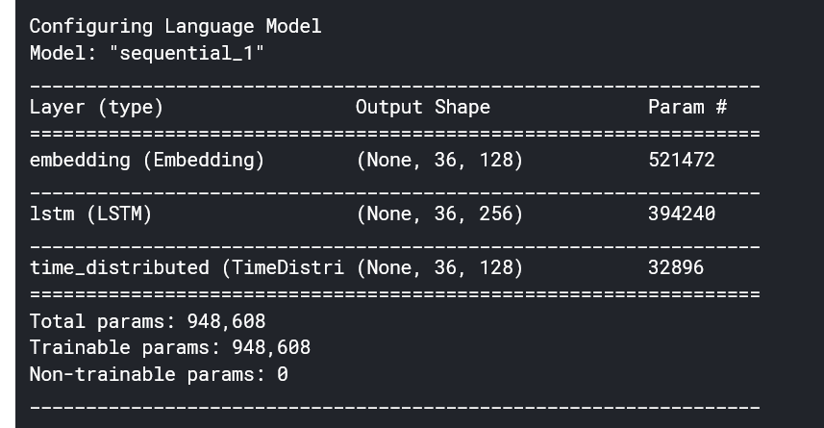

Figure 31: Output showing the language sequential model

Both of the models i.e. image and language model are combined using the concatenate layer and the resulting model layers are shown in figure 32. Figure 33 is the descriptive model generated through Keras plot model method. This shows different layers along with the shapes and when they are added to the model and the output generated by them.

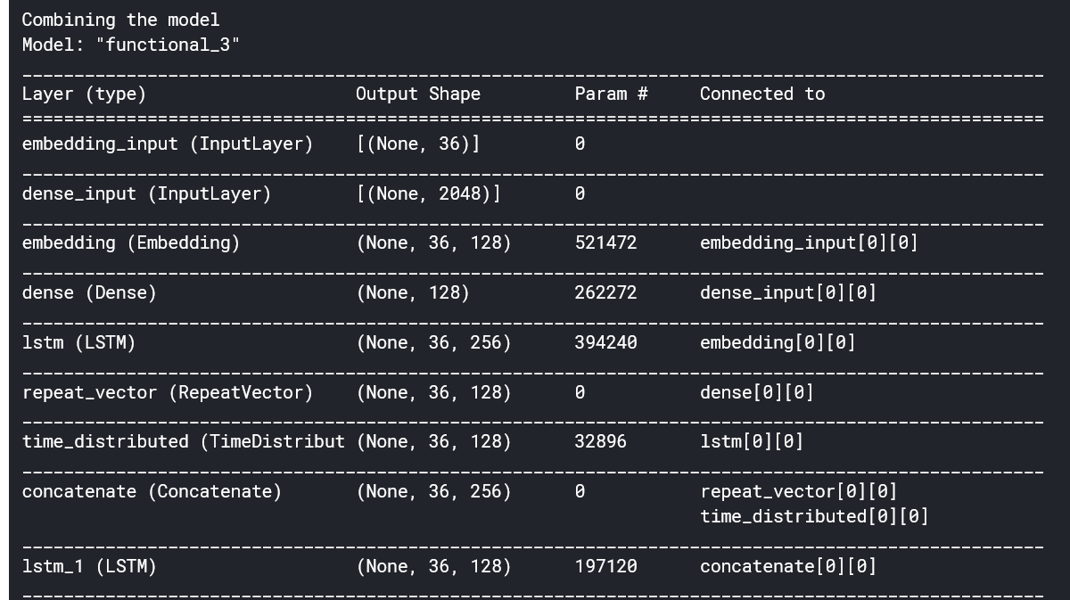

Figure 32: Output showing the combined model

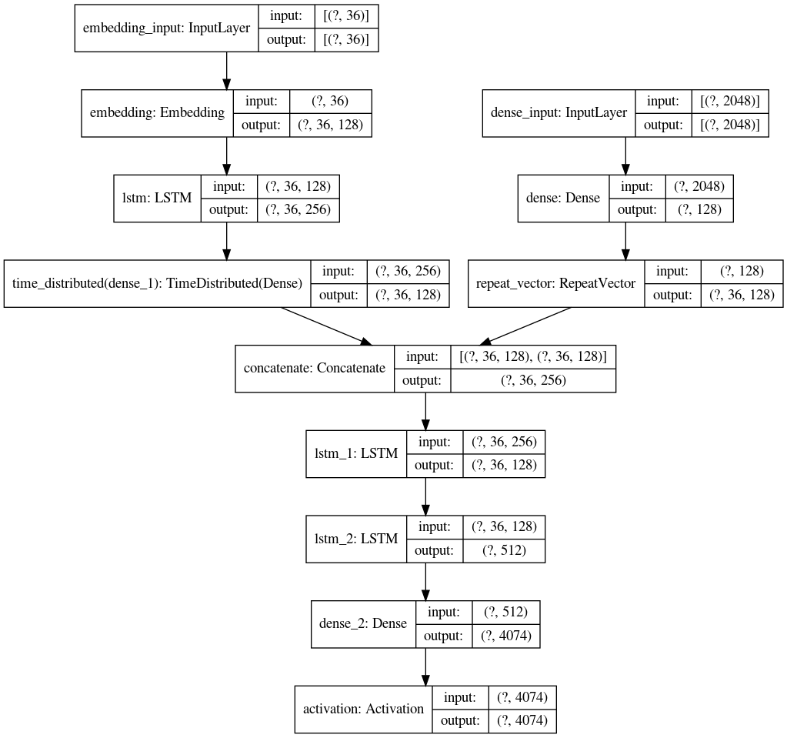

Figure 33: Detailed layout of the model along with shapes of inputs

**5.8 TRAINING AND SAVING THE MODEL**

We put the model on training with the inputs we have generated through the generator function in the above section using TensorFlow model.fit() function for 50 epochs as shown in figure 34. Once the training is complete we save the trained model for later use and operating in offline mode. An output snippet showing the training process is attached in figure 35. Then we prepare an inverse dictionary where every number of the word dictionary is now the key and every word of the dictionary is value. The inverse dictionary sample output is displayed in figure 36. This will be used in prediction when our model will give the number out of the dictionary having the highest probability we will check the corresponding value and return that word.

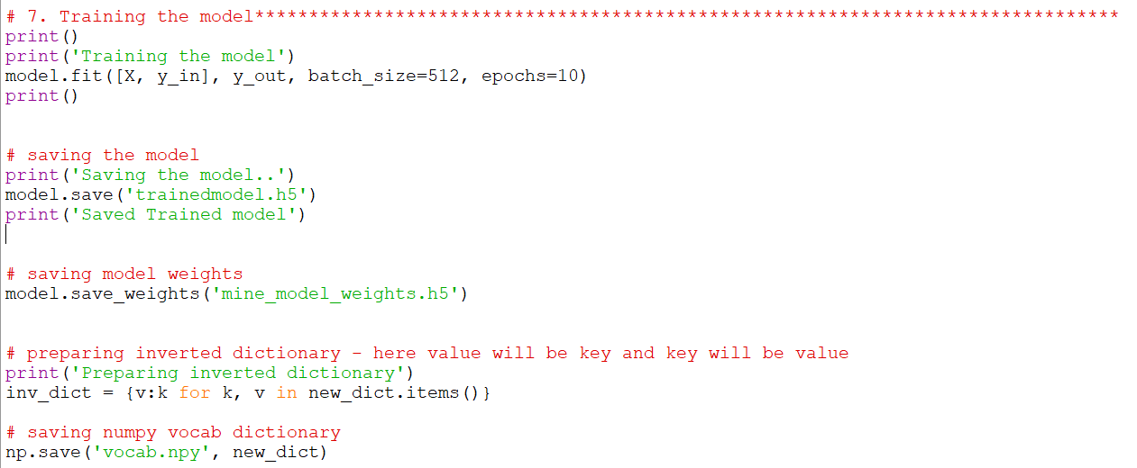

Figure 34: Code snippet showing the training process and creation of an inverse dictionary

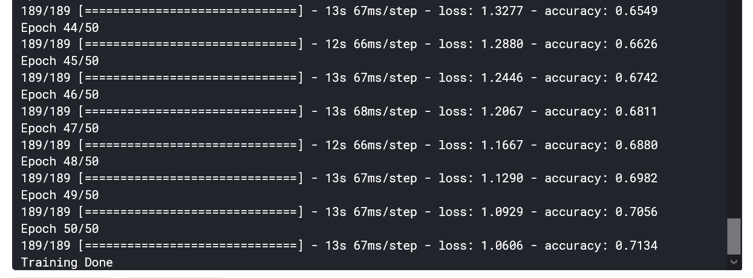

Figure 35: Sample output of the training process

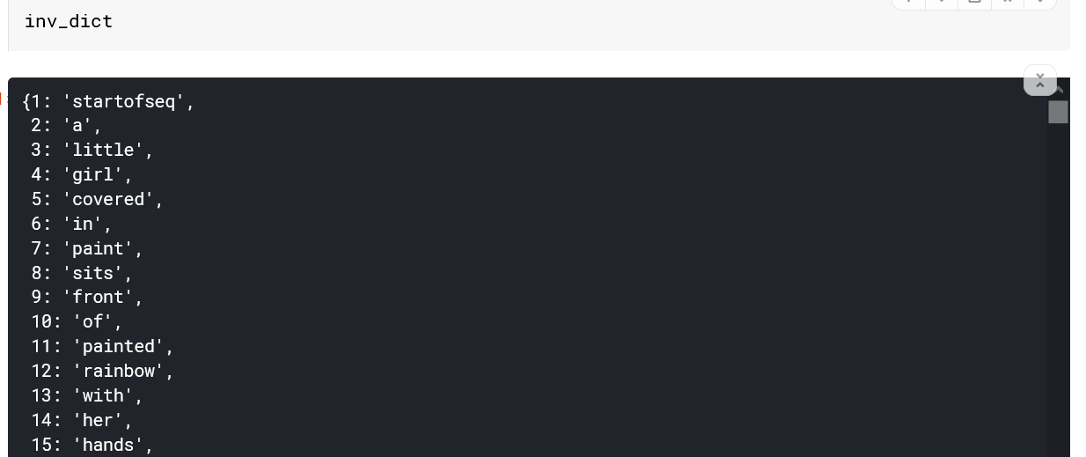

Figure 36: Sample output of the inverse dictionary

**5.9 PREDICTING THE CAPTIONS**

Now we have stored the ResNet50 model, trained model, dictionary of words and inverted dictionary. We can use these stored files to run or model on images to predict the captions. We have prepared a function which can fetch the images from our test folder and provide it one by one for predicting the captions. Figure 37 shows the process of preparation of test image provided by the user.

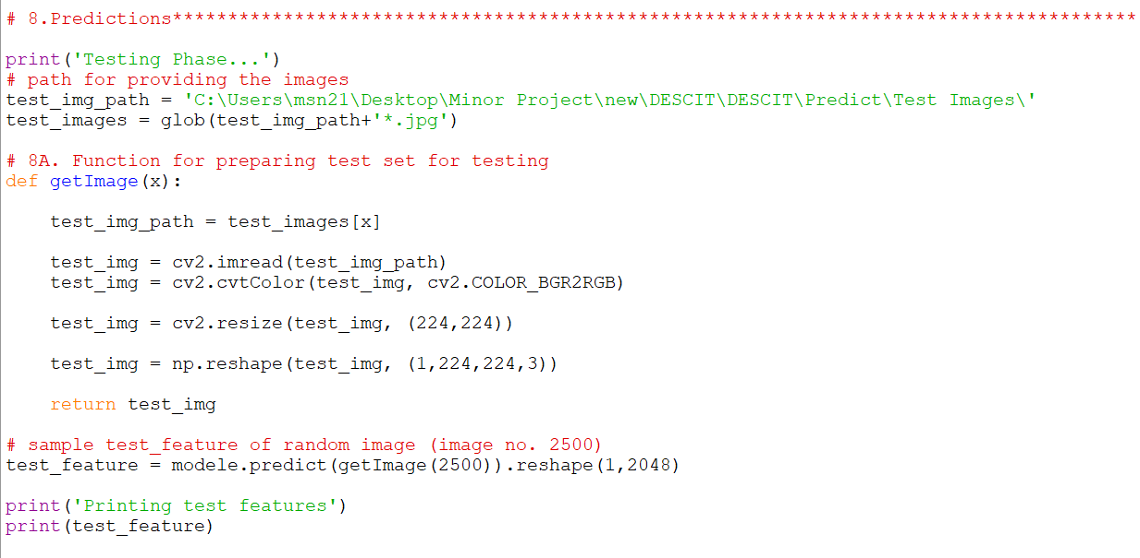

Figure 37: Code snippet showing the image preprocessing for the testing purpose

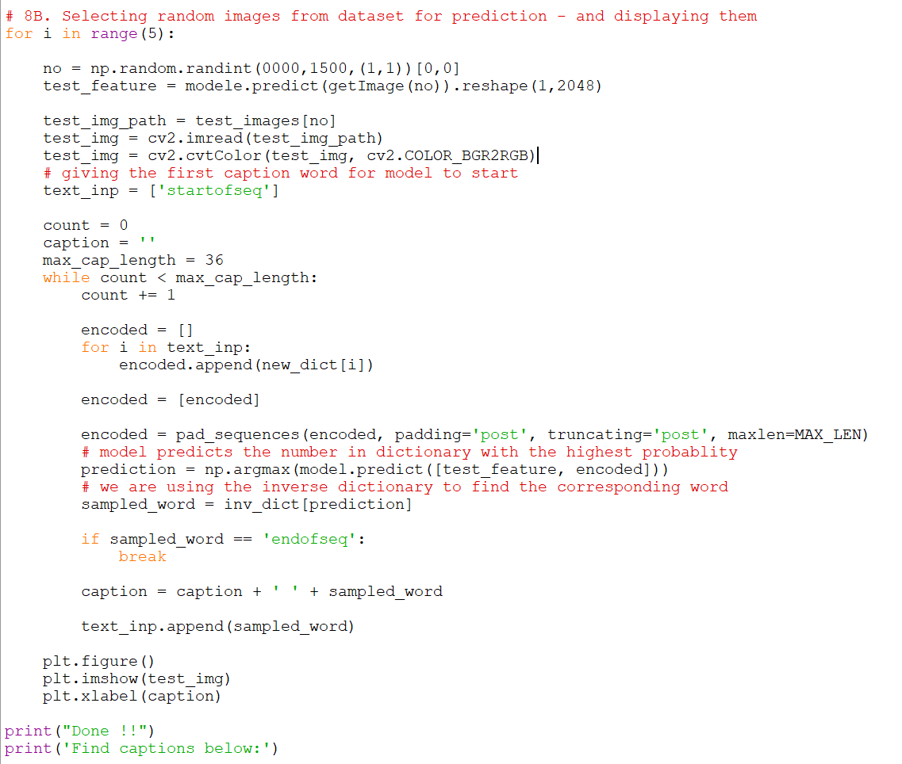

Figure 38: Code snippet showing the prediction process and results

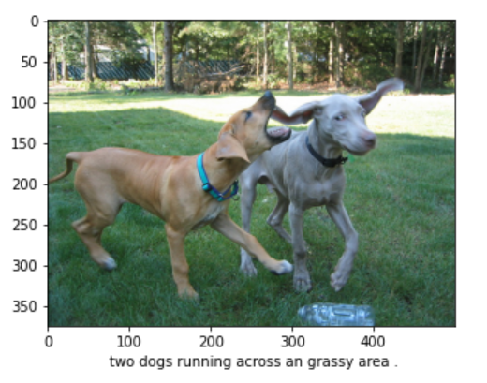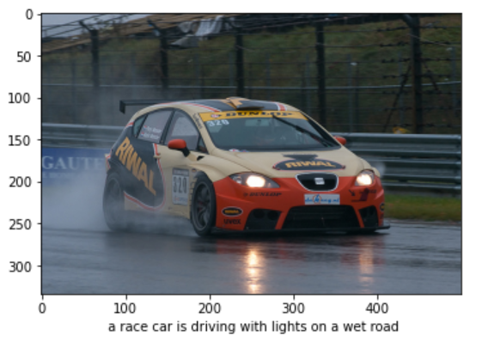

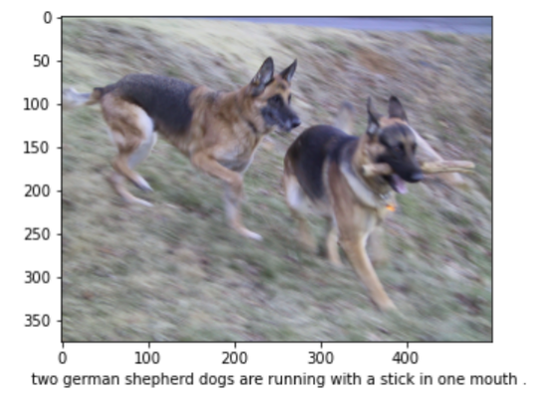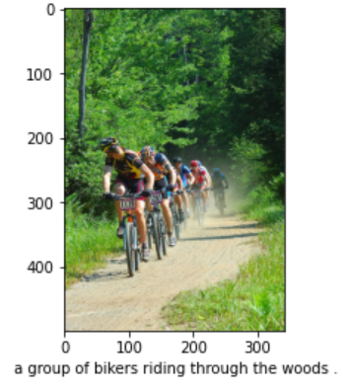

Figure 39: Some sample results generated by the model

Figure 38 code snippet shows the batch mode operation of the model which selects some random images from the test images folder and provides captions for them. Few of the results are attached in Figure 39.

**5.10 WEB PAGE DEVELOPMENT**

For the purpose of providing interfaces to users, we needed to develop a platform. Thus we chose web development for this. In this project, we created a web app using Python and it’s web framework flask, which reduces development time and allows us to build faster and smarter.

For the Frontend, we have created 5 web pages which include:

1. **Index.html** - Main welcome page of our web app, allows navigation to other pages and displays the categories of available quotes.
2. **Services.html -** It can be considered as the second option in Navigation. It is an important page because a user can actually upload the image here and gets the extracted caption.
3. **About.html** - About Page is for users knowledge about website, developers etc
4. **Contact.html -** In case of any query, enquiry, report, appreciation users can communicate to the development team
5. **Single.html -** Last but not least, this page is not directly accessible. On the index page when a user wants the quotes of a particular category and thus clicks its card, he/she is directed to this page, where they get a number of related quotes of that single category.

**5.11 API INTEGRATION**

In order to provide a vast number of quotes and categories, we connected our app to API. In this project, we used GoodQuotes API. API Integration is done using Javascript.

**5.12 CONNECTING MODEL WITH FRONTEND AND PYTHON CODE**

The backend and frontend both work together to serve a single goal. It’s pretty helpful to keep it in mind at all times. They are made, so a user can access them.

WORKING OF WEBSITE

The user points their browser to one of your website’s URLs and waits for the browser to render the page. The user sees a useful and usable page. The user interacts with the page.

Thus till now, our website was working as static, it was just connected to API. In order to connect it to our working python code, we used flask i.e, micro-framework of python. In this, we created several routes using route decorator and thus it helped us in hosting it to a local server - http://localhost:7000/

**5.13 PROVIDING USER WITH CAPTIONS ON THE PLATFORM**

On reaching Upload Page when a user inputs an image, The services() function is decorated with @app.route so that it is invoked when the browser sends a POST request. Using the request module of Flask it creates an object of the file and saves it in local storage. At the same time, it sends that image to python code by calling its function which in response returns the output string, which is then displayed as a caption.

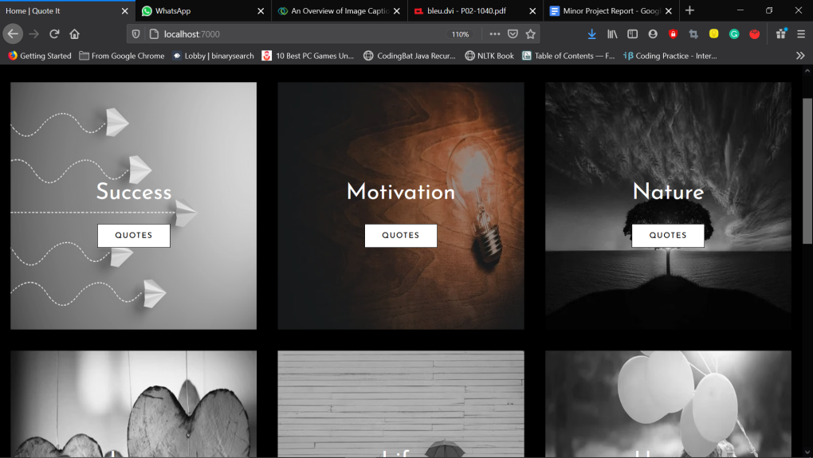

Figure 40: Layout of the Home page of the Web App

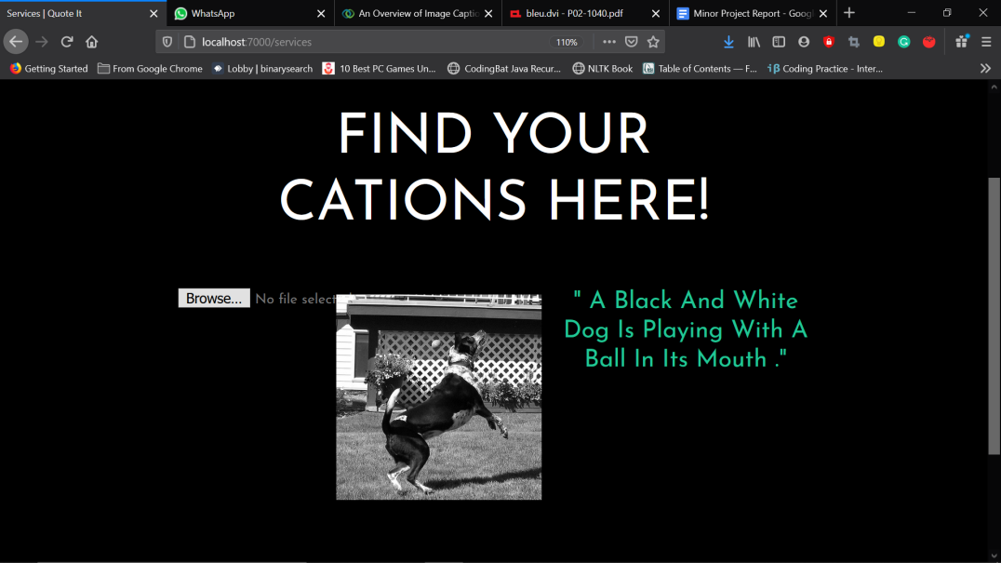

Figure 41: Sample results displayed at the Web Platform when using the model for prediction

Figure 40 shows the front page of the Web App as visible to the user. Here he/she can select the category of their choice to get the captions or they can select the Upload tab in the left top parallel bars. When the user will upload the image and press on the button. The model functions in the background and provide the caption which is shown on the Web App as shown in figure 41. Flask library is used to fetch the caption predicted by the model and display it on the Web Page.

**CHAPTER - 6**

**CONCLUSIONS AND FUTURE SCOPE**

**6.1 CONCLUSIONS**

Through the project, we were able to achieve an accuracy of 74.34 and a loss of 1.06 when training for 50 epochs. The model is able to predict the caption to a very close extent. Through this project, the user can obtain the caption of images from anywhere by just uploading the image within a few seconds. A batch of images can also be passed to obtain the captions for all the images, which can be used by the user for automating the task of manual captioning the images or classification of images by the use of captions of the images.

**6.2 FUTURE SCOPE**

There is a huge feature approach for this model some of which are enlisted below:

* This model is currently trained for a set of 1500 images from the desired set of 6000 images from the Flickr8k dataset, due to limitations of the hardware. Even then it has shown quite promising results for a large set of images. If this model can be made to train on 6000 images the model’s accuracy will enhance a lot and the loss will also decrease. Thus we will be able to provide users with better results.
* Option for single and batch mode operation. This feature will provide the user with the option to choose the single and batch mode right from the platform only.
* Bunch caption suggestion - this feature will provide the user with a bunch of captions that can be used by the user.
* Text-to-speech conversion option - this feature will provide an option to generate the audio clip for the caption generated which can be used to help the visually impaired peoples.
* Video Frames Recognition - this feature will provide the user with the option to provide videos as input and obtain the important features like captions, or summary from it.
* An android app using this model can be a handy tool, which can be used by a huge number of people.
* Plugin feature - this feature will provide it with the functionality to be added with different image apps in the device and directly suggest them captions.

**CHAPTER - 7**

**REFERENCES**

[1] Kaiming He, Xiangyu Zhang, Shaoqing Ren and Jian Sun - Deep Residual Learning for Image Recognition - Dec 10, 2015 - (arXiv:1512.03385v1)

[2] Christian Szegedy, Wei Liu, Yangqing Jia, Pierre Sermanet, Scott Reed, Dragomir Anguelov, Dumitru Erhan, Vincent Vanhoucke and Andrew Rabinovich - Going deeper with convolutions - Sep 17, 2014 - (arXiv:1409.4842v1)

[3] Franc¸ois Chollet - Xception: Deep Learning with Depthwise Separable Convolutions - Apr 4, 2017 - (arXiv:1610.02357v3)

[4] Priyanka Jadhav, Sayali Joag, Rohini Chaure, Sarika Koli - Automatic Caption Generation for News Images - ISSN:0975-9646

[5] Vishwash Batra, Yulan He, George Vogiatzis - Neural Caption Generation for News Images

[6] Kishor Prajapati, Shardul Wadekar, Bhushan Bobhate and Amruta Mhatre - Auto-Caption Generation for News Images - ISSN: 2278-0181

[7] Mohmedhanif Nashipudi - WEB 2.0 AND FOLKSONOMY - ISSN: 2250-1142 - March2012

[8] Kaiming He, Xiangyu Zhang, Shaoqing Ren and Jian Sun - Delving Deep into Rectifiers: Surpassing Human-Level Performance on ImageNet Classification - Feb 6, 2015 - (arXiv:1502.01852v1) {Parametric Rectified Linear Unit (PReLU)}

[9] Kaiming He, Xiangyu Zhang, Shaoqing Ren, and Jian Sun - Identity Mappings in Deep Residual Networks - Jul 25, 2016 - (arXiv:1603:05027v3) {2.3.1 and 2.3.2}

[10] Diederik P. Kingma and Jimmy Lei Ba - ADAM: A METHOD FOR STOCHASTIC OPTIMIZATION - Jun 30, 2017 - (arXiv:1412.6980v9)

[11] Andrej Karpathy and Li Fei-Fei - Deep Visual-Semantic Alignments for Generating Image Descriptions

[12] Yansong Feng - Automatic Caption Generation for News Images - 2011

[13] Junyoung Chung, Caglar Gulcehre, KyungHyun Cho and Yoshua Bengio - Empirical Evaluation of Gated Recurrent Neural Networks on Sequence Modeling - Dec 11, 2014 - (arXiv:1412.3555v1) {LSTM - GRU}

[14] Marc Tanti, Albert Gatt and Kenneth P. Camilleri - What is the Role of Recurrent Neural Networks (RNNs) in an Image Caption Generator? - Aug 25, 2017 - (arXiv:1708.02043v2)

[15] Jing Yang and Jun Wang - Tag clustering algorithm LMMSK: improved K-means algorithm based on latent semantic analysis - April 2017

[16] Marc Tanti, Albert Gatt and Kenneth P. Camilleri - Where to put the Image in an Image Caption Generator - 12-Mar-2018 - (arXiv:1703.09137v2)

[17] A. Farhadi, M. Hejrati, M. A. Sadeghi et al., “Every picture tells a story: generating sentences from images,” in *Computer Vision – ECCV 2010*, K. Daniilidis, P. Maragos, and N. Paragios, Eds., pp. 15–29, Springer, 2010.

[18] S. M. Li, G. Kulkarni, T. L. Berg, A. C. Berg, and Y. J. Choi, “Composing simple image descriptions using web-scale n-grams,” in *Proceedings of the Fifteenth Conference on Computational Natural Language Learning. Association for Computational Linguistics*, pp. 220–228, Portland, Oregon, USA, 2011.

[19] G. Kulkarni, V. Premraj, S. Dhar et al., “Baby talk: understanding and generating image descriptions,” in *CVPR means IEEE Conference on Computer Vision and Pattern Recognition*, pp. 2891–2903, 2011.

[20] Y. Gong, L. Wang, M. Hodosh, J. Hockenmaier, and S. Lazebnik, “Improving image sentence embeddings using large weakly annotated photo collections,” in *European Conference on Computer Vision*, pp. 529–545, Springer, 2014.

[21] V. Ordonez, G. Kulkarni, and T. L. Berg, “Im2Text: Describing images using 1 million captioned photographs,” *Advances in Neural Information Processing Systems*, pp. 1143–1151, 2011.

[22] C. Sun, C. Gan, and R. Nevatia, “Automatic concept discovery from parallel text and visual corpora,” in *Proceedings of the IEEE International Conference on Computer Vision (ICCV)*, pp. 2596–2604, Santiago, Chile, 2015.

[23] M. Hodosh, P. Young, and J. Hockenmaier, “Framing image description as a ranking task: Data, models and evaluation metrics,” *Journal of Artificial Intelligence Research*, vol. 47, pp. 853–899, 2013.

[24] O. Vinyals, A. Toshev, S. Bengio, and D. Erhan, “Show and tell: a neural image caption generator,” in *Proceedings of the IEEE conference on computer vision and pattern recognition*, pp. 3156–3164, Boston, MA, USA, 2015.

[25] A. Karpathy and L. Fei-Fei, *Deep visual-semantic alignments for generating image descriptions*, Stanford University, 2017.

[26] K. Xu, J. Ba, R. Kiros et al., “Show, attend and tell: neural image caption generation with visual attention,” in *International conference on machine learning*, pp. 2048–2057, Lile, France, 2015.

[27] R. Kiros, R. Salakhutdinov, and R. S. Zemel, “Unifying visual-semantic embeddings with multimodal neural language models,” *Workshop on Neural Information Processing Systems (NIPS)*, 2014.

[28] X. Yu, Y. Chu, F. Jiang, Y. Guo, and D. Gong, “SVMs Classification based two-side cross domain Collaborative Filtering by inferring intrinsic user and item features,” *Knowledge- Based Systems*, vol. 141, pp. 80–91, 2018.

[29] X. Yu, F. Jiang, J. Du, and D. Gong, “A cross-domain collaborative filtering algorithm with expanding user and item features via the latent factor space of auxiliary domains,” *Patten Recognition*, vol. 94, pp. 96–109, 2019.

[30] https://www.hindawi.com/journals/wcmc/2020/8909458/

**APPENDICES**

**APPENDIX 1**

**1.1 DETAILED TEST STRATEGY AND TEST CASES**

For the testing process, we have selected the last 1000 images from the Flickr8k Dataset and by using the ‘random function’ of Numpy library we have fetched images from the Test Data Set and checked the captioning accuracy.

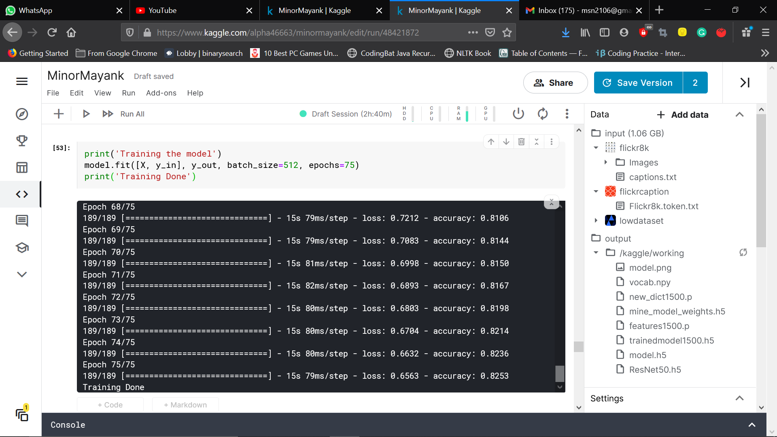

Figure A1: Sample image showing loss and accuracy obtained by the model

The last measured accuracy of the model at 50 epochs was 74.34 and the loss was 1.06. The model has the best accuracy on training it for 75 epochs is 82.53 and the loss of 0.65. We have used the inbuilt function of the model.train() to obtain the accuracy of the model. Figure A1 shows that model.fit() function’s inbuilt mechanism for detecting the loss and predicting the accuracy show us the loss and accuracy of the model.

**APPENDIX 2**

**2.1 USER GUIDE**

The user needs to follow the below-mentioned procedure for obtaining the captions for the images they provide.

Step 1: Visit to the webpage using _______

Step 2: Browse to upload section of the website

Step 3: Click on the browse button to select the image present in the system

Step 4: After selecting the image, the image will appear on the web page. Then press the Predict Caption button.

Step 5: Wait for a while, the model will provide you with the caption within a short interval

Step 6: Done. Now the user can copy the caption and use it at the place of their choice.

**EOF**